Year …… Home Learning – Week 2
We have provided some guidelines for your child’s home learning. We appreciate that these are stressful times for all involved. Where possible, please encourage your child to complete the learning outlined below. We appreciate that in some cases this may not be possible. Please try your best and don’t get too worried about it. Most importantly stay safe and enjoy this time with your family.
English |  | Topic
Spring acrostic poem  Day 1- pick two senses that you are going to focus on today. Go into the garden and collect ideas for two senses boxes (See attached sheet. Use as an example if you cannot print it).  Day 2- repeat the above for the other two senses (I know that’s only 4!)  Day 3- turn your ideas into noun phrases. E.g. fresh cut grass, pretty flowers, blazing hot sun. Try some alliterative phrases – shining sun, beautiful buds blossoming, gorgeous, green grass.  Day 4- write your poem starting each line of it with a letter from the word Spring. (see sheet below).  Day 5- copy your poem up in neat to practise your handwriting and decorate it. (Sheet provided if able to print).  - Please also try to complete daily reading of 10 minutes. Children can read to parents, parents can read to children, parents and children can read a page each, whatever works for you! We would love to hear about any books that you’ve enjoyed. |  | Art:  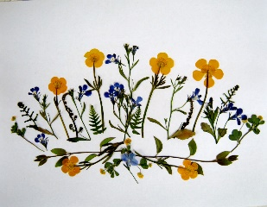  Try pressing some flowers- pick some daisies or buttercups, place them between two pieces of paper and surround in some newspaper. Put this package between some heavy books and wait a while!  Observational drawing- use some pencil skills learnt in school to draw flowers or other Spring objects.  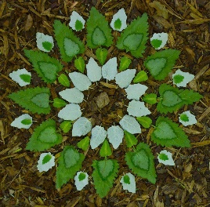  Collection pictures- collect some things from around the garden (stones, grass, flowers, twigs etc) and create a picture either on the ground or on paper and stick down.
Maths
- Two My Maths tasks have been set. Please remember to do the lesson before completing the activity.
- Daily maths lessons on the White Rose website. Go to https://whiterosemaths.com/ and click the Home Learning tab at the top of the page. Click on Year 2. There are lessons for you to follow, and optional worksheets to complete. We recommend that you start with Week 1- Lesson 1 is Make Equal Parts. The learning then builds on knowledge from the previous week.
- If your child finds the work challenging, you can also access the Year 1 home learning.
- Continue to learn 2, 5 and 10 times tables.
- Telling the time is a vital skill. Practise telling the time to the o’clock and half past, and then begin to introduce quarter past and quarter to. We learn analogue time in Year 2, not digital.
Science | Spellings | PE | RE
- In the first half of the Spring Term, we were learning about Materials. We would like you to research a particular material. You can choose from: wood, rubber, wool, cotton, nylon or plastic.  - You may want to find out the answers to the following questions in your research:  - Is the material natural or manmade?  - Where is the material found?  - What products is the material used to make?  - Any other interesting facts that you may find out during your research.  - You may choose to present your research as a poster, a leaflet or as a Powerpoint presentation. | - Please continue to practise spelling the Year One and Year Two common exception words that were sent home in the Spring Term. Remember that little and often is best! | - Tying shoelaces is an important fine motor skill that children need to learn. Please take the time to teach your child.  - Joe Wicks, the Body Coach is providing daily, fun workouts for everyone to take part in, Visit https://www.youtube.com/user/thebodycoach1 and click on PE With Joe. | - This term in RE we will be studying What is the ‘good news’ Christians believe Jesus brings?  - This week we would like you, as a family, to come up with a list of 12 people (or professions) that you feel could change the world and why. You may want to list qualities that these people need, for example to be kind, strong, helpful etc. You may also want to draw pictures of these people.

Collecting ideas for a Spring poem.

Things I see | Things I hear
Things I feel (emotional and physical) | Things I smell

S

P

R

I

N

G

