Year 6 Home Learning – Week 2
Dear children in 6H and 6W. We hope you have had a lovely Easter break – we’ve had lovely weather for it! Below are some things to do this week – take your time, don’t try to rush through it and we have tried to think of things that are a bit more fun to do! We’re missing you all and feel free to email us (Mr Hudson and Mr Watson) with things you have done or got up to – your parents should have our email addresses.
School message: We have provided some guidelines for your child’s home learning. We appreciate that these are stressful times for all involved. Where possible, please encourage your child to complete the learning outlined below. We appreciate that in some cases this may not be possible. Please try your best and don’t get too worried about it. Most importantly stay safe and enjoy this time with your family.
English |  | ICT and French
Step 1  I hope you and your parents are enjoying the weather now it has changed recently compared to the wet, moody and cold winter months. I wonder how many ways you can observe and notice changes that have taken place by simply looking out of the window or taking a lovely sunny family walk together. It might be that you notice how warm the sun feels on your skin, the birds in song or how trees and flowers are bursting into glorious colour.  Step 2  Have a look at these Poems:  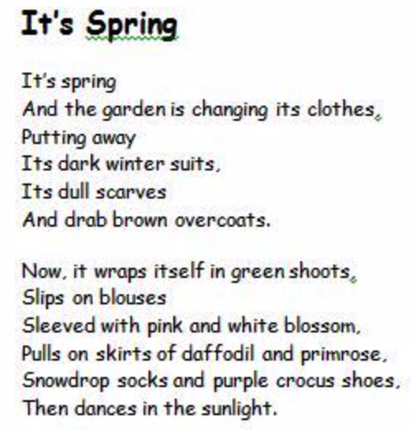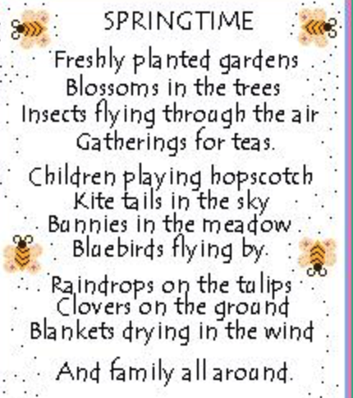  Children: Make some notes on what you like about the poems. What words do you love and what do you think you could magpie for your own Springtime poem.  Step 3  Challenge : Create your own Springtime poem and decorate it with some beautiful pictures. Top Tips: Using https://www.thesaurus.com find some alternative/additional vocabulary for nouns, adjectives, verbs and adverbs you use. For example :  Before : The hot sun shines down upon the ground.  After: The blazing sun radiantly shines upon the eager ground.  Remember, poems can rhyme but they do not have to! |  | 'ICT - Create an animation.  You will need to use Scratch for this and can access it free either via the free App on a tablet or phone, or using this link through the internet on a computer or laptop.  https://scratch.mit.edu/projects/editor/?tutorial=getStarted  Can you create an Easter scratch animation? You can save it to your Scratch account if you have one (free to set up), or it will automatically save if you are using the App.  Remember to use the tutorials to help you if you get stuck, or the 'explore' section if you need some inspiration Have fun and get creating!'  'French - labelling clothes and body parts.  We have been learning about different body parts and clothing items in French.  Can you design a poster of your favourite celebrity or person and label their outfit and body with French words? For example their hand, la main or their trousers, un pantalon.  You may use the internet to help you with the vocabulary. Make sure you remember the correct french spelling at the start of each word for either masculine or feminine (le/la and un/une).  If you're after a challenge, maybe you could put your labels into a few sentences in French? Perhaps say what colour their hair is.
Maths
Ratio and MyMaths Challenges
Week by week we are going to be following the fantastic White Rose Home Learning Scheme starting with week 1: see link below.

https://whiterosemaths.com/homelearning/year-6/

In addition, children will have a weekly familiar MyMaths challenge to complete too!

1) WHITE ROSE
Simply click on the link
Select: Week 1 - Lesson 1. If you look at the large picture situated on the left side of the lesson, you should see a play button. This will play a small lesson to help the children with the independent activities. Children should listen carefully to the lesson taking notes. Once completed the children should click and complete the Get the Activity button. Once completed, children can mark their work.
2)MyMaths
Teachers now have all login details for each child so please get in touch if they have forgotten or misplaced their login details.

Login in as normal and complete maths task. REMEMBER, if you are not sure PLEASE use the teacher button to get help and practise.

Science | Spellings | PE | RE
Can you correctly label the human body using the images below? You can draw the picture and labels on paper - you may need to do some research online!  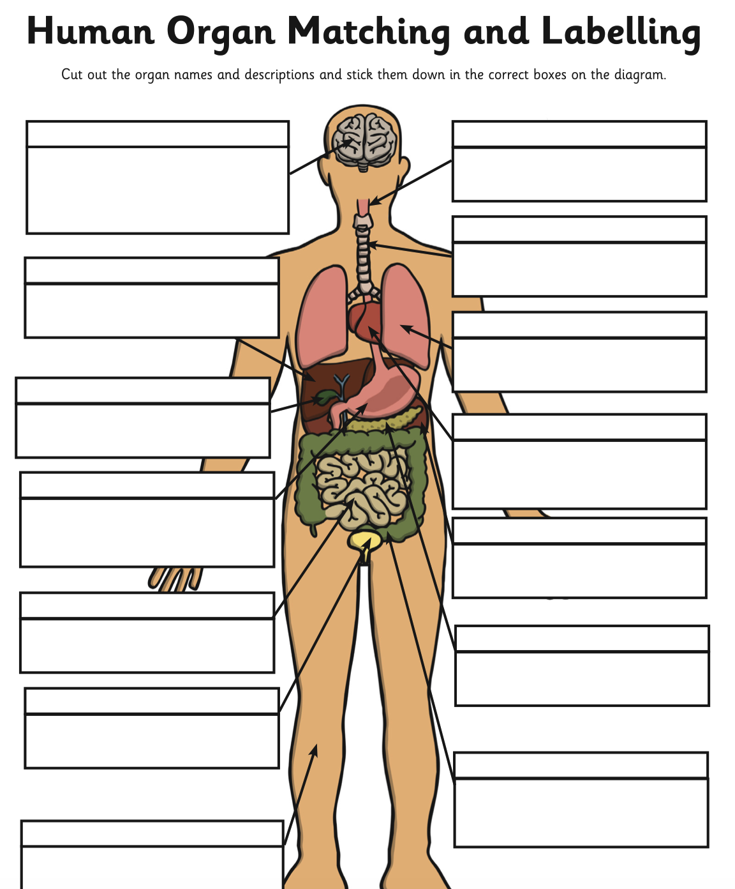  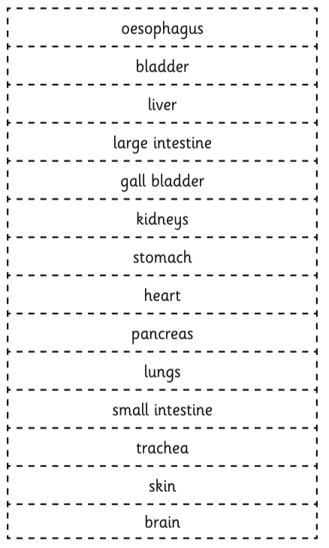 | It is really important that we continue to practise our spellings weekly over the next few weeks.  Step 1  Ask someone at home to test you on these words and record your score.  Step 2  Use the Pyramid Writing strategy to practise spelling the words from the list below.  Step 3  When ready, ask someone at home to test you on the spellings again and record your score! Have you improved your score?  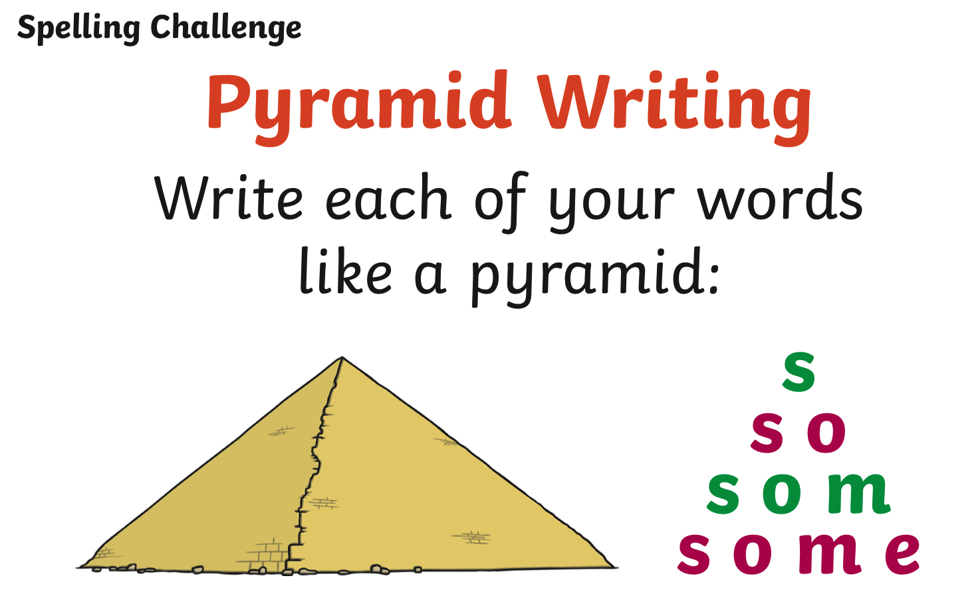  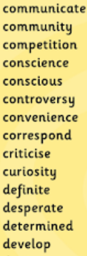 | River Crossing. (Adult supervision needed)  Choose a room in your house (or hallway, or in the garden.)  Choose some things from your house that you can stand on (cushions, mats, piece of paper, tray...) plan a route from one end of the room to the other.  CHALLENGES:  - Use less things to step on  - Get chairs to use as obstacles to go round  - Blindfold an adult and instruct them around the route  - Swap over and get the adult to instruct you  - Can you create a route from one area to another? | As it is Easter, use the internet to remind yourself of the Easter story.  https://www.youtube.com/watch?v=HL8R158Ujp4  The above youtube video explains it well – watch it.  Choose 3 to 5 separate parts of the story.  Draw a picture for each part, and explain, in detail, below the picture what is happening.

