Year 6 Home Learning – Week 2
Dear children in 6H and 6W. We hope the first week back after the Easter holidays was good. Well done to so many of you getting on with the home learning – we've seen and heard about you doing some great work. As usual, this week is below. There are some reading links too (online), as I imagine some of you will be running out of books at home by now! Have a nice week – as usual your parents have our email addresses if needed. It is nice to hear from them and you.
School message: We have provided some guidelines for your child’s home learning. We appreciate that these are stressful times for all involved. Where possible, please encourage your child to complete the learning outlined below. We appreciate that in some cases this may not be possible. Please try your best and don’t get too worried about it. Most importantly stay safe and enjoy this time with your family.
English |  | ICT, French and Art
Watch this short story. https://vimeo.com/36276188 or on youtube  https://www.youtube.com/watch?v=CkHrcePAW40  Here is an explanation of the story. This explanation uses some tricky words – if you are unsure of any of them note them down and use a dictionary (or online dictionary) to find out their meanings.  A solitary, one winged creature called Wing is harassed by a group of oppressive crows due to being weak and different from them. He decides that he wants to overcome his disability and escape from the forest. He builds a catapult and a mechanical wing to accomplish this. When he launches himself away from the forest, the wing malfunctions, and he crashes into the territory of the crows. The crows are about to harm him, but are then lured away by a two-winged humanoid, who the crows attack instead. Wing finds the creature, and discovers it is a female of his own kind, and that the crows have torn one of her wings off. As the crows come towards them, Wing gets the idea that he and the female can fly in tandem by flapping each of their single wings while holding onto each other, and they manage to escape from the forest.  You’ve seen the story told in video form. Now you are going to write the story. This could take a few days – don't try to do it all in one go! We have done all of these things in class so you should remember them!  1) Create a storyboard for your story (piece of paper folded into 8 parts. A picture and notes for each part.)  2) Create a story mountain for the story (Include opening, build up, problem, climax, resolution, ending)  3) Write a setting description for the place it happens in, and a character description for the boy.  4) Finally, use all of these things to write a story that tells the story of the video. You can give the characters names and make up some speech if you want. Can you include prepositions? Complex sentences? Adverbial phrases?  This will take a while to do. You could do one part a day to make it as good as possible. Also do this in order! We look forward to reading your finished stories 😊 .  Reading  I imagine that you are starting to run out of books to read at home. Here is a link to e-books or texts online. There are lots of different genres of texts so you’ll be able to find something that interests you. Also explore AR online. Don’t worry about it if you can’t get AR to work at home – we'll update this and give you more information about it next week.  https://home.oxfordowl.co.uk/ |  | French  Last week you practiced some written French, now it is your turn to try some French vocabulary!  Can you watch this clip that focuses on birthdays and clothes, and use it to reinforce some of your words you used last week with your posters?  Pause the clip after you hear the dog 'Farley' speaking and see if you can repeat what he is saying in French. Spud and Soda then translate it back to English for you. You may want to watch the clip a few times to build up your confidence speaking in French.  https://www.bbc.co.uk/bitesize/clips/zdm8q6f  ICT  Now you have become more familiar with Scratch again after creating your Easter animations, we are going to move on to creating some games in Scratch. You may remember the shark game we created from last year in Year 5, well there is a link below to remind you. Have a play and press the 'see inside' button to look at the code. The best way to load onto your computer is to open it once you have got Scratch open on your web browser, from file.  https://scratch.mit.edu/projects/24156418/  Before you can code your own game however, you need to decide on a character. Watch this clip below and afterwards decide on a good character for your game. Now can you design it in Scratch using the costumes tab?  https://www.bbc.co.uk/bitesize/topics/zv63d2p/articles/zprj7ty  Art  Outdoor Art! Make a piece of outdoor art using things you can collect on a daily walk or in the garden. Use repeating patterns to create your own design. Below are some pictures to give you some ideas.  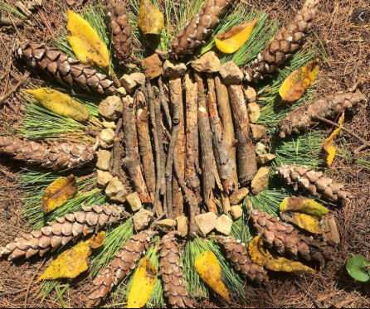  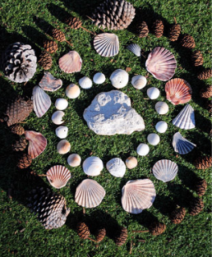
Maths
Continue with the White Rose Maths home learning – you are now on week 2. Remember to watch the videos before answering the questions on the link next to the video. You can write the questions down on paper, you don’t need to print off the questions. If this is too tricky, you could always look at the year 4 or 5 work. If you fancy a challenge, there is also year 7 and 8 home learning activities on there!

https://whiterosemaths.com/homelearning/year-6/

You also have some revision on MyMaths to do.

1) WHITE ROSE
Simply click on the link above.
Select week 2. If you look at the large picture on the left side of the lesson, you should see a play button. This will play a small lesson to help with the independent activities. You should listen carefully to the lesson taking notes. Once it is completed, you should click and complete the Get the Activity button. Once that is completed, you can mark your work.
2) MyMaths
Teachers now have all login details for each child so please get in touch if you have forgotten or misplaced your login details.

Login in as normal and complete maths task. Remember, if you are not sure please use the teacher button to get help and practise.
Science | Spellings | PE | RE
Last week we looked at the human body in a bit more detail.  But what about what we actually put in our body?  Over the next week create a food and drink diary. Write down every single thing that you eat or drink!  Next week in Science we will use this information to find out more about the types of food we eat in a ‘normal’ week.  I’ve created what this diary could look like in a separate document on this week’s home learning folder. | It is important that we continue to practise our spellings weekly over the next few weeks.  Over the next week test yourself on all of the year 3 and 4 words. (Use an adult or sibling to read them to you). Make a note of any you get wrong. Choose up to 10 of those you got wrong. With an adult, or older sibling, think of more words that are similar to the ones you have got wrong. Practice them.  For example, if you have spelt ‘could’ wrong, you also need to practice ‘would’, ‘should’, ‘mould’, ‘shoulder’.  If you get all the year 3 and 4 words right, do this exact thing for the first column of year 5 and 6 words (accommodate to competition).  The spelling lists are on a separate document on this week’s home learning folder. | As I’m sure you have seen, Joe Wicks is doing daily exercise classes - have a look and try one! You don’t have to do this at 9:00 each morning – they are always there for you to look at.  https://www.youtube.com/channel/UCAxW1XT0iEJo0TYlRfn6rYQ | This unit is about trying to transform the world. What would a better world be like?  Talk about or think about what the main problems are in the world. You can make a list if you like.  e.g. hunger, violence/crime.  Find out about some people who have made a difference to the world. You could have a look at winners of the Nobel Peace Prize or the Niwano Peace Prize.  Make a list of ways in which people could make the world a better place over the next 50 years.

