**WALT: locate and identify the countries Saint George is the patron saint of.**

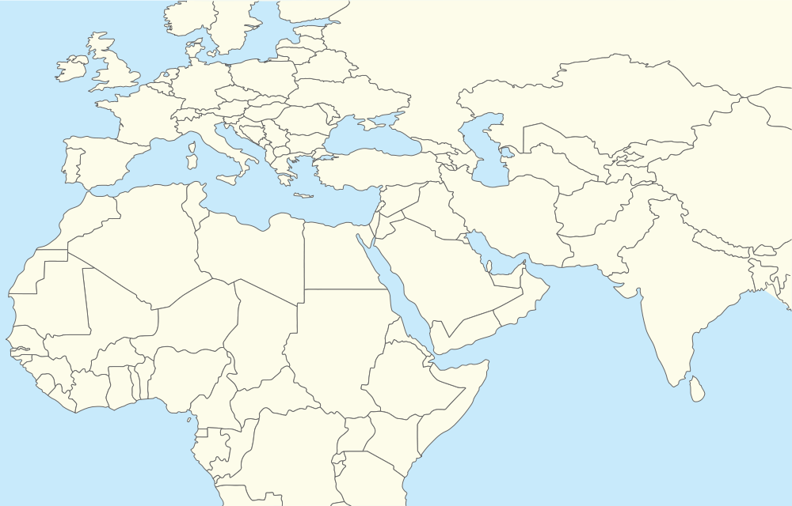

Wordbank: England Ethiopia Georgia Portugal