Nursery Home Learning – Week 2
We have provided some guidelines for your child’s home learning. We appreciate that these are stressful times for all involved. Where possible, please encourage your child to complete the learning outlined below. We appreciate that in some cases this may not be possible. Please try your best and don’t get too worried about it. Most importantly stay safe and enjoy this time with your family.
Literacy | Topic – The Woods
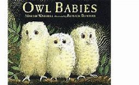  Story of the week – Owl Babies by Martin Waddell  Share the story ‘Owl Babies’ – using the link below, or if you have the book at home share that with your child. https://www.youtube.com/watch?v=TPQRiSTYFHo  Listen to the story a few times across the week. Once your child becomes familiar with the story encourage them to join in with the story and repeated refrains such as; ‘I want my Mummy’.  - Discuss with your child where the owls live (the story setting).  - Who are the characters in the story?  - What happens at the beginning, middle and end?  - How does Sarah, Percy and Bill feel at different points within the story?  - What is your favourite part of the story and why?  Star challenge: Children, can you make your own Owl Babies puppets and use these to retell the  story? Act out the story for your family, creating your very own puppet show.  Phonics  N2 – (Pre-schoolers):  In phonics this week, encourage your child to recognise the letter sounds (phonemes):  s / a / t / p / i / n / m / d / g / using home-made flash cards.  To make your own flash cards – write one (lower-case) letter on each piece of paper and show these to your child, can they recall the letter sounds (not the letter name)?  We have been teaching the children to recognise the phonemes using Jolly Phonics – access the Jolly Phonics YouTube clips through the link and encourage your child to sing along: https://www.youtube.com/watch?v=1Qpn2839Kro  Ms Hughes has made her own YouTube video of ‘Silly Soup’, click on the link below and encourage your child to join in with the game, pretending they have their own bowl and spoon and sing along. You can then make your own silly soup, finding different objects that begin with one letter sound (phoneme), you could choose from; a / t / p / i / n / m / d. Emphasise the initial sound of the objects. https://www.youtube.com/watch?v=dlUGJovz2UI  N1 – (younger nursery pupils)  This week we are focusing on our listening skills. We are going to be listening for sounds in the environment. Ask your child what makes them a good listener? Eyes looking, ears listening and lips closed – listening carefully. Have a go at playing the following games.  Drum outdoors  Give your child a beater or make drumsticks, using a pencil or twig. Encourage the children to explore the garden and discover how different sounds are made by tapping or stroking, with their beaters, a wooden door, a wire fence, a metal slide, and a few items such as pipes and upturned pots you have ‘planted’.  Ask your child to demonstrate their favourite and join in too. You can be the conductor and raises a beater high in the air to signal the children to play loudly and lowers it to signal playing softly.  Listening walk  This is a listening activity that can take place indoors or outdoors.  Remind your child about the things that good listeners do. Invite your child to show you how good they are at listening and talk about why listening carefully is important. Encourage them to listen attentively to the sounds around them. Talk about the different sounds they can hear. After you have enjoyed a listening walk indoors or outdoors, make a list of all the sounds they can remember. The list can be in words or pictures and prompted by replaying sounds recorded on the walk.  There are also a range of listening games online:  www.phonicsbloom.co.uk – Phase 1  http://www.letters-and-sounds.com/phase-1-games.html - Phase 1 | 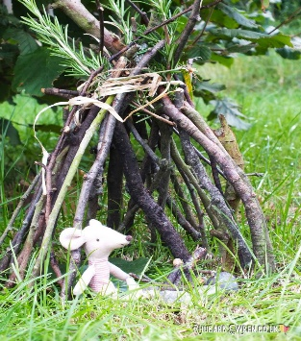  Our topic for the first few weeks of the Summer term is: The Woods  Please share the story Owl Babies and other stories set in a woods and encourage your child to talk about what they can see. I have also attached some pictures of woods and woodland animals. Discuss what types of animals might live there. Where do they live (in the trees / underground) and what do they eat? You may also discuss that some animals are awake in the daytime and some animals are awake at night (night time animals are nocturnal). The Owl babies are nocturnal; what other animals are nocturnal?  Activities:  - Can you collect natural objects from the garden and make a shelter or home for a small toy animal? You could use leaves, twigs, grass etc…  - Leaf rubbings  - Make a leaf necklace by threading string through leaves.  - Nature detectives – have a piece of paper ready and draw the different animals, bugs and birds that you can see out of your window or in the garden. Remember children you will need to be very quiet! Shhhhhh.  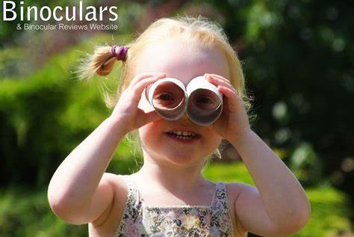  Maybe you could even make your own pair of binoculars to help look for signs of nature.
Maths | Expressive Arts and Design
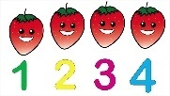  Keep Counting! Remember it is really important that your child touches each item as they say the number name. Encourage your child to either line up the objects or move the object as they count them, this will ensure accurate counting.  Choose a few activities this week to complete from the list below:  - Make a tower and count the bricks, then draw the tower and write the correct numeral.  - Play What’s the time Mr Wolf and count your steps.  - Pretend it is Teddy’s Birthday and have a tea party. Make a playdough cake and put candles on it. Count the candles. Can they make a badge with the corresponding number on it? 4 candles and a badge with number 4.  - Play a skittles game. How many have you knocked down? How many are still standing? How many do we have altogether? Who can knock the most down?  - Encourage your child to help you set the table. How many knives/forks/spoons do we need? Can your child count out the cutlery and lay the table?  - Play simple counting games with a puppet where the puppet gets it wrong. Can your child show the puppet how to count carefully, pointing to each object as they count?  - Play a counting game online: https://www.topmarks.co.uk/learning-to-count/teddy-numbers  - Sing a range of counting songs: https://www.bbc.co.uk/teach/school-radio/nursery-rhymes-counting-songs/zn67kmn | 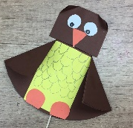  Make your own Owl babies puppets and use  these to retell the story Owl Babies.  We would love to see some photos of you with  your puppets.  Learn the rhyme: Wide Eye Owl  There's a wide eye owl (make binoculars with hands on eyes)  With a pointed nose (point at your nose)  Two pointed ears (grab ears)  And claws for toes (wiggle fingers and point to toes)  He lives way up in the tree (point up to the ceiling)  And when he looks at you (point)  He flaps his wings (flap arms like wings)  And says Who....Whooo! (continue flapping)
 | Physical Development
 | Gross Motor:  - Action songs are great for getting children active. There are lots of songs online.  - Try one of the 10 Minute Shake up activities: https://www.nhs.uk/change4life/activities/indoor-activities  - Make an indoor assault course and time your child to complete it. Include: crawling under, over through, hopping and jumping with both feet together. | Fine Motor:  Fine motor activities are also really important in order to develop your child’s pincer grip which will enable them to use a pencil effectively.  Encourage your child to:  - Thread beads /pasta /cheerio’s etc... onto string.  - Snipping paper with scissors.  - Playdough - rolling, pinching, squeezing and squashing playdough develops the muscles in their hands – try this to music, the children love Dough Disco!

The Woods
