Nursery Home Learning – Week 4 27.4.20

Literacy |  | Topic – The Very Hungry Caterpillar
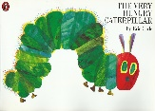  Story of the week – The Very Hungry Caterpillar by Eric Carle  Share the story; The Very Hungry Caterpillar – using the link below, or if you  have the book at home share that with your child. https://www.youtube.com/watch?v=75NQK-Sm1YY  Listen to the story a few times across the week. Once your child becomes familiar with the story encourage them to join in with the story and repeated refrains such as; ‘…but he was still hungry’.  - Can you remember what the Hungry Caterpillar ate and the order they came in?  - Why did he have a tummy ache?  - What happened at the end of the story?  - What is your favourite part of the story and why?  - Children, can you retell the story? Maybe you could find some toys and food from around your house to use as props.  Phonics  N2 – (Pre-schoolers):  Continue to practise learning the phonemes (letter sounds): s / a / t / p / i / n / m / d / g / using home-made flash cards. You can also watch the Jolly Phonics YouTube clips.  https://www.youtube.com/watch?v=1Qpn2839Kro  Introduce the next phoneme ‘o’ – remember we are teaching the letter sound not the name at this stage. Share the Jolly phonics song and sing along. For the action, pretend to turn a light switch on and off:  (sing to the tune of Old McDonald had a farm)  Now it’s dark the lights go on, /o/o/o/o/o,  Time for bed the lights go off, /o/o/o/o/o.  (I have attached the Jolly phonics picture card/song for ‘o’ below)  - Go on a scavenger hunt for objects that begin with the phoneme /o/.  How many objects can you find that begin with the phoneme /o/?  Practise forming the letter /o/ using a range of writing tools: pens, pencils, crayons, chalk, paint, trace your finger in sand, foam, flour…remember keep it FUN!  - Play Metal Mike: It is really important that your child practises orally blending and segmenting sounds in words. Have a selection of objects, toys or pictures, that are made up of three to four letter sounds like: cat, dog, pan, frog, sad, pram, etc… Pretend to be a robot and sound out one of the objects, leaving a pause between each phoneme. For example, c - a - t. Encourage your child to say the word and select the matching object. Repeat this a few times and when they are confident, encourage your child to be the robot and sound out an object for you to select.  - Online phonics games:  www.phonicsbloom.co.uk (phase 1/ phase 2 – set 1)  http://www.letters-and-sounds.com/phase-1-games.html - Phase 1  https://new.phonicsplay.co.uk (phase 1 / phase 2 – set 1)  N1 – (younger nursery pupils)  This week we are going to be developing an awareness of sounds and rhythms.  Singing songs and action rhymes is a vital part of early phonics. Singing should be an everyday event, where children need to develop a wide repertoire of songs and rhymes. Try and include multi-sensory experiences such as action songs in which your child has to add claps, knee pats and foot stamps or move in a particular way. Add body percussion sounds to nursery rhymes, performing the sounds in time to the beat.  Sing a range of action songs such as:  - Heads, shoulders, knees and toes  - If your happy and you know it …  - Wind the bobbin up  Visit: https://www.bbc.co.uk/teach/school-radio/nursery-rhymes-songs-index/zhwdgwx  for a huge collection of songs to sing along to.  Find out what your child’s favourite song is. Tell them about your favourite song. |  | Please share the story The Very Hungry Caterpillar and other stories by the author Eric Carle such as The Bad Tempered Ladybird and The Mixed up Chameleon. There are animated  versions on You Tube.  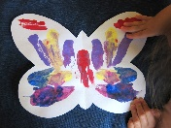  Discuss the different characters in the stories and consider; where they live, what they look like, how they move, how they change.  You may like to complete some of the activities below:  Activities:  - Make your very own Hungry Caterpillar out of toilet roll tubes  or an egg box.  - Practise saying the days of the week – use the book to help you.  - Research the life cycle of a caterpillar, there is a great clip  - online, use the link below:  https://www.youtube.com/watch?v=QYbMScXPEV0  - Make a mirror painting of a butterfly by folding the paper in half.  - Go on a mini-beast hunt and see if you can find any caterpillars, butterflies or other mini-beasts. I found lots of woodlice under a flower pot in my garden!
 |  | Maths
Counting – Keep counting!!!! The children need to be able to consistently count objects touching each object and recalling the number. They need to understand that the final number represents how many there are in the group (the total). Encourage your child to line the objects up, count steady and slowly, pointing to each object as they go along the line and recalling the numbers in sequence.

We would also like the children to represent number through mark making, as well as encouraging them to use the words more/less and the same when comparing quantities.
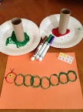
Choose a few activities this week to complete from the list below:
- Make 2 or 3 caterpillars by using the circle shape at the end of the toilet roll. Print a caterpillar with green paint and a red head to make the Hungry Caterpillar (alternatively they could draw a caterpillar). Which one is the longest? Shortest? Can you make one the same as one of the others? How many circles are there in each caterpillar? Can you put the caterpillars in order of size? Which caterpillar has more circles/which has less?
- Make fingerprint caterpillars. Make sure you count when you make a finger print.
- Using the story, can you draw the correct number of fruit for each day? You could make a little book like the one in the picture.
- Try and encourage your child to use the words more and less when talking about the fruit.
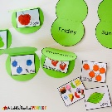
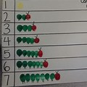
- Use the language more / less and the same in everyday situations. Who has got more grapes? Who has got less? Can they recognise when you have the same amount of grapes?

Physical Development |  | Personal, social and emotional development
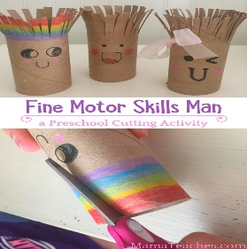  Fine motor: Have a go at making a toilet roll person or one of  the activities below.  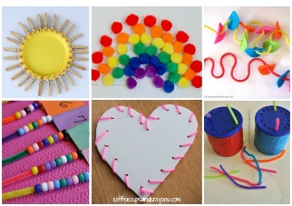 | Gross Motor: Learn to hop  Have a go at learning to hop.  To begin with, use something to hold on to. Then put your arms out either side to help you to balance.  Try hopping on your left and then your right foot.  How many hops can you do before putting your other foot down? Go for it!!!!  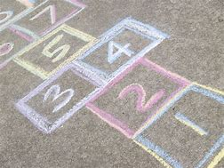  Once you have mastered  hopping, why not play  hopscotch! | 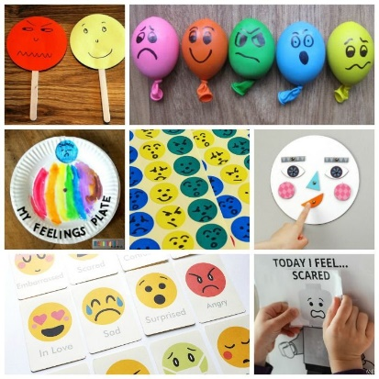  Young children can find it extremely hard to recognise and express their feelings and emotions appropriately.  I am sure it is even harder in times of such change and uncertainty.  Why not try a few of the activities to help your child to begin to understand different emotions and feelings.  It is also good to name your child’s feelings aloud as and when they feel them. This will help them to put a name to the feeling. For example, “I can see you are feeling really excited because you are jumping up and down”. Or “I can see you are feeling really sad, because you are crying” and then offer some solutions.

Phonics /O/

