Reception Home Learning – Week 3
Literacy / Topic: The Gingerbread Man
Writing
Using your sound/phoneme mat and common exception word bookmarks have a go at writing the story of the Gingerbread Man, remember to include what happens at the beginning, middle and end. You can either write it on an A4 piece of paper or make a book by folding some paper. You can add pictures if you would like to.
Remember to leave finger spaces, use your phoneme and common exception word knowledge, use your best cursive handwriting and remember capital letters and full stops.
Write a diary entry each day, include a sentence about the weather, how you feel and something you have enjoyed. Include what day it is. (this can be incorporated with the daily activities below).
Practice writing the Phase 2, 3 & 4 common exception words using pencils, pens, chalk or paint.

Phonics
Daily flashcards – Phase 2 phonemes and phase 3 digraphs & trigraphs
- Phase 2,3, & 4 common exception word bookmarks
Read the regular words below (read a few a day). Your child needs to firstly identify the digraphs/trigraphs within the words and then segment the word and blend together.
Reading sentences – Your child needs to look at the sentences below, what can they see? Look for common exception words, digraphs, trigraphs, punctuation and how many words are in each sentence.

Reading
Continue to read books from Oxford Owl site under their current book band colour.
Re-read the story of the Gingerbread Man with an adult - https://www.twinkl.co.uk/resource/t-t-10794-the-gingerbread-man-story-powerpoint. Re-tell the story to your adult. Can you name the animals that are in the story? What happens at the beginning, middle and end of the story? Which part of the story is funny or sad? Which part of the story is repetitive?

Maths
This week we are developing more complex patterns.
Show your child an AB pattern and a similar AAB pattern and ask them to tell you what they notice. What is the same and what is different?
Here they may describe the yellow, blue pattern or the circle, triangle pattern.
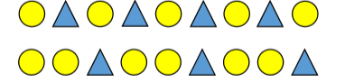
Repeat with a similar ABB pattern. What is different this time?
Ask the children to make their own AB, AAB and ABB patterns using objects from around the home. What other patterns could you make using 2 colours? Ask your child to describe their pattern. Can their family members carry on the pattern they have made?

Provide a selection of fruit in pieces such as grapes, banana slices, apple chunks etc…. and allow your child to make their own fruit kebab patterns. Encourage them to compare their kebab patterns with their family members as they enjoy their tasty treat.

Provide your child with a range of loose parts such as buttons, beads, pebbles, shells or seeds. They can use these to create a variety of different patterns. You can add variety by providing wavy lines, spirals and zigzags for them to build their patterns along.
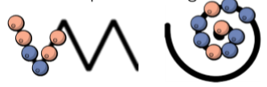

Go on a walk to hunt for natural objects to make their patterns such as long sticks, short sticks, daisies, leaves, pebbles etc… They could arrange their patterns in straight lines or around the edge of a hoop to create a circular pattern.
Encourage your child to make patterns using these structures with different objects both indoors and outside.

Additional maths activities: https://whiterosemaths.com/homelearning/early-years/
Other games to play:
- Duck, Duck, Goose circle game
- We will rock you – Queen (clapping pattern)
- AAB Pattern Song- Musical Math (YouTube)
Physical Development |  | Expressive Arts and Design
Gross Motor:  Linked to the Gingerbread man.  WARM UP: Practise moving in a range of ways, like the animals in the story (bunny hops, leaping from one foot to the other, hopping, two footed jumping).  Practise the following rolls.  EGG ROLL: Kneel down and curl up into an egg shaped ball. Hold onto your knees tightly and roll onto your side. Now roll onto your back. Keep rolling until you get back to your starting position. Remember to tuck your chin into your chest to protect it.  LOG ROLL: Lie down on your back and out your arms and legs out straight. Keep your arms and legs together and your body in a stiff position as you roll onto your side. Roll onto your tummy and then keep rolling until you get back to your starting position.  TWO FOOTED JUMP: Put your feet together and arms by your side. Slightly bend your knees. Jump forwards, swinging your arms to help you jump higher. Can you jump forwards like the Gingerbread man jumping from the fox’s back onto his nose?  Can you travel around the room, including some of your rolls?  Cool down: Think about the way some of the characters in the story move. Can you jog on the spot like the old lady? Skip like the children? Walk like the cockerel and trot like the horse? | Fine Motor:  Practise scissor control by drawing different lines on a piece of paper and asking your child to cut along the lines.  Try this with shapes too, asking them to name the shape before they cut it out!  Try some mindfulness colouring. There are lots of resources on the Twinkl website. Encourage your child to keep inside the lines.  Use lego to make a house for the Gingerbread man. Can you put the bricks together and then pull them apart again when you have finished?  Using tweezers, see if you can pick up small objects and transfer them from one bowl to another. You could use pasta, frozen peas, dried beans, baking balls or similar.  If you have any paper clips, try making a chain of them. Can you count how many paperclips you have linked together? Can you take them all apart again?  Thread pipe cleaners (if you have any) or some bits of string or wool through the holes in a colander or cooling rack. | Make a gingerbread man using empty toilet rolls and buttons.  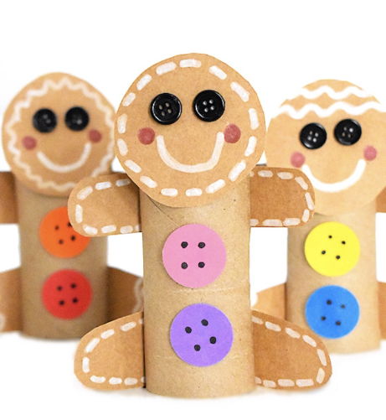  Sing the Gingerbread man song: Gingerbread Man on the Run  (to the tune of London Bridge is falling down)  Gingerbread man on the run,  On the run, on the run.  Gingerbread man on the run;  Let’s all chase him.  Gingerbread man cannot swim,  Cannot swim, cannot swim.  Gingerbread man cannot swim;  What will he do?  Gingerbread man meets a fox.  Meets a fox, meets a fox.  Gingerbread man meets a fox;  Will he help him?  Gingerbread man trusts a fox,  Trusts a fox, trusts a fox.  Gingerbread man trusts a fox;  He climbs on him.  Gingerbread man meets his end,  Meets his end, meets his end.  Gingerbread man meets his end;  Fox has tricked him!  Observational drawing  Ask your child to choose an object from around the house. This could be their favourite toy, a piece of fruit or even an ornament.  Ask them to look carefully at it. Talk about what they can see. Shapes or lines? Any curved features?  Using only a pencil, first experiment with different ways of creating lines. Thick lines, thin lines, curved lines, straight lines. What happens if you hold the pencil on the side? Upright?  Draw the object, incorporating some of the different types of lines. Try shading your object using your pencil.
Understanding the World
Science Experiment
Gingerbread Man in Different Puddles
You will need:
4 gingerbread men (pre bought or home-made)
4 bowls
Oil, water, juice, vinegar
4 spoons
Method:
- Put a gingerbread man into each bowl
- Add 1 table spoon of oil into one bowl, 1 tablespoon of water into another bowl, 1 tablespoon of juice into another bowl and 1 tablespoon of vinegar into the last bowl
- Watch the effect the liquid has on the biscuit. Talk about the changes and describe what is happening to each biscuit.
Prompts you might use:
What do you think will happen to the gingerbread men when we put them in oil, water, juice, and vinegar?
Watch the gingerbread men closely. What changes can you see?
Have any gingerbread men changed size?
Have any gingerbread men changed shape?
Daily activities:
- Every morning, go through the days of the week. Ask what day of the week it is today and what sound they can hear at the beginning of that word.
- Discuss the daily weather. Ask your child to draw a picture of the daily weather and label it (sun, cloud, hot, cold, wind, rain)
- Ask how your child is feeling every day. Get them to draw a face showing how they are feeling (smiley face for happy, sad face for sad, straight line for ok, zig zag line for cross/grumpy)
- Play board games together. This is good for turn taking, accepting and tolerating delay, understanding, listening and attention to name but a few skills!

Regular word reading | Sentence reading
soap  cool  took  hard | Max and Vikram sail a wooden boat.
born  hurt  bow  soil | Jeff chucks bits of bun in the river for the ducks.
near  cure  dinner  chill | Yasmin sits on a rock and looks for fish.
cash  thin  King  main | Having food in the wigwam is fun.

