Year 1 Home Learning – Week 4
We have provided some guidelines for your child’s home learning. We appreciate that these are stressful times for all involved. Where possible, please encourage your child to complete the learning outlined below. We appreciate that in some cases this may not be possible. Please try your best and don’t get too worried about it. Most importantly stay safe and enjoy this time with your family.
English |  | Topic: Animals (Science) / Music
Please use the Oxford Owl website (link in the teacher’s email) and hear your child read every day.  This week’s learning is all about nouns. A noun is a naming word. A noun is a person, place or thing. Proper nouns are people (Tim) or specific places (Plymouth) and they need a capital letter. Common nouns are things/objects (bed) or general places (school) and they do not require a capital letter.  Lesson 1:  Teach your child the definition of a noun as described above. Check that they understand. Watch the BBC clip on nouns: https://www.bbc.co.uk/bitesize/topics/zrqqtfr/articles/zpd8ng8  Complete the two activities under the video clip, then complete the quiz underneath.  Lesson 2:  Remind your child of the definition of a noun and replay the clip from yesterday. Explain that some words can be common nouns of proper nouns. For example, ‘ruby’ is a common noun because it is a red gem, but ‘Ruby’ is a proper noun with a capital letter because it is a name. The same applies to ‘poppy’ a red flower and ‘Poppy’ a name.  Ask your child to sort these nouns into two groups: common nouns or proper nouns. The nouns are: Jack, pen, bed, Tiverton, coat, Buckingham Palace, London, apple, plate, Sam. Ask your child to go on a noun hunt around the house to write down some common nouns (things) and proper nouns (names of people in the house).  Lesson 3:  Teach your child that nouns can be singular (one) or plural (more than one). For example, one cat or six cats. If we want to make a noun plural we have to add – s or – es to the end of the noun. For example, one dog / three dogs or one kiss / two kisses. Notice how the – es makes the /is/ sound but we don’t write ‘is’.  Ask your child to write these nouns in their plural form. For example, cat and cats.  The words are: chair, book, fork, toy, game, dish, match, fox, box, church.  Notice that game already ends in the letter ‘e’ so just needs the ‘s’.  Lesson 4:  Ask your child to write a sentence using these nouns and conjunctions to extend the sentence. There is an example in brackets. Remember to start each sentence with a capital letter and end it with a full stop.  chair / and (Mum sat in the chair and watched TV.)  rabbit / because (The rabbit was sleepy because he had hopped too much.)  toys / or (I can play with my toys or read my book.)  dishes / if (I can have a treat if I help daddy to wash the dishes.)  pen / but (We needed a pen but could not find one.)  boxes / when (We need six boxes when we move house.)  Lesson 5:  Write a diary extract about one of your days this week. Write the events in time order and try to use these sentence starters. This morning… / Then… / After that… / Next… / Finally… Try to use some conjunctions to extend your sentences. Conjunctions are: and / or / but / if/ when/ because  For example:  This morning I read my book and did some phonics with daddy. Then I had a snack and played in the garden because I needed some fresh air. After that I did some maths work and some English work. Next, I had fish for lunch but I wanted pizza. Finally, we played in the garden and if I am good tomorrow I can play on the trampoline. |  | Science (Animals)  Lesson 5 – Revise the animal groups  Ask your child to remember the five animal groups. Can they remember any of the features of each group?  Watch each video clip about the animal groups then do a mini quiz by asking your child to recall the features. For example, ‘reptiles, like snakes, have dry, scaly skin.’  Video clips: https://www.bbc.co.uk/bitesize/topics/z6882hv  Lesson 6 – animal eating habits  Explain the animals can be either:  A carnivore – meat eater, has sharp teeth to tear flesh  A herbivore – plant eater, has flat teeth to grind plants and grass  An omnivore – eats both meat and plants – has both types of teeth  Look online at the jaws and teeth of different animals and talk about the teeth and what the animal might eat. Talk about predator (eats another animal) and prey (is eaten by another animal).  Watch: https://www.bbc.co.uk/bitesize/clips/zwfd2p3  Use the general websites below to find out what a variety of animals eat. Make a list of carnivores, herbivores and omnivores.  Lesson 7 – animal eating habits  Ask your child what the words carnivore, herbivore and omnivore mean. Remind that teeth shape and size gives them a clue about what the animal eats. E.g., elephants have broad, flat teeth and they eat plants. Ask your child to draw and colour a poster that has the headings ‘carnivore’, ‘herbivore’ and ‘omnivore’. Under each heading write the definition and draw some animals belonging to that group.  General websites:  https://www.ducksters.com/animals.php  https://www.natgeokids.com/uk/category/discover/animals/  https://animalfactguide.com/animal-facts/  Music  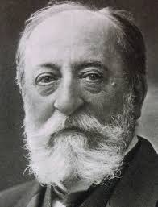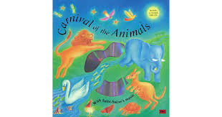  The Carnival of the Animals was written by a French composer called Camille Saint-Saëns in 1886. Saint-Saëns loved animals and this famous piece is a collection of 14 movements, each based on a different animal or idea. Listen to Hens and Roosters from The Carnival of the Animals and discuss the music with a grown up.  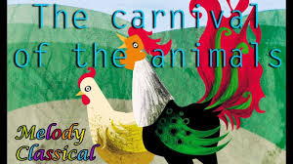  https://www.youtube.com/watch?v=Y0jkYaZ0QXU  - Talk about the tempo (speed) - is it fast or slow? (mostly fast).  - Can you name any of the instruments? (hens clucking – strings, piano and cock crowing – clarinet).  - Is the pitch of the music mostly high or low? (high).  - Do you like this piece of music? Why / why not?  Now listen to The Swan:  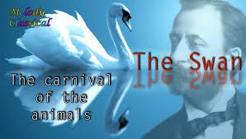  https://www.youtube.com/watch?v=ZEIWgSb0uv4  - Is the tempo fast or slow? (slow). Why do you think this is? (The swan is gliding gracefully across the water.)  - Can you name the instrument playing the melody? (cello).  - Does the pitch change? (yes). Can you move your hand up and down to show how the pitch gets higher and lower?  - Do you prefer Hens and Roosters or The Swan? Can you explain your choice?  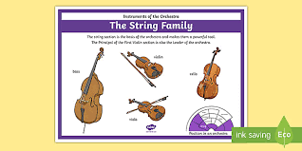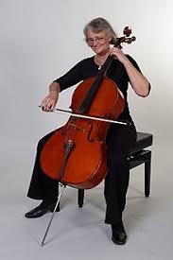  string instruments cello  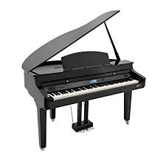  clarinet piano  If you’d like to listen to the whole of The Carnival of the Animals (23 minutes!) then here is a link:  https://www.youtube.com/watch?v=k2RPKMJmSp0  You could make up a dance to one of the animals or draw a picture. We’d love to see a photo of your work!
Maths
If you go to the White Rose Maths website, there is a home learning link and a page for each year group. If you click on Year 1, there are five activities for the week – one activity per day. We are now on Summer term Week 2

Each day there is a video clip and a corresponding activity sheet. We suggest that you watch the video clip with your child, pausing it a various points so that you can explain and clarify certain concepts. You can watch this video clip as many times as you like.

When completing the activity sheet, encourage your child to read the questions aloud to you, helping where necessary. Rather than your child just telling you the answer, ask them to explain their thinking. They can use some paper if they need to do any workings out. Alternatively, print the activity sheet if you have a printer. The answers are on a separate document, under the activity sheet.

The web link is: https://whiterosemaths.com/homelearning/year-1/

Science | Spellings | PE | RE
See the topic box above. | Use the uploaded Phonics Home Learning Schedule. Each week there are two sound families to learn; one highlighted in yellow and one highlighted in blue. We are currently on Week 4.  Monday/Tuesday/Wednesday – learn the /igh/ sounds  Thursday/Friday – learn the /oi/ sounds  Each day:  - Practise spelling these six Common Exception Words: be, he, me, she, we, my, by  - Ask your child to segment and blend each word in the sound family. E.g., all the ‘igh’, ‘i_e’ and ‘ie’ words.  - Ask your child to read the words again, but this time on sight without sounding them out.  - Ask your child to practise spelling each of the words using their neatest handwriting.  - Ask your child to write a sentence using some of the words, like they do in their homework.  - Test your child on a few of the words, reminding them to think about using the correct grapheme (letters). For example, night and not nite. | This week, try one of Jumpstart Johnny’s daily workouts. They are hard work but lots of fun!  https://www.youtube.com/watch?v=EbTV9Cew74Q  If you prefer Joe Wicks’ workouts, then stick with those.  Try joining in with Joe Wicks for his Fancy Dress Friday Workout. I wonder what he will be wearing this week?  https://www.youtube.com/channel/UCAxW1XT0iEJo0TYlRfn6rYQ  PE with Joe | Christian unit: Creation  Who Made the World?  Questions to discuss:  - Who do Christians believe made the world?  - How many days do Christians believe God took to make the world?  - Where can the Christian Creation story be found? (Name of Christian’s holy book).  Answers: Christians believe that God made the world in seven days (he took six days and rested on the seventh day). The Creation story is the first story in the Bible in the book of Genesis.  Watch this film about the Creation story:  https://www.youtube.com/watch?v=teu7BCZTgDs  Now practise retelling the Creation story to a grown up. Can you remember what God did on each day?  Make a poster of the Creation story with a picture for each of the seven days. Here are some ideas:  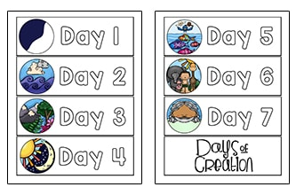  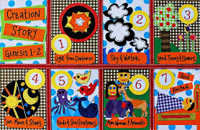  Day 1 God made the light (day and night).  Day 2 God made the sky.  Day 3 God made the land and sea.  Day 4 God made the sun, moon and stars.  Day 5 God made the birds and fish.  Day 6 God made the animals and humans.  Day 7 God rested.

