Year 3 Home Learning – Week 2
We have provided some guidelines for your child’s home learning. We appreciate that these are stressful times for all involved. Where possible, please encourage your child to complete the learning outlined below. We appreciate that in some cases this may not be possible. Please try your best and don’t get too worried about it. Most importantly stay safe and enjoy this time with your family.
English |  | Science
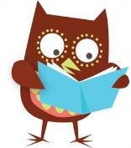  Daily Reading  You can read to yourself, read to someone else or listen to someone else read. There are some websites at the moment where you can download eBooks for free to listen to some brilliant stories. The Oxford Owl website has a big variety to suit all interests which are free until Sept 2020. When you have talked about your book to an adult then you can go onto our school’s AR reading site and do your quiz from home. |  | Our topic this half term is about the different parts of a plant and their jobs.  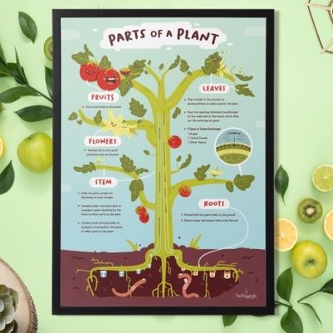  You could investigate how water is transported in plants. Use the dyed flowers science experiment to show this or celery works really well too. It effectively demonstrates how the water is transported up the stem to hydrate the leaves and flowers in a short space of time.  You will need:  -a few stems of bright, white flowers such as chrysanthemums, gerberas or carnations OR pieces of celery  -jars filled with water and different food colouring  Colour the water in each jar, and simply place the flowers/celery in, watch and wait! Ask for their prediction and their observations with photos/drawings/explanation sentences during and at the end of the investigation to be able to compare.  What they are learning while they play:  performing a simple science experiment, making predictions and observations, understanding the parts of a plant, learning how water moves through a plant, drawing simple conclusions  creativity: drawing from observation and noticing changes in appearance
Maths
Times Tables
There are the usual ways to learn your times tables such as reciting them, writing them out and spending fun time with the TT Rock Stars. You could always try other ways such as:
Dance Mat – Write out the answers to the times table you are learning and put them in a circle. An adult asks you a question and you tap the answer with your foot. Try to get faster so that it becomes a dance!
Splat – write the answers on smaller bits of paper. When an adult asks a question you have to splat the answer with your hand or an object like a fly swat. If you are playing with more than one person then the winner is the first person to splay the correct answer.

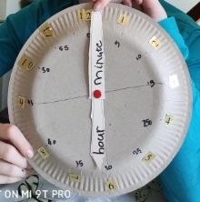
Maths – There is another My Maths activity that has been set to review quarter past and quarter to. Make sure you go through the lesson part as well as the activity. You can also make your own clocks using a paper plate like we have in our house.

Science continued | Spellings | PE | French
Other experiments you could try.  Can a plant survive on orange juice rather than water? Choose two plants of the same kind; two containers, one filled with water, the other with orange juice. Put one plant in each container, observe and record the difference of growth.  To go little deeper in the subject, you can ask how long can different plants survive without sunlight and water? Design an experiment putting plants of different sizes in a black room and don’t water them. But do go check their status daily and record the data. Do you see a difference between the plants of different sizes? | The following words are from the Y3/4 statutory word list:  enough exercise experience experiment extreme eighth  earth early  You could also use them to practise their handwriting by putting them into sentences.  Board game – adapt a game that helps you practise ie. snakes and ladders but pick up a card and spell the word if you land on a blank square. | We will be focusing on balancing and reaction/response areas in PE which you can practice at home. Throwing and catching and batting skills are good to practice in your gardens.  Times table tennis – count in 3s etc as you hit a ball with the racket. You can do it with a partner and keep counting until someone gets it wrong or drops the ball, then start again. | Counting to 20 and colours.  un onze  deux douze  trois treize  quatre quatorze  cinq quinze  six seize  sept dix-sept  huit dix-huit  neuf dix-neuf  dix vingt  noir – black blanc - white  rouge – red bleu – blue  jaune – yellow vert - green
Websites
There are so many websites that are offering free high-quality online learning resources while schools are closed that it’s hard to know which to use.
Have a look at a few listed below that are appropriate for Y3, to see which you like.
Oxford Owl - free access to eBooks until Sept 2020
Classroom secrets – activities across all subjects for EYFS to Y6
The Maths Factor – Lessons, activities and games with Carol Vorderman
Bayam – Free games and videos in French for children aged 3-10
Kids’ Learning Tube – A Youtube channel dedicated to education children through music and animation
Mystery Science – Mini and full video lessons answering scientific questions

