Year 3 Home Learning – Week 4 27th April
We have provided some guidelines for your child’s home learning. We appreciate that these are stressful times for all involved. Where possible, please encourage your child to complete the learning outlined below. We appreciate that in some cases this may not be possible. Please try your best and don’t get too worried about it. Most importantly stay safe and enjoy this time with your family.

English |  | Topic
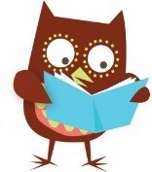  Daily Reading  You can read to yourself, read to someone else or listen to someone else read. When you have talked about your book to an adult, you can go onto our school’s AR reading site and do your quiz from home.  Writing  The disgusting sandwich.  We were going to be looking at this book this term. There is a link to a version you can listen to if you would like.  https://www.youtube.com/watch?v=yzeeROO6XbU  It’s all about a badger who wants a sandwich that keeps getting dropped in different things and becomes more disgusting as the story goes on.  What would be a disgusting sandwich for you?  Can you think up the worst and most disgusting sandwich ever? Draw a picture and tell me everything that is in it.  Remember to use lots of expanded nouns phrases and adjectives to describe your sandwich.  ‘Worms’ is a bit boring but ‘long, squiggly, juicy, disgusting green worms’ would be a much more interesting description.  Can you write instruction on how to make a sandwich? Don’t forget to include bossy (imperative) verbs. Cut, add, spread, fold etc. |  | Geography  We are looking at the environment and how we can help keep it safe.  Write a letter or design a poster to remind people that we should be recycling our rubbish. What are you going to focus on? What could you add to make it really clear for everyone to understand?  We will add them to the website if you can send pictures to us.  ICT – we are programmers  If you have access to the internet try hour of cade from code.org  https://hourofcode.com/uk/learn this will let you create your own games and activity by coding them yourself. There are lots to choose from.  If you can’t access this, don’t worry you can code a member of your family. Create a course around the garden or house with a few obstacles and write the instructions for them to get through the course. Forward 3 steps, turn left ¼ turn, etc. they must only do what they are told to. Write out the instructions first, then change them (de-bug) them until they make it through correctly.
Maths
Times Tables
There are the usual ways to learn your times tables such as reciting them, writing them out and spending fun time with the TT Rock Stars.

There are more MyMaths activity to do around adding and subtracting. I have also added an activity that should link you to a Topmarks game that will help you learn your odd and even numbers. I have added the link below just in case I got it wrong on the mymaths page.

Even numbers can be shared between 2 with none left over (evenly). Odd numbers will have 1 left over (the odd one out)

https://www.topmarks.co.uk/learning-to-count/coconut-odd-or-even

Lots of children have been helping cook at home, this is a great way to practice maths, measuring and reading scales and a great way to help out around the house.
Science | Spellings | PE | French
Did you do the colour experiment? What happened?  Continue to check on your plants.  Are they all growing?  Which ones are doing best?  How are you recording your findings?  Parts of flowers  Can you draw a picture and label the parts of a flower?  Can you add the following in the correct place?  Petals  Pollen  Stamen  Sepal  Stem  Stigma  Style  (bonus – anther and filament)  What do they look like?  What do they do?  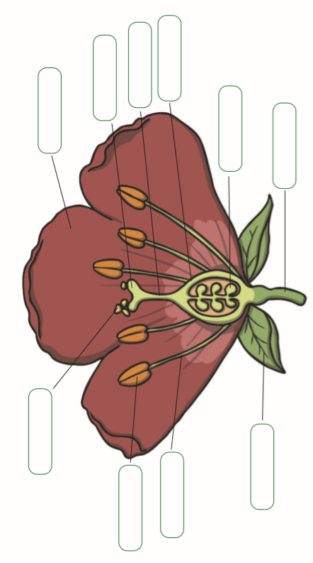 | The following words are from the Y3/4 statutory word list;  grammar, group, guard, guide, heard, heart, height, history.  We notice that lots of you make errors when spelling numbers, try these;  hundred, thousand, tenth, quarter, half, third.  Remember to use the strategies that you have already been given. | Agility, action and response.  Ask a partner to hold a ball (or any object that isn’t breakable) in each hand at shoulder height.  Stand 1m away. They then drop 1 of the balls, can you catch it before it hits the ground?  Variations  - Let the ball bounce once before you catch it.  - Stand further away from each other.  - stand facing away from your partner and they give you a count down.  - different sized objects may be easier/harder to catch, try experimenting.  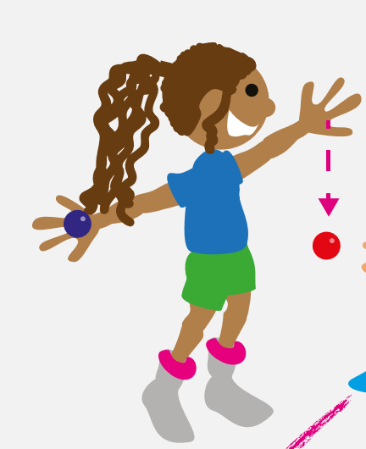 | Arc un ciel  Can you draw a French rainbow?  Draw a rainbow and then colour it in. Write the French names for the colours on it in the correct place.  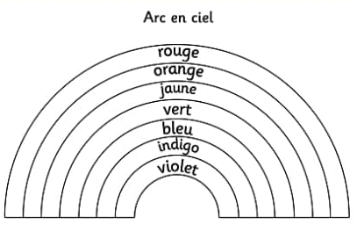
Websites
Oxford Owl - free access to eBooks until Sept 2020
Classroom secrets – activities across all subjects for EYFS to Y6
The Maths Factor – Lessons, activities and games with Carol Vorderman
Bayam – Free games and videos in French for children aged 3-10
Kids’ Learning Tube – A Youtube channel dedicated to education children through music and animation
Mystery Science – Mini and full video lessons answering scientific questions
Twinkl – has lots of resources to look at. We will be using it for some of our science in a week or so.
BBC bite size daily has now launched with a range of online learning lessons and videos. The link below will take you to the year 3 section, there are lots of different ideas and lesson to explore if you would like.
https://www.bbc.co.uk/bitesize/tags/zmyxxyc/year-3-lessons/1
Don’t forget to check out this week’s challenge from Theatre Alibi. https://bit.ly/2wXQYOw Make a flying puppet!

