Year …… Home Learning – Week 3 20th April
We have provided some guidelines for your child’s home learning. We appreciate that these are stressful times for all involved. Where possible, please encourage your child to complete the learning outlined below. We appreciate that in some cases this may not be possible. Please try your best and don’t get too worried about it. Most importantly stay safe and enjoy this time with your family.
English |  | Topic
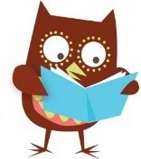Daily Reading  You can read to yourself, read to someone else or listen to someone else read. There are some websites at the moment where you can download eBooks for free to listen to some brilliant stories. The Oxford Owl website has a big variety to suit all interests which are free until Sept 2020. When you have talked about your book to an adult then you can go onto our school’s AR reading site and do your quiz from home.  Try the Theatre Alibi challenge –https://www.theatrealibi.co.uk/the-alibi-exchange-your-favourite-book-story/ You can record 30 seconds video of yourself talking about your favourite book, or draw a picture about it, or write a letter about it. Send your work directly to Theatre Alibi (not to school) info@theatrealibi.co.uk by Tuesday 28th April. Good luck! |  | Time capsules  These are really interesting times. We thought it would be a good idea if we could ‘capture’ them in some way so would like you to create a Time Capsule; a record of what is happening in your life now.  These capsules will be buried in the ground, either at home, or in school. It is very important that a map is made recording where the capsules are hidden, (I know that there are at least ten that were buried by children 25 years ago in the school grounds but the map of their location has been lost…. who knows when they will be discovered again) and that they are waterproof… an adapted 2L drinks bottle would be ideal.  The capsules could include almost anything; things that you have made or collected.  A list of top ten songs  Newspaper headlines, articles and T.V. schedules  Your family tree, their hand prints and what they are doing  Photographs  A couple of diary entries - ‘Yesterday I ………’  The book that you are reading  An online game you are playing and your score  A story and/or picture you have made  An example of seeds that you are growing  Something that you have just learned  The list is endless, get the people that you live with to help you. We are expecting this to take you all of this week.
Maths
Times Tables
There are the usual ways to learn your times tables such as reciting them, writing them out and spending fun time with the TT Rock Stars.

There are another 2 MyMaths activity to do; time at 5 minute intervals and comparison of time units.
Please keep practising with clock faces and digital clocks at home. Can you use both?
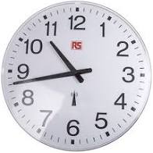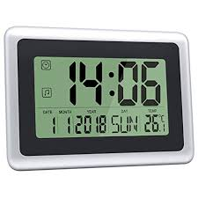
Science | Spellings | PE | French
Continue to check on your plants.  Are they all growing?  Which ones are doing best?  How are you recording your findings?  You could 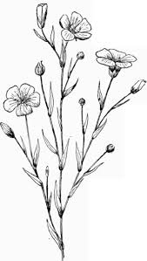use bar/line graphs or draw pictures. Something else for your capsule. | The following words are from the Y3/4 statutory word list;  famous favourite February  forward fruit  We notice that lots of you make errors when spelling numbers, try these;  eleven twelve thirteen fourteen fifteen sixteen seventeen eighteen nineteen twenty thirty forty fifty  sixty seventy eighty ninety  Remember to use the strategies that you have already been given. | Make a circuit around your garden and house. Include; throwing/catching, jumping press-ups, rolling etc.  Time yourself doing a circuit. Can you beat your siblings?  Can you beat your parents/carers?  Can you get faster each day?  You could keep a record to go into your capsule. | Draw a picture, divide it into different sections.  Use your French numbers and colours.  Give each section a number.  Each number could then relate to a colour,  e.g. 1= rouge  Give your picture to somebody else and see if they can complete it correctly.  This could go into your capsule.
Websites
There are so many websites that are offering free high-quality online learning resources while schools are closed that it’s hard to know which to use.
Have a look at a few listed below that are appropriate for Y3, to see which you like.
Oxford Owl - free access to eBooks until Sept 2020
Classroom secrets – activities across all subjects for EYFS to Y6
The Maths Factor – Lessons, activities and games with Carol Vorderman
Bayam – Free games and videos in French for children aged 3-10
Kids’ Learning Tube – A Youtube channel dedicated to education children through music and animation
Mystery Science – Mini and full video lessons answering scientific questions
Twinkl – has lots of resources to look at. We will be using it for some of our science in a week or so.

