We are offering HPS children in KS2 the opportunity to take part in a competition to say THANK YOU to the NHS. This competition has been set for children to say “thank you” after learning about the job roles and opportunities available in the NHS.
Children will be exploring more than 350 different roles in the NHS – from non-clinical jobs such as gardener, chef, accountant and engineer, to wide-ranging roles in health and social care.
Step into the NHS aims to help children understand themselves better, explore a wide range of jobs, talk positively about what they might like to do, think about where different choices can take them and feel inspired about the world of work and their future.

The challenge is for pupils to:
- Think about the wide range of jobs they have learnt about in the NHS
- Surprising facts they have collected
- Think about how the NHS has helped them, one of their friends or family.

Competition Rules: Children will need to produce either:
Creative artwork: painting, drawing, temporary street artwork, performance, video or slideshow OR
Creative writing: a story, song, poem or thank you card
Entries must be submitted online via school. Pupils can enter individually or as a pair.

Prizes: This is a National Competition and the overall national winning student(s) will receive Amazon vouchers worth £50. Ten regional winners will each receive an Amazon voucher worth £25 and highly commended certificates will also be awarded. Whether you enter individually or as a pair, each pupil will receive a prize if your entry is chosen as a winner.

Judging Criteria

50%: Evidence of learning of NHS careers from the resources
- Are the pupils aware of a range of NHS careers and services and have the pupils explored the challenging of stereotypes?

50%: Creativity
- Is the design creative and eye-catching. Is there anything that demonstrates that they have gone the extra mile with their work?

Full terms and conditions can be found here: https://www.stepintothenhs.nhs.uk/primary-schools/KS2-competition?dm_i=5EPN,6ZOD,1WDL2B,QSMP,1

Entries must be received no later than 19 June 2020. All HPS children in KS2 can enter this competition, however your entry must be sent via school. You cannot send it straight to the judges yourself. Therefore make sure you email your entry to your class teacher by 18th June 2020 so that they can forward it to the judges by 19th June 2020 (the closing date). Good luck!
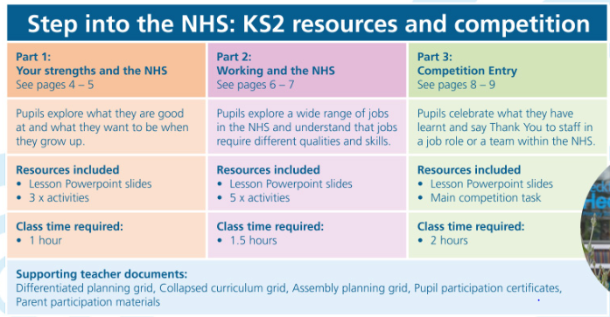
RESOURCES: this is the link for the resources that you will need. https://www.stepintothenhs.nhs.uk/primary-schools/KS2-resources

PART 1 - Your strengths and the NHS
Watch the powerpoint – Supporting slides PPT part 1.
Complete (either on the worksheet, or through discussion) the 2 worksheets, Who am I? and Like Me or Not?
PART 2 – Working in the NHS
Watch the powerpoint – Supporting slides PPT 2
Jobcard worksheet
Look at the patient stories – Sophie, Ajay
Jobcard resources
Hire me! Worksheet
PART 3 – Competition Entry
Supporting slides PPT 3
Thank you worksheet - PDF

