Nursery Home Learning – Week 5 04.05.20

Literacy | Topic – The Very Hungry Caterpillar
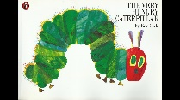  We are going to continue to learn and practise retelling the story, The Very Hungry Caterpillar by Eric Carle.  - Encourage your child to join in with the story language. Read some of the story or watch it on YouTube and then pause before the end of a sentence, can they finish the sentence?  - https://www.youtube.com/watch?v=75NQK-Sm1YY  - Can they recall the story by themselves using the pictures?  - Are they able to recall the four stages of the life cycle? (Egg, caterpillar, chrysalis and butterfly)  Phonics  N2 – (Pre-schoolers):  Continue to practise learning the phonemes (letter sounds): s / a / t / p / i / n / m / d / g / o / using home-made flash cards. You can also watch the Jolly Phonics YouTube clips.  https://www.youtube.com/watch?v=1Qpn2839Kro  - An alternative way to practise recognising the phonemes, is by putting the flash cards up around the room / garden and then calling out one phoneme which your child has to run/hop/skip to. Once the have found it call out a different phoneme and encourage them to move to that one. Repeat until they have found all of the phonemes.  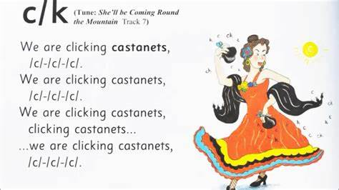  Introduce the next phoneme ‘c’ – remember we are teaching the letter sound not the name at this stage. Share the Jolly phonics song and sing along. For the action, pretend to be clicking a pair of castanets. Explain to your child what castanets are and look at some pictures of castanets to help them understand.  Song:  We are clicking castanets / c / c / c /  We are clicking castanets / c / c / c /  We are clicking castanets  clicking castanets  clicking castanets / c / c / c /  (I have attached the Jolly phonics picture card/song for ‘c’ below)  Metal Mike – In Nursery we play an oral blending game called Metal Mike, which the children are very familiar with. It would be great if you can have a go at making your own robot and play the game at home. I have attached some pictures to inspire you! Once you have made a robot, make a collection of object, toys or pictures that contain 3-4 phonemes – such as cat, log, rat, frog, jet etc…  To play the game: have 4 objects/pictures in front of you, sound out (segment) one object slowly e.g.: c – a – t. Encourage your child to blend the sounds together and select the corresponding object. They can then feed the toy/picture to the robot, placing it in its mouth. If they find it difficult to hear the word (blending) sound it out again leaving a shorter pause between letter sounds. This is a skill that they initially find tricky, but with lots of repetition and practise they begin to blend the phonemes much easier and hear the word.  N1 – (younger nursery pupils)  This week we would like you to play a listening game called ‘What’s in the box?’  Find an empty box or container that is not transparent. Place a range of toy animals inside (or pictures of animals) and explain to your child that they will need to use their listening ears to work out what is in the box. Slowly open the box (but don’t let them see inside) and as you do, make the sound of one of the animals, start of quiet, this will encourage them to listen more carefully. Can they guess what is in the box? Repeat with the other animals. Once they have guessed all of the animals, ask them if they would like to have a turn at making the sounds for you to guess the animals. Another alternative to this is to have different objects from around the home that will make a noise, such as; an alarm clock, crisp packet, keys, water in a bottle etc… See if they can identify the object. If this is too tricky you could show them the objects first, let them listen to the sounds they make and then place them back inside the box. Make a sound with one of the objects, can they guess what it is?  There are also a range of listening games online:  www.phonicsbloom.co.uk  http://www.letters-and-sounds.com/phase-1-games.html  https://new.phonicsplay.co.uk/ | Choose from a few of the activities below:  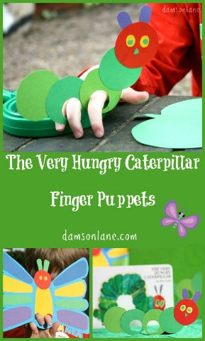  Activities:  - Make a caterpillar hat or finger puppets to retell the story.  - Try some of the fruit the Hungry Caterpillar ate. Which is your favourite?  - Draw a butterfly and make the wings symmetrical. What colours will you use?  - Can you draw the life cycle of the caterpillar?  - Look around your garden or park and see if you can find any caterpillars or butterflies. Take a photo of them and send your photo to Miss Hughes and Miss Neale. Check under leaves!  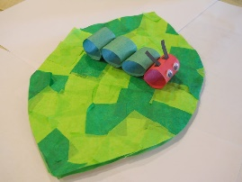  - Make a leaf for your caterpillar.  Star challenge: At the end of the story the Hungry Caterpillar turns into a butterfly. Can you find out what a tadpole turns into? Can you draw the lifecycle of the tadpole?
 | Expressive Arts and Design
Learn the song:
There’s a tiny caterpillar on a leaf
There’s a tiny caterpillar on a leaf (wiggle, wiggle)
There’s a tiny caterpillar on a leaf (wiggle, wiggle)
There’s a tiny caterpillar, tiny caterpillar,
There’s a tiny caterpillar on a leaf (wiggle, wiggle)
He will eat the leaves around him ‘til he’s full (munch, munch)
He will eat the leaves around him ‘til he’s full (munch, munch)
He will eat the leaves around, eat the leaves around
He will eat the leaves around him ‘til he’s full (munch, munch)
A cocoon is what he’s spinning for his home (spin, spin)
A cocoon is what he’s spinning for his home (spin, spin)
A cocoon is what he’s spinning, cocoon is what he’s spinning,
A cocoon is what he’s spinning for his home (spin, spin)
Then he’ll be a butterfly and fly away (flap, flap)
Then he’ll be a butterfly and fly away (flap, flap)
Then he’ll be a butterfly, be a butterfly,
Then he’ll be a butterfly and fly away (flap, flap)
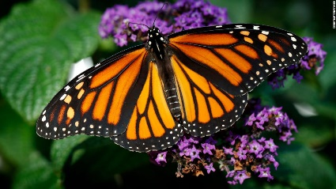
Maths
Counting and recognising numbers
This week we would like the children to continue practising their counting and recognising numbers to 10. Can they count a small group of objects and match it to the correct number? Do they understand that the number represents the total number of objects in the group?

Keep reminding the children to count slow and steady, touching or moving the objects if they need to.
If there are 1, 2 or 3 objects, can they tell you how many there are without needing to count them?
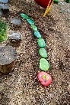
Choose a few activities this week to complete from the list below:
- Discuss all the fruit that the caterpillar ate and how many of each item.
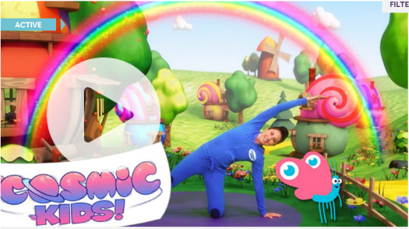
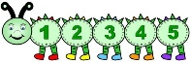
- Make large caterpillars out of stones or milk bottle tops. Paint the stones green. How many stones long is your caterpillar? Make another caterpillar and discuss which one has more / less stones.
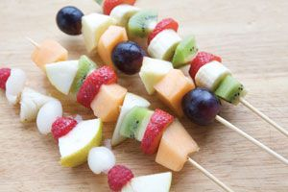
- Make your own caterpillar number line. Roll a dice and quickly point at the correct number on the caterpillar.
- Make a repeating pattern fruit kebab. How many grapes do you have? How many strawberries? Can you show me that number using your fingers? Can you point to the number?
- Try and encourage them to use the words more and less when talking about the fruit.
- Play the Hungry Caterpillar game attached to help with number recognition.
- There are 5 caterpillars on a leaf and one flies away. How many will you have left? You could draw a picture to help you, use your fingers or use counters.
- Ask an adult to draw you some small circles to make a caterpillar. Can you make a
repeating patterns by colouring it in?

 | Physical Development
 | Gross Motor:  - Cosmic Kids Yoga. Have a go at one of the Cosmic Kids yoga routines. They are great for helping your child to relax in a fun and interesting way.  There is also a Very Hungry Caterpillar version. Have fun!  www.cosmickids.com | Fine Motor:  Draw, draw, draw!  It is so important that your child regularly draws, colours and explores mark making tools. This will develop their strength, pencil grip and control in their fingers and prepare them for writing.  Drawing while lying down on their tummy is really good to develop their core strength and helps them to position their hand correctly.  If they are reluctant to draw a picture, why not get them to ‘take their pen for a walk’ (doodle). This takes away the pressure to produce an end result. Can they draw lines, zig-zags, circles, squares? What other shapes can they draw?  Remember keep it fun!
Phonics – C

Metal Mike – Phonics
We would love to see photos of your robots!

