Nursery Home Learning – Week 7 18.5.20
We hope you enjoyed learning about the important role of doctors and nurses last week. This week we are going to continue our topic People who help us, and learn about the role of fire fighters. We hope you enjoy completing some of the activities below.
Literacy |  | Topic – People who help us: Firefighters
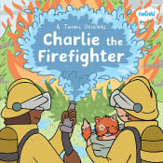  Story of the week: Charlie the Firefighter - ebook (use the link below)  Read the story and explore the role of Firefighter Charlie.  https://www.twinkl.co.uk/resource/t-or-271-charlie-the-firefighter-ebook  Watch this clip for more information about Firefighters.  https://www.youtube.com/watch?v=syWonYeJOQU  You may also like to watch the Cebeebies episode; Let’s Play, where they learn about and pretend to be firefighters.  https://www.youtube.com/watch?v=al4yBOTWYQc  - Explore the vocabulary sheet to help your child learn a range of new words and their meaning (see attached sheet)  - Ask your child if they can explain what a firefighter is. What do they do?  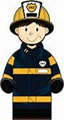  - Would you like to be a firefighter like Charlie?  - Why might a fire start? How do firefighters put fires out?  - Do firefighters do anything else?  - Discuss where firefighters work.  - What is the fire engine like?  - How do firefighters know there is a fire?  - Why do they wear a special uniform?  - What would you do if the smoke alarm sounded?  Phonics  N2 – (Pre-schoolers):  This week we would like you to recap all of the phonemes learnt so far: /s/a/t/p/i/n/m/d/g/o/c/k/. You may choose to watch the Jolly phonics songs using the link: https://www.youtube.com/watch?v=1Qpn2839Kro and complete a few of the activities below:  - Using flash cards, encourage your child to recall the phonemes (letter sound).  - Stick the flash cards up on a window and get your child to use a water pistol to squirt the correct phoneme as you call it out.  - Phoneme treasure hunt - hide the flash cards around the house and garden, give your child a list with all of the phonemes on for them to tick off once they find the phonemes.  - Write the letter using chalk on the ground and make them into a hopscotch or stepping stones, encourage your child to say the phoneme as they jump on the letter.  - Encourage your child to have a go at writing the letters (lower case at this stage). Focus on a few to begin with.  Online phonics games:  www.phonicsbloom.co.uk (phase 1/ phase 2 – set 1)  http://www.letters-and-sounds.com/phase-1-games.html phase 1/2  https://new.phonicsplay.co.uk (phase 1 / phase 2 – set 1)  Name writing  It would be great if your child can practise writing their own name (using the pre-cursive letter formation) See sheet below.  To make it fun, encourage them to practise writing it using a range of mark making tools, such as pens, crayons, paints, writing in foam, flour, chalk and with water and large paintbrushes etc… It’s really important you keep this fun. If your child finds letter formation really tricky, then keep working on the pre-writing shapes. If your child has mastered their first name, can they now write their surname or other names such as Mum, Dad, Gran or their siblings names?  N1 – (younger nursery pupils)  Listening skills:  This week we are going to continue to develop your child’s attention and listening skills.  Have a go at playing the listening games using the link below:  https://www.bbc.co.uk/teach/school-radio/eyfs-listening-skills-sound-games-1/zm72kmn  - Remind your child that they need to listen carefully, sitting quietly.  - Can they identify the different sounds?  - Can they imitate the sound using their voice?  Go on a listening walk: how many different sounds can they identify? Can you record the sounds using your phone and listen back to them? Can your child draw the different sounds they hear?  Nursery Rhymes:  Sing a range of nursery rhymes with your child each day.  Do they have a favourite rhyme?  Can they finish the rhyme if you begin it?  Can you learn a new rhyme together?  There are lots of brilliant nursery rhymes and songs on the internet. We love using the BBC school radio website: https://www.bbc.co.uk/teach/school-radio/nursery-rhymes-songs-index/zhwdgwx |  | Use the internet and books to look at photos and research the role of a Firefighter.  Activities:  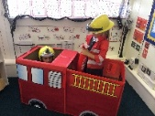  - Role play firefighters – Why not pretend to be a firefighter? Children, can you find or make a helmet? Use some recycling to create a hose pipe. Parents, role play together, modelling how to call for a fire engine (but also remind your child this is only for emergencies) and act out being a Firefighter. Have fun!  - Look at the different equipment firefighters use on the attached poster.  - Make a firefighter’s helmet (see instructions attached)  - Make a 5 little firefighters handprint (see attached instructions)  - Make a junk model fire engine – raid the recycling box and see if you can make a fire engine together. We would love to see a photo!  - Sing the song - 5 Little Firemen  Key vocabulary/phrases  Danger, fire, hot, burn, hose, smoke, smoke detector, safe, protect.  - GET OUT  - STAY OUT  - CALL THE FIRE BRIGADE  - 999  Have a look at the stay safe poster attached and discuss with your child.
 |  | Maths
Measures

Choose a few activities this week to complete from the list below:

- Draw three ladders for your child. Children, can you cut them out and order them by size, sticking them onto a piece of paper.
Use the language: long, short, longest, shortest, longer and shorter.
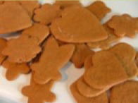
- Cooking:
Cooking is a fantastic way to teach your child lots of mathematical skills and language.
It is good to involve your child in the whole process. If possible start by writing a shopping list with them. Encourage them to remember the ingredients and read the recipe together.
Counting skills:
• When counting out and weighing ingredients say one number for each object
• Talk about what they did first, next and last.
Shape, space and measure:
• Use every-day and mathematical language to describe the size, weight and quantity (e.g. half, quarter, a little, a lot, heavy, light, kg, grams etc.)
• Notice the numbers on the scales, discuss what happens when weighing the ingredients.
Capacity:
Set up a water tray or a washing up bowl with coloured water and some bottles and flasks/containers of varying dimensions, with some plastic cups.
Challenge – Provide your child with a ‘problem’ “We want to take some water out to the garden, I wonder which bottles will hold the most water?”
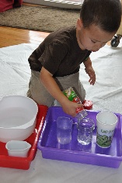
- How are the bottles different?
-What happens if you pour this one into this one?
- How can we find out which container holds most?
-How do you know which one holds more?
-How many cups will they each fill up?
- Can you order them from biggest to smallest (which one holds the most to the least?)
-Can you put labels on the bottles to help us remember how many cups they fill?

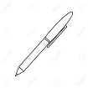
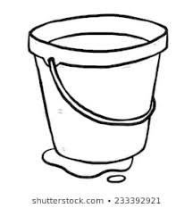
- Draw and order lots of different objects according to their size – for example bicycles, bucket and pen.
Physical Development |  | Expressive Arts and Design
Fine motor:  Using paper clips can you make a clip worm?  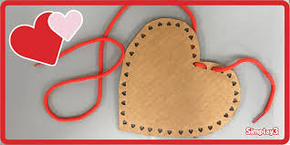  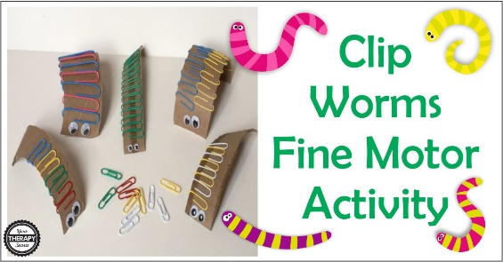  Make your own threading cards  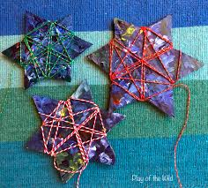 | Gross Motor:  HPS standing long jump competition  How far can you jump?  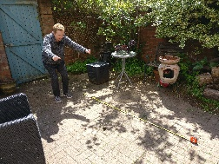  Measure how far you jumped and take an action photo to send to us. Miss Hughes can jump just over a metre.  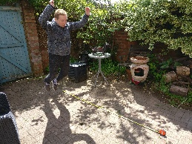 | Learn the song: 5 Little Firemen standing in a row. Can you learn the Makaton signs too? https://www.youtube.com/watch?v=x_I2ysM0w0g&list=RDx_I2ysM0w0g&start_radio=1  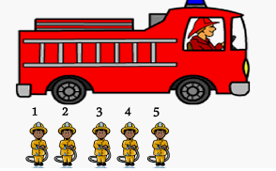  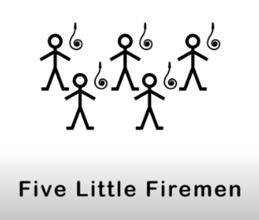  Five little firemen standing in a row,  1 2 3 4 5 let’s go.  Jump on the engine with a SHOUT,  As quick as a wink the fire is out.  Four little firemen standing in a row,  1 2 3 4 shhh let’s go.  Jump on the engine with a Shout  As quick as a wink the fire is out.  Three little firemen standing in a row,  1 2 3 shhh shhh let’s go.  Jump on the engine with a Shout  As quick as a wink the fire is out.  Two little firemen standing in a row,  1 2 shhh shhh shhh let’s go.  Jump on the engine with a Shout  As quick as a wink the fire is out.  One little firemen standing in a row,  1 shhh shhh shhh shhh let’s go.  Jump on the engine with a Shout  As quick as a wink the fire is out.

