Reception Home Learning – Week 6 - 11.05.2020
We have provided some guidelines for your child’s home learning. We appreciate that these are stressful times for all involved. Where possible, please encourage your child to complete the learning outlined below. We appreciate that in some cases this may not be possible. Please try your best and don’t get too worried about it. Most importantly stay safe and enjoy this time with your family.
Literacy |  | Topic
Writing  Write a shopping list of your favourite foods make sure you have some healthy options and some treats!  Draw a picture of your favourite meal and label it. You could also include your favourite desert.  Write a set of instructions of how you made a sandwich for your picnic.  Reading  - Continue to read books from the Oxford owl website.  - Read labels on items of food from within your home can you spot any digraphs or trigraphs?  Phonics  - Continue practicing your phonemes, digraphs & trigraphs and common exception words.  - Read the words and sentences below. Can you spot the digraphs, trigraphs and punctuation.  - Use the phonics play website to play a range of games (phase 2,3, and 4 games) |  | With the help of your parents find a recipe you would like to make. Can you have a go at reading and measuring the ingredients and then making it. We would love to see a photo of what you have made and maybe then you can write a sentence of what it tasted like.  Find out about food from a different country of your choice , do they have special meals at certain times of the year?  Have you ever tried some of the different types of food?  Create a picnic lunch for you and your family. Can you make sure you have the right amount of plates and cutlery?  Ask your family members what their favourite fruit is. Can you record this as a tally chart?  Fruit Tally  strawberries IIIII  orange II  bananas I  grapes IIIII  Which was the most popular fruit and the least popular?  Collect some items of food from your kitchen and sort them into healthy and unhealthy.  Design a new healthy menu for one day at school. Think about having a meat option and a vegetarian (non-meat) option. Can you draw your meals?  Investigate the different food groups (carbohydrates, protein, fat, dairy, fruit and veg). Look at the food in your cupboards and fridge and see if you can say which food group they are from.  With a grown up, make some toast for breakfast. Think about each step of the process from getting the bread to finally eating it! Afterwards, see if you can do an oral re-telling of how to make toast.
Maths
This week we are counting to 20.

Provide opportunities for your child to count beyond 10, learning the number names and in order.
Play the game – Don’t say 20.
A game for 2 players. On their turn, the players choose to continue the count with 1, 2 or 3 numbers. The next player continues the count. E.g if the first player counts 1, 2 the second player could count 3 or 3, 4 or 3, 4, 5.
The aim is to avoid saying 20.

Play the game- Counting forward and backwards
A game for 2 players. The first player counts on in ones. The second player counts back in ones. The adult ‘conducts’ the 2 players by pointing at each player to take in turns.
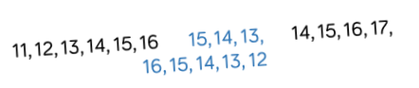
Play the game- Spot the mistake!
The adult makes deliberate errors whilst counting up and down to 20. ( A puppet is great for this). Ask your child to listen carefully and stop you if they hear something wrong. Errors can include omitted numbers, repeated numbers or numbers in the wrong place.
You could then extend by playing the game but asking tour child to watch carefully as you write number sequences.
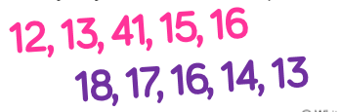

Once your child can confidently say the number names, provide them opportunities for them to match them to quantities and symbols. Prompt your child to recognise that as we count, each number is 1 more than the number before – building staircases to show the growing pattern within the numbers to 20.

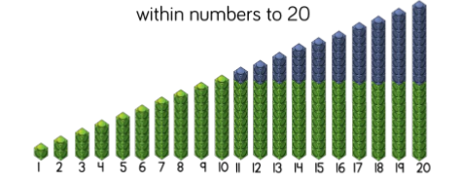
You could use 2 10 frames and 20 counters to build the numbers as they count.

Provide different collections of loose parts such as buttons, beads, pegs, stones for your child to count. Encourage your child to estimate how many first and to arrange the items onto 10 frames as they count to help them see the full 10 and part of the next 10.
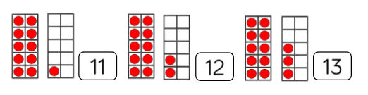
Play the game – One more, one less
Use the loose parts to build teen numbers.
Ask your child to identify which number you have made and discuss what one more and one less would be. Encourage them to build each number and line them up to check.
Extend by continuing the game beyond 20 and ask what patterns they can find?

Play the game – Race to 20.
Provide/ draw a number track from 1-20. Take in turns to roll a dice. If they roll 1-5 then they collect the corresponding counters to fill their track. If they If they roll a 6 they go back to the start. The winner is the first to make it to 20.
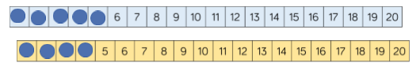

Other Resources-
Watch BBC Numberblocks series 5 :
Episode 2 On your Head
Episode 14 I can count to 20.
Daily activities on – www. whiterose/home learning
Physical Development |  | Expressive Arts and Design
Gross Motor:  The link below has lots of ideas of PE activities can you try at least one of them?  https://www.youtube.com/playlist?list=PLYGRaluWWTojV3An2WEgsQ4qGFy_91jDL.  Alphabet Challenge!  Use this secret PE code to send a message to your family! Can you spell your name or send back a reply?  - 10 Jumping Jacks  - 15 High Knees  - 5 Squats  - 4 Push ups  - 4 Sit ups  - 1 Burpee  - One legged balance  - 10 second wall sit  - Fast running for 10 seconds  - 6 Elbow to knees  - 10 Skips  - 10 Second Plank  - 5 Star Jumps  - 6 Tuck Jumps  - 10 front Lunges  - 10 Crunches  - Superman balance  - 10 Side Lunges  - Hold a squat for 5 seconds  - 3 squat jumps  - 3 Jumping Jacks  - 6 Jumps  - 2 Burpee’s  - 5 steps up the stairs and back  - 5 Crunches  - 3 Sit ups | Fine Motor:  Use playdough to create a meal. Try rolling, squeezing, patting, cutting and moulding the playdough.  Practice forming the tall letters in a pre cursive print  i, l, t, u, j, y  If you have chalk can you write these on the ground? Or use felt pens or paint.  Rainbow salt tray:  Colour in a piece of A4 paper with stripes a bit like a rainbow. Stick it to a tray from the kitchen or something similar with a small lip around the edge. Pour table salt all over the rainbow till it is covered up. Use a fine paintbrush to practise your letter formation and tricky words. When you write in the salt your words reveal the rainbow underneath! | Look at the work of the artist: Lynn Flavell. How does she represent fruit and vegetables? Can you create a piece of artwork in the style of Lynn Flavell.  Draw an observational drawing of a piece of fruit or vegetable.  Design a new milkshake. Which ingredients will you include? Can you label the milkshake? Will you have a mascot that is linked to your new creation? Can you make the milkshake?

Regular word reading | Reading
year  manure  better  rich | This year we went to the zoo.
hush  sing  rain  deep | We can smell the flowers in the garden
tight  small  moon  hook | The moon is very bright tonight.
market  torn  grower  town | He is growing turnips and leeks.

