Reception Home Learning – Week 7 - 18.05.2020
We have provided some guidelines for your child’s home learning. We appreciate that these are stressful times for all involved. Where possible, please encourage your child to complete the learning outlined below. We appreciate that in some cases this may not be possible. Please try your best and don’t get too worried about it. Most importantly stay safe and enjoy this time with your family.
Literacy |  | Topic – Animals
Writing  - Alphabet Game: Can you think of an animal for each letter of the alphabet?  - Draw a picture of your favourite animal and label it. Can you write sentences about it using adjectives? Adjectives are describing words e.g. simple sentence “The cat sat on the mat” using adjectives could read “The brown, fluffy cat, sat quietly on the green mat.”  - Watch this CBeebies episode of ‘Do you know’ about the life cycle of a butterfly: https://www.bbc.co.uk/iplayer/episode/m0004xrx/sign/maddies-do-you-know-series-3-7-butterfly-and-wallpaper  - Now, draw a picture of the life cycle and label your drawing. Can you explain the life cycle to someone else?  - Research an animal of your choice on the internet (under adult supervision). Draw a picture of the animal and write a list of words to describe your animal. For example; “Bear” strong, big, loud, sharp claws, soft fur etc.  - Create your own non-fiction book about an animal of your choice.  - Put the sound buttons under the following words: Owl, bat, sheep, pig, cow, chicken, dog, cat, frog, fish. We use dots for phonemes and lines for digraphs.  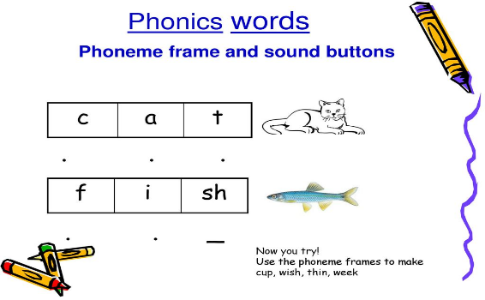  - Continue writing a diary entry, each day include a sentence about the weather, how you feel and something you have enjoyed. Include what day it is.  Reading  - Continue to read books from the Oxford owl website.  - Read labels on items from within your home, can you spot any digraphs or trigraphs?  - Create a bookmark for the Devon library competition  Phonics  - Continue practicing your phonemes, digraphs & trigraphs and common exception words.  - Read the words and sentences below. Can you spot the digraphs, trigraphs and punctuation?  - Use the phonics play website to play a range of games (phase 2,3, and 4 games)  https://new.phonicsplay.co.uk/ |  | - Find out about the 5 different animal classifications (mammals, reptiles, amphibians, birds, fish). Can you work out which group you belong to?  - Find out what the young is called for the following animals: sheep, cow, pig, cat, dog, horse, chicken  - Which animals make the following noises? Quack, oink, moo, woof, meow, neighhh, ribbit ribbit, twit twoo, baaa  - Make a set of 5 animal picture cards (elephant, sheep, giraffe, lion, snake) Play “Guess the animal” with your family. Place the picture cards face down. Child chooses one and looks at it but doesn’t reveal what is on the card. Parent or sibling to ask yes/no questions to find out more about the animal and to try and guess what it is. For example, ‘Does it have 4 legs?’ or ‘can it fly?’ or ‘does it have a trunk?’. If your child is confident, swap roles and they can ask the questions!  - With adult supervision, look up what “nocturnal” means. Can you draw a picture showing different nocturnal animals? Label your animals. B-a-t, Ow-l.
Maths
This week we will be Doubling- meaning ‘twice as many’.

- Give your child the opportunities to build doubles using real objects.
- Building numbers using the pair-wise patterns on a 10 frame which will help them see the doubles much more clearly.
- Using mirrors are also a fun way for your child to see ‘double’ the quantities they build.
- Encourage your child to say the doubles as they build them, eg. Double 2 is 4.
- Provide examples of doubles and non-doubles for your child to sort and explain.

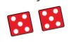

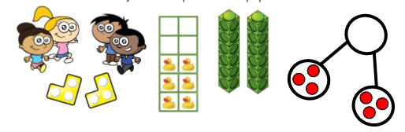

- Provide sets of dominoes and ask your child to find the doubles. Then play a game of dominoes and look for all the doubles they make as they play.
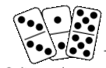
- Play doubles – your child takes turns to roll 2 dice and score a point each time they roll a double. The first to reach 5 points wins the game.
- Sit opposite your child and set out a small quantity of objects e.g, stones or cubes. Your child then doubles it by making the same quantity. They can also hold up their fingers and match with you to make a double.
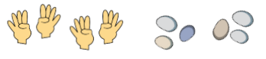
- Play snap or matching pairs games using pictorial playing cards. Encourage your child to say the doubles as they make them. The person with the most doubles or pairs at the end wins the game.

- Make towers or rows using blocks and ask your child to build towers that are double the height or double the length. Can they thread double the number of beads? Can they find a container which holds double the amount of water or sand?

- Make a butterfly or ladybird template and ask your child to make doubles by adding the same number of spots to each side. How many different doubles can they make? Can you make one which is not a double and tell you why?

- Watch BBC Numberblocks series 2 – episode 9 Double Trouble https://www.bbc.co.uk/iplayer/episode/b08q4jkq/numberblocks-series-2-double-trouble

- Daily maths activity on https://whiterosemaths.com/homelearning/early-years/

Physical Development |  | Expressive Arts and Design
Gross Motor:  Daily Joe Wicks work out on Joe Wicks TV via YouTube. Every day at 9am  Go Noodle  Star Jump Challenge: In pairs (you perform, whilst the other person rests & cheers you on! Then you swap) Try to do this to music &/or in the garden if possible:  15secs  30secs  45secs  1min  If star-jumps are a bit tricky you could just jump or run/march on the spot. If you are a wheelchair user you could try to move your arms out, your legs up, whatever you can do you should try to do.  Cuddly Toy Challenge : Collect as many cuddly toys together as you can find.  Put all the toys in a box at one end of the room/garden.  Put an empty box as far away as possible. This could be upstairs.  Take one toy at a time & place it in the empty box. You can do this as a relay if the box is a long way away or you are tired.  You can time yourself against yourself or others if you want to.  To make it harder you could think of different ways of taking the toy e.g. under your armpit/between your knees/throwing it up & down if you are outside. Or you could travel differently e.g. hop/jump/backward | Fine Motor:  Keep practising your dough disco techniques using playdough (rolling, squashing, squeezing, patting, moulding) Make sure you do this with both hands to work the muscles in both your hands.  Use Mummy’s tweezers to transfer small objects like marbles, baking beads, frozen peas or mixed veg from one bowl to another.  Draw some lines on a piece of paper. They can be straight, curved or zig zags. Practise using scissors to carefully cut along the lines. | Using different materials around the house, create a mask of their favourite animal. Think about the colours and shape. Can they add different textures to their mask?  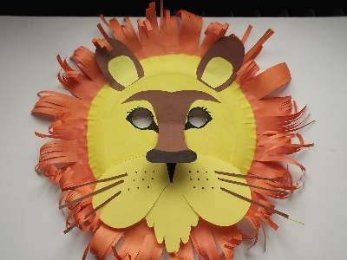  Sing the song “Old Macdonald had a farm”. Think carefully about the animals you choose and the noises they make.  Make an animal of your choice using recycled materials from home. If you were making a dog, you could use a box for the body, a smaller box for the head (or even a yoghurt pot), toilet roll tubes for the legs and make ears out of paper. Decorate your animal.  Fold a piece of plain paper in half. Paint half of a butterfly and then fold the paper and press together. Open out your butterfly and you should have a symmetrical butterfly painting.  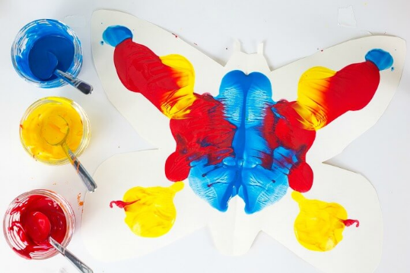  Try making an animal out of a toilet roll. Some examples are below:  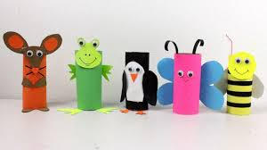  If you have some plastic farm animals, create your own small world farm, with different enclosures, a farmhouse and fields. You could make the enclosures from Lego, or building blocks, or even boxes from the recycling!  Make up a song about your favourite animal. Record it and send it to your teacher (Please note, only short clips please less than 1 minute in length).

Every day:
- Share how you are feeling, what day of the week it is and talk about what you are doing that day
- Practise counting to 10 and then 20. Count objects around your home to practise your 1:1 counting and accuracy
- Read through your tricky words
- Daily reading (shared or independent)

Awe and wonder – Make your own bird feeder
Please note: DO NOT DO THIS IF YOUR CHILD HAS A NUT ALLERGY
You will need: an empty toilet roll, string, bird seed, peanut butter
Instructions: Paste peanut butter all over the empty toilet roll tube. Roll it in the bird seed seed until it is completely covered. Thread string through the middle and tie. Hang up outside for the birds to enjoy!
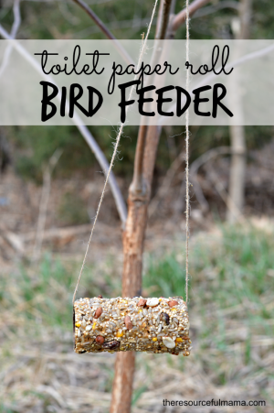
Phonics
Regular word reading | Sentence reading
black oil  rear boot  mature cheese  hot summer | The bats are in the roof of the barn.
chicken run  big rush  ping-pong  fish bait | The brown dog is running down the road after the black cat.
keep still  tonight  boatman  rooftop | The frog can hop high in the air and land on the rock.
red hood  farmyard  lemon curd  big towel | I can hear an owl hooting from his perch in the tree.

