Year 2 Home Learning – Week 7, week beginning 18.5.20
We have provided some guidelines for your child’s home learning. We appreciate that these are stressful times for all involved. Where possible, please encourage your child to complete the learning outlined below. We appreciate that in some cases this may not be possible. Please try your best and don’t get too worried about it. Most importantly stay safe and enjoy this time with your family.
English |  | Topic- History / Art
Reading- Please try to complete daily reading of 10 minutes. Children can read to parents, parents can read to children, parents and children can read a page each, whatever works for you! We would love to hear about any books that you’ve enjoyed or to see any pictures of you reading at home. Is there a special place in your home that you like to read?  Oxford Owl website- this is a great website that has access to lots of free ebooks and other activities. Just create an account (it’s free) and have a look.  Reading & Writing activities-  Once you have read a book (or had a book read to you);  - Write five questions that you could answer about the book.  - Try different style questions like the ones we’ve had at school; a multiple choice tick box question, a matching question, a true or false question or one where you have to write an answer. |  | Last week, you wrote your own weekly diary. This week you are going to learn about another important piece of evidence from the time of the fire.  In 1666, there were no cameras to take pictures of things that have happened. Instead, some people wrote about what happened. The most famous of these people was called Samuel Pepys.  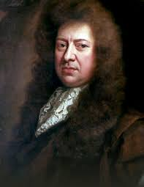  Day 1:  - At the bottom of this page, we have included some images of Samuel Pepys and his diary. Spend some time looking at these pictures. Can you research and find different images? Remember to ask an adult to help you to search the internet safely.  Day 2:  - Watch the Magic Grandad clip:  https://www.youtube.com/watch?v=VarSSAwiimU  Talk to your family about facts that you have learned about Samuel Pepys. It is helpful to watch the clip more than once to help you to remember facts.  Day 3:  - Complete the fire feelings grid (attached document). Think about what you would have smelled, touched, seen, heard if you were there during the fire. Use descriptive language, for example “burnt, charred wood,” “thick smoke.” Also think carefully about your feelings during this time. Would you be scared? Worried? Frightened?
Maths
We would like you to spend time this week concentrating on 2D and 3D shapes.
- Go on a shape hunt around your house and garden. Remember not to confuse 2D with 3D shapes when you are naming them. Talk about
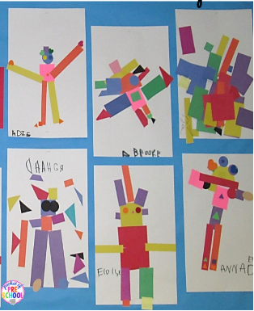
- Try making pictures using lots of different cut out shapes. You could link it to topic work and try to do a portrait of Samuel Pepys or make another Great Fire picture.
- If you have some shapes at home (building blocks or stencils) try sorting them in different ways; 2D and 3D shapes, shapes with straight sides or edges and not etc.
- You could also use them to print with.
- There is a shape worksheet below to colour and count the shapes.
- Have a go at making some shape ‘Top Trump’ cards. There are lots of examples online. Just search ‘shape Top Trumps’.

- Two My Maths tasks have been set. Please remember to do the lesson before completing the activity. If you get less than 80% on the homework, work through the lessons again and then have another try at the homework. The lessons are there to help you and are the most important bit!
- Maths Challenge: https://nrich.maths.org/7009
- Or… can you draw a picture only using straight lines?
Computing | Spellings/Phonics | PE | PSHE
In our Computing lessons, we were learning how to use Scratch.  Go to https://scratch.mit.edu/projects/editor/?tutorial=getStarted  - Watch the tutorial to learn how to use Scratch.  - Spend some time exploring Scratch.  - Can you add a sprite to your work?  - Can you change the background?  - Can you add a sound? | Please continue to practise spelling the Year One and Year Two common exception words that were sent home in the Spring Term. Remember that little and often is best!  This week we have also given you some words to practise writing using the “oa” phoneme.  These are written at the bottom of the sheet. With these words you can complete the following activities:  - Read all of the words and talk about their meanings.  - Practise using these words in a sentence, spelling them correctly.  - Walk around your house and find words that contain the oa phoneme (sound). Write them as a list. Can you spell them correctly? | - Joe Wicks, the Body Coach is providing daily, fun workouts for everyone to take part in, Visit https://www.youtube.com/user/thebodycoach1 and click on PE With Joe.  - Go Noodle is also a good website for physical activity ideas. https://www.gonoodle.com/  Cuddly Toy Challenge;  Collect as many cuddly toys together as you can find.  Put all the toys in a bin or box at one end of the room/garden.  Put an empty bin or box as far away as possible. This could be upstairs.  Take one toy at a time & place it in the empty box. You can do this as a relay if the box is a long way away or you are tired.  You can time yourself against yourself or others if you want to.  To make it harder you could think of different ways of taking the toy eg-under your armpit/between your knees/throwing it up & down if you are outside. Or you could travel differently e.g. hop/jump/backward. | Mindfulness  In previous PSHE lessons, Mrs Moore has taught you ways of calming down. Lots of people find a fiddle toy comforting and useful.  - Below are some instructions on how to make a stress ball.  - Try putting different things inside the balloon and see which texture you like best.  - It may be worth using two balloons to double the strength of your stress ball.

Phonics focus graphemes for the week- the “oa” phoneme.
oa  coat  goat  boat  road  soap  toad | o_e  bone  froze  home  joke  stone  those | ow  grow  own  slow  snow  throw  window | oe  toe  goes  woe | o /oa/  both  cold  folder  told  most  over

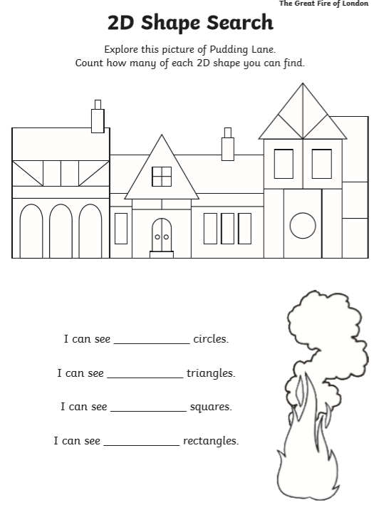
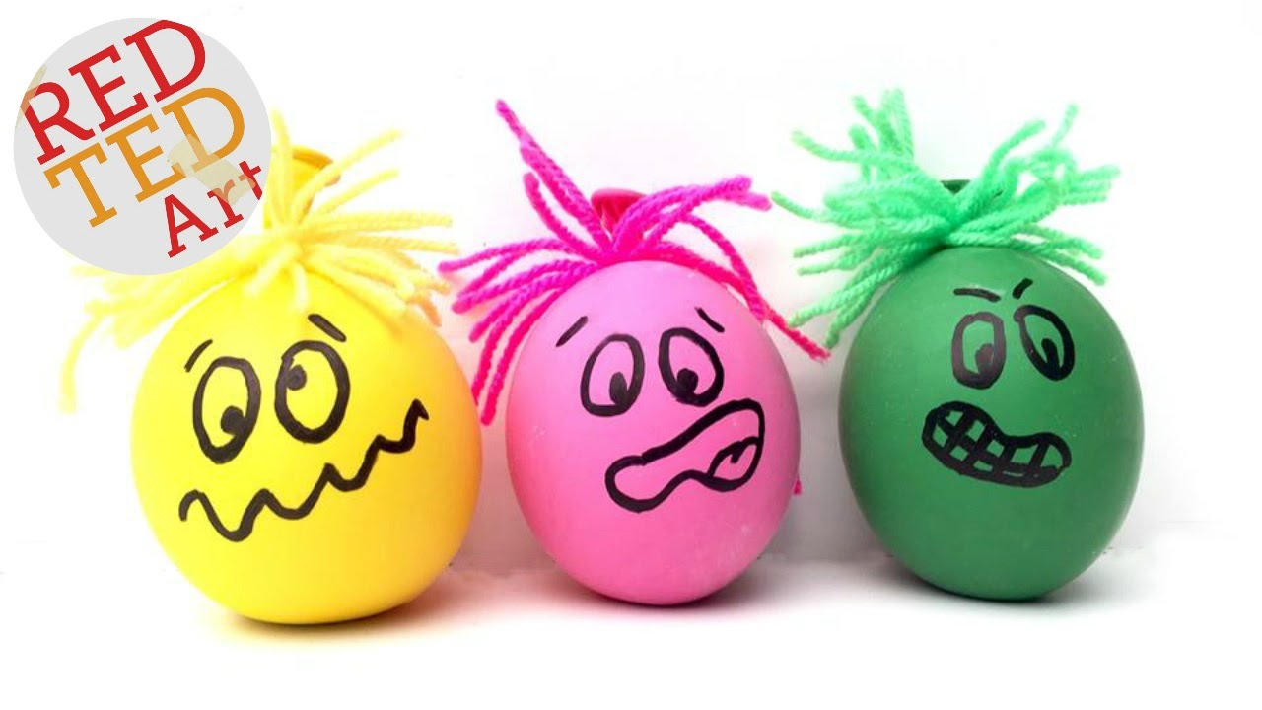
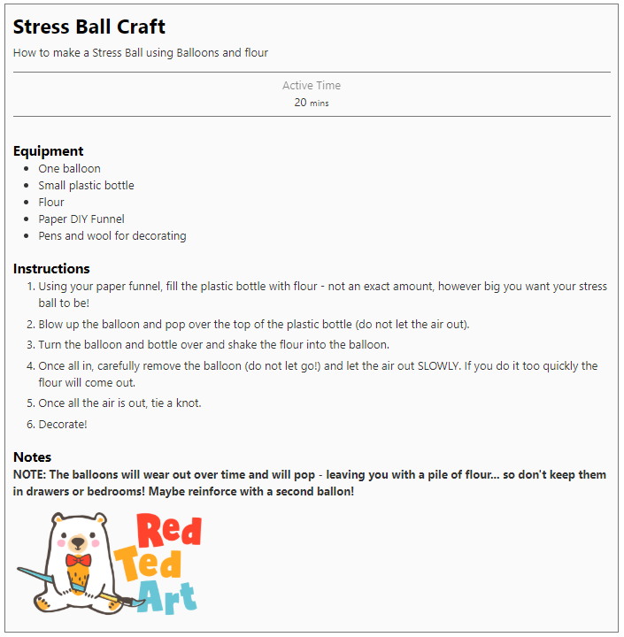

How did the fire make me feel?
What did I smell and feel?
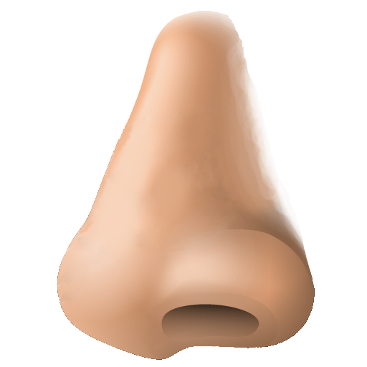
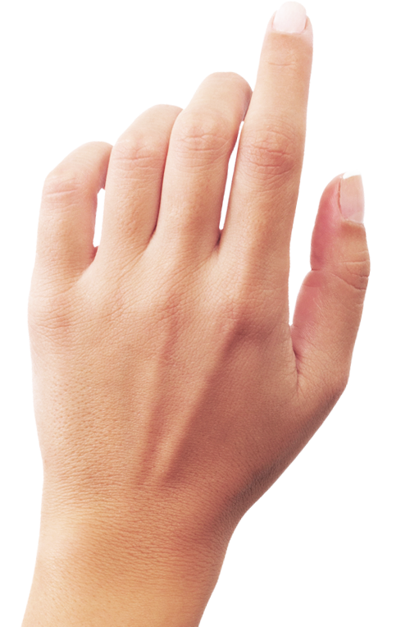

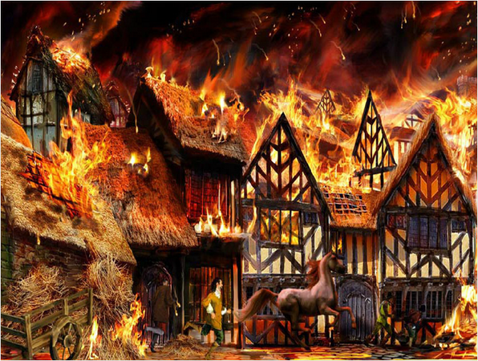

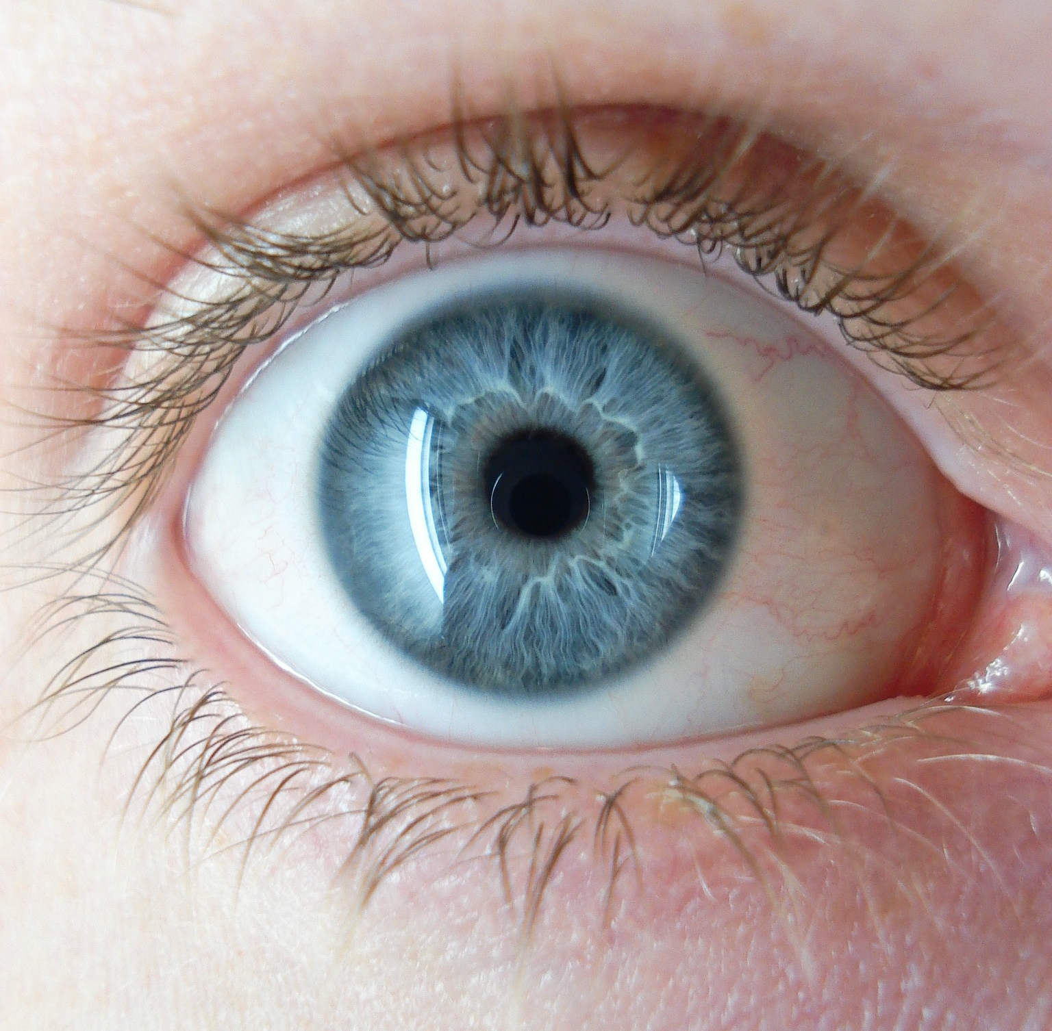
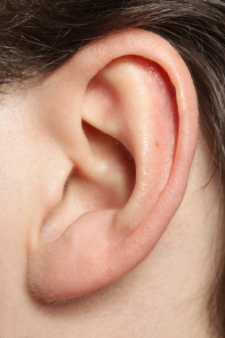
What did I see?
What did I hear?

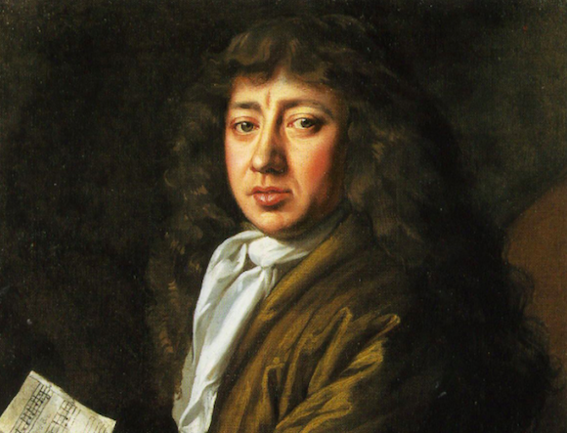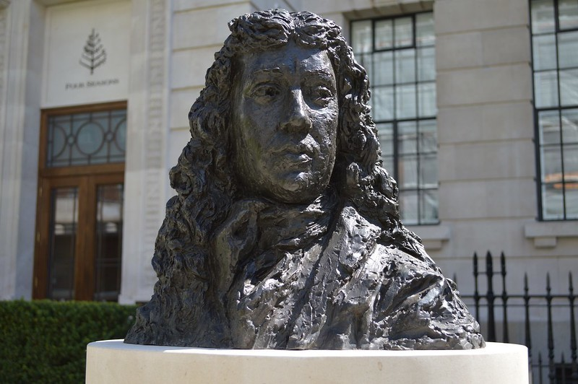
Samuel Pepys and his diary
