Year 3 Home Learning – Week beginning 18th May 2020
We have provided some guidelines for your child’s home learning. We appreciate that these are stressful times for all involved. Where possible, please encourage your child to complete the learning outlined below. We appreciate that in some cases this may not be possible. Please try your best and don’t get too worried about it. Most importantly stay safe and enjoy this time with your family.

English |  | Maths
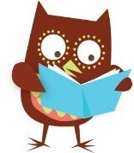  Daily Reading  You can read to yourself, read to someone else or listen to someone else read. When you have talked about your book to an adult then you can go onto our school’s AR reading site and do your quiz from home.  Writing  This week is ‘Walk to school week’ unfortunately you can’t do that, but you can all go for a walk (even if it’s around the house)  Your writing challenge is to write a recount of your walk.  There is a sheet attached showing the features of a recount. Remember your recount should be accurate, but who really knows what you saw on your walk? Was there actually a dinosaur in the park? Did that flying saucer really crash near you? No one is going to be able to check if you are telling the truth. You must use the features of a recount, but you can also have some fun if you like. |  | Times Tables  There are the usual ways to learn your times tables such as reciting them, writing them out and spending fun time with the TT Rock Stars. There are more MyMaths activity to do around money.  Remember, there are lots of practical ways to do maths at home, cooking, measuring when making things, counting out money and telling the time are all good practice  White Rose maths  We have added a link to the ‘White Rose’ web site. This is an excellent site that has lessons and activities for each year group. If you follow the link, you will find short lessons to watch (pause and try the activities as you go) and some worksheets are attached to go with each session. This is new for year 3 and a brilliant option if you would like to try it. It will explain the worksheet really clearly and your parents can watch the video and help you if required. Please don’t feel you have to do both this and the Mymaths all this week. It would be interesting to see what you think of the White Rose maths, so please let us know.
White Rose maths  Follow the link then scroll down to find week 3 (w/c 4th May)  https://whiterosemaths.com/homelearning/year-3/  This will link to money and give you access to the work sheets for each session. (and the answers if you need them)  I have chosen this week to do as other weeks don’t have the work sheets, so this might be easier for your first time. Remember you can choose to do this or Mymaths. |  |  | 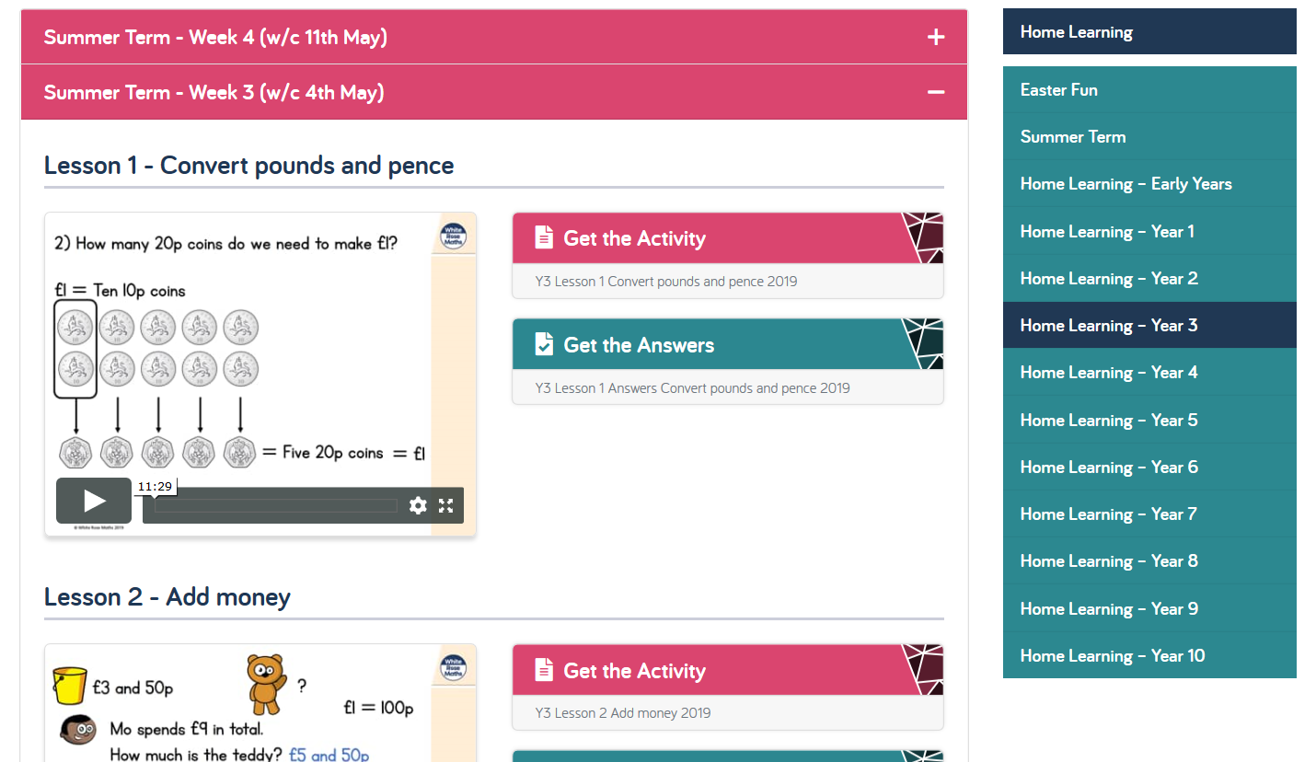
Topic | Spellings | PE |  | French
Geography  During lock down there are less cars, trains and planes travelling around. This means that there is also less pollution around the world.  What can you find out about pollution and what causes it? How could we keep pollution down when the lock down is over?  What could you do to encourage people to continue to walk more or ride bikes instead of driving their cars?  ICT – we are programmers  I am going to add this on again as the children in school have really enjoyed learning to code and get their certificate.  https://hourofcode.com/uk/learn | The following words are from the Y3/4 statutory word list; | Front curling game.  Stay in a front support position (see below) and try to throw objects at a target.  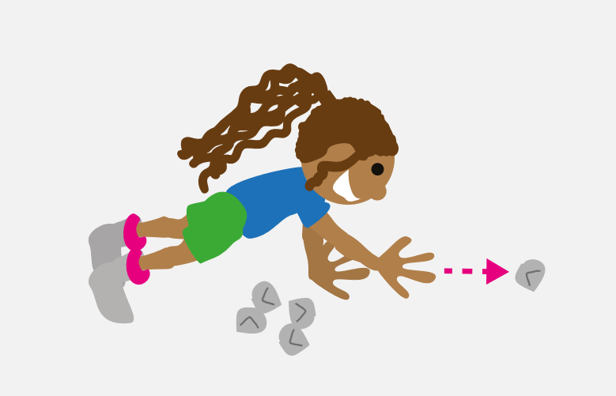  Make the target smaller or further away to change the difficulty of the game.  In school we would use bean bags, but at home you can use anything you have, even rolled up socks would make good bean bags! |  | Practice the numbers and see if you can use them to solve some simple calculations.  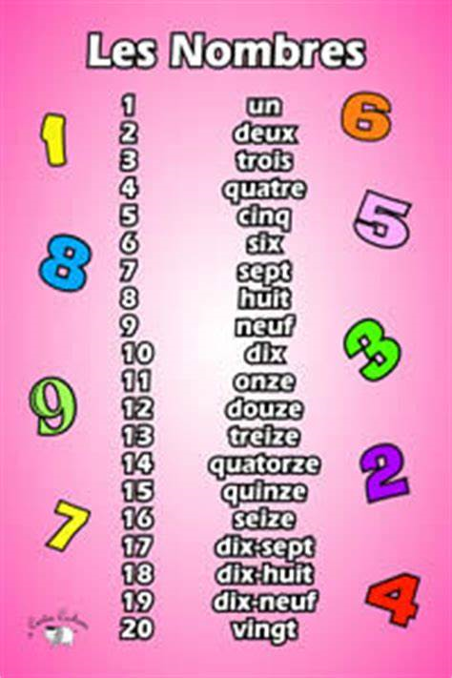
Book Tasctic competition

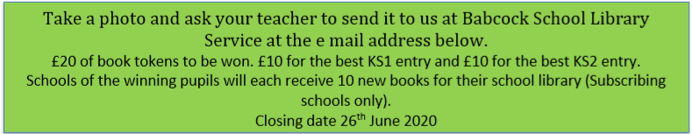

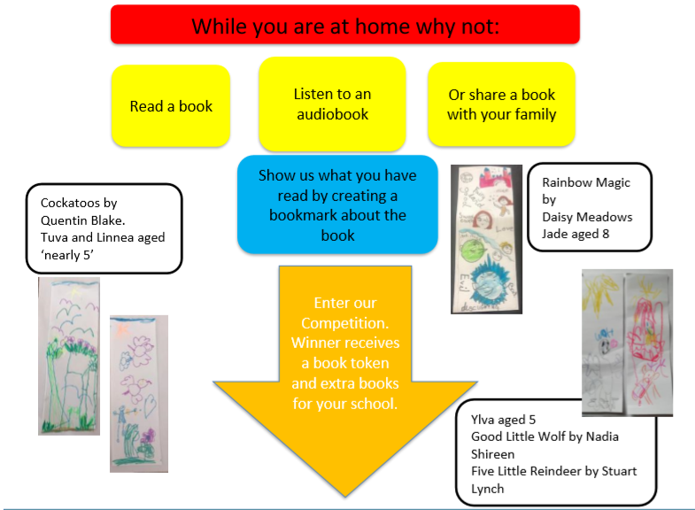

Websites
Oxford Owl - free access to eBooks until Sept 2020
Classroom secrets – activities across all subjects for EYFS to Y6
The Maths Factor – Lessons, activities and games with Carol Vorderman
Bayam – Free games and videos in French for children aged 3-10
Kids’ Learning Tube – A Youtube channel dedicated to education children through music and animation
Mystery Science – Mini and full video lessons answering scientific questions
Twinkl – has lots of resources to look at. We will be using it for some of our science in a week or so.
BBC bite size daily has now launched with a range of online learning lessons and videos. The link below will take you to the year 3 section, there are lots of different ideas and lesson to explore if you would like.
https://www.bbc.co.uk/bitesize/tags/zmyxxyc/year-3-lessons/1
Don’t forget to check Theatre Alibi’s challenge this week. Make a ‘story house’. More information can be found on HPS website. Good luck!

