Hello, Year 4. Hope you are all ok and ready for this weeks’ challenges. We have provided some guidelines for your child’s home learning. We appreciate that these are stressful times for all involved. Where possible, please encourage your child to complete the learning outlined below. We appreciate that in some cases this may not be possible. Please try your best and don’t get too worried about it. Most importantly stay safe and enjoy this time with your family. From Mrs Cornish and Mrs Emanuel
English |  | Topic- Geography- Volcanoes around the Wolrd
Planning and creating a story idea are very important parts of writing. In school, we normally use other story ideas to help us come up with our own. Mr Simm has created some videos to show you how he’s used Mrs Armitage on Wheels to help him create his own story. You can then create your own plan- then go ahead and write your story!  https://www.youtube.com/watch?v=7rSpaljsn_U Part 1  https://www.youtube.com/watch?v=nJfLnnCqemE Part 2 |  | First, look at this introduction to volcanoes.  How are volcanic eruptions formed?  There are many famous volcanoes around the world. Let’s see if you can find where the following volcanoes are on the map we’ve provided.  Krakatoa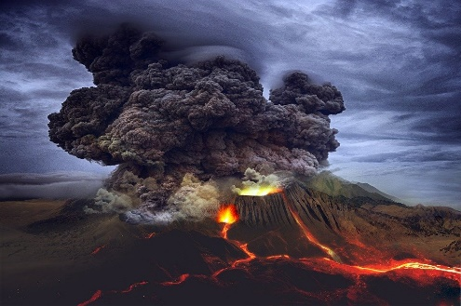  Mount St Helens  Cotopaxi  Mount Vesuvius  Mount Ruiz  Mount Tambora  Mauna Loa  Mount Fuji  A great way to locate these volcanoes would be to type them in on Google Maps or Google Earth. Or if you happen to have a globe or atlas at home, can you find them on there?
Maths
Please continue to follow the White Rose Home learning resources (go to ‘Summer term Week 4 -w/c 11th May) https://whiterosemaths.com/homelearning/year-4/ The videos are shown on this link and we have saved the activities alongside this document on the HPS website.
You can also explore the BBC bitesize videos to support your multiplication and division learning: https://www.bbc.co.uk/bitesize/articles/zmbtpg8
Don’t forget your My maths and TT Rockstars. We’ve set up a ‘Battle of the Bands’ challenge on TTRockstars to see who will win out of 4C and 4E.
Science
Use a chemical reaction to create your own volcanic eruption (see ‘Make Volcanic Eruption instructions sheet) You could even use paper mache to create your own life like volcano for your eruption to flow out of.

How many other chemical reactions can you think of? Did you know lots of chemical reactions occur when you cook/ bake something?
https://www.bbc.co.uk/bitesize/clips/zjrs34j
Have you cooked something where a chemical reaction has happened to create a new product?

French | Spellings |  | ICT- Internet Safety
Watch this video which shows famous Everton footballers sharing how they greet people in French  https://www.bbc.co.uk/teach/supermovers/ks1--ks2-mfl-french-greetings-with-ben-shires/zdpdvk7  Now see if you can greet your family at different times of the day using these French greetings:  Bonjour: Good morning  Bonne nuit: Good evening  Au Revoir: Goodbye  Salut: Hi  Ca Va: How are you? | Spooky Spellings http://www.ictgames.com/mobilePage/spookySpellings/index.html: an online game to help you practise your spellings below. |  | At the start of every new unit we always have a brush up on our internet safety rules and make sure we understand how to stay safe online. Here is a website to have a look at to polish up your skills while being a fun interactive game. It can be run off a phone, computer or tablet.  It is called Interland, and has four levels. Just swipe left or right to decide on an island you want to start on. I chose 'Tower of Treasure'. Then follow the instructions to play the game, as the game moves on you will get little lessons at the end of each level to help you to understand more about digital literacy and online safety.  After you have have played it, can you tell an adult or another member of your family a few lessons that can be learnt from how we can stay safe online?  https://beinternetawesome.withgoogle.com/en_us/interland/landing/tower-of-treasure

Affixes |  | Words ending /er/ | Rare grapheme phoneme correspondences | Less common digraphs | Different spellings of /sh/ | 2 syllable words
important describe  occasion occasionally accident accidentally | potato  potatoes  busy  business | quarter remember consider | minute  build  fruit  guard  guide | island  knowledge | special  pressure | promise  purpose
Spellings of /shun/ | Polysyllabic words with unstressed consonants | Words ending /ar/ | Words ending /ear/ | Suffix -le to -ly |  | Polysyllabic
position  mention  question  possess possession | answer  often  strange  actual  actually  material  natural  various | particular peculiar  popular  calendar  regular | appear  disappear | probable probably  possible  possibly impossible | exercise experience experiment | difficult  continue

