Year 5 Home Learning – Week 18th- 22nd May 2020 We have provided some guidelines for your child’s home learning. We appreciate that these are stressful times for all involved. Where possible, please encourage your child to complete the learning outlined below. We appreciate that in some cases this may not be possible. Please try your best and don’t get too worried about it. Most importantly stay safe and enjoy this time with your family. Like last week, we have put all the English/spelling on one document, all the maths on another and topic/RE on a third. There is also the art competition entries to finish off. We have also attached some tessellation ideas for your ICT work to this document..
English |  | History /Art/ PSHE
Please use the attached boxed up plan to help structure a story of your own using a similar theme/idea to the Mouth-Organ Boys or the Swimming Squad: a story about something you desperately want to do or need.  Once you have finished planning your story, we would like you to write your story up using full sentences and paragraphs. It is important that you include some speech/conversation between your different characters. Be careful to mix up the speech and narrative story-telling. You can write or type your story up. If you would like you could turn your story into a diary or book with some illustrations or a front cover. Please make sure you send a copy or your novel for proof reading to your teacher to enjoy! |  | Art: Finish your entry for the competition called ‘See What I see.’ This is a great art competition for Nine to 12-year olds: an opportunity to explore and creatively re-make the world around us by re-imagining their local community and use their imagination to design changes to the environment to make it a better place to live. Deadline 30th May 2020. Further details are below.  PSHE: To finish your entry for the NHS competition (see last week’s overview for details) All entries must come via school - so you can send off any entries by 18th June (the closing date is 19th).  History: I can explain who Muhammad is, say how the first caliphate came to be formed and can create a poster to explain the roles and responsibilities of a caliph.  ICT - We are artists  We are starting a new unit this week focusing on Tessellation. Do you know what tessellation is? Well it's a repeating pattern of shapes that fit perfectly together. Can you go on shape hunt around your house, or when you are out on your daily exercise and look out for some examples of tessellation? See the sheet attached for some of the examples I found. Do you recogise some of the buildings? Make a note of all the examples of tessellation you find, and if you're up for a challenge maybe see if you can draw a tessellation pattern in preparation for next week, when we'll be looking at famous artists that use tessellation like M.C Escher. This link can also help you to understand tessellation.  https://www.bbc.co.uk/bitesize/topics/zbtp34j/articles/z7b66v4
Maths: This week we are starting our new block of ‘5.10 Number Sense’. You will need to recall your previous knowledge and understanding of value of each digit up to a seven- digit number (million place value). On the maths documents there are some explanations.
Activity 1: Revision of the place value of up to a seven- digit number and partitioning the number to show what each digit represents.
Activity 2: Rounding numbers up to a million to the nearest 10/100/1000/10000/100000
Activity 3: Negative numbers, what they are? How to read, understand and compare to find the smallest to the greatest in value.
Activity 4: Negative numbers continued, reading, plotting and solving problems with negative numbers.
Time Tables Games:
Please complete 15 games from www.ttrockstars.com
(For further times tables practice-use the following websites:
https://www.mathplayground.com/ASB_GrandPrixMultiplication.html
https://www.topmarks.co.uk/maths-games/hit-the-button
https://beinternetawesome.withgoogle.com/en_us/interland/landing/tower-of-treasure
https://www.youtube.com/watch?v=C3PojOwjHcc Compilation of songs to help learn 12x12
Spellings – This week the first two spelling sessions are revising the words learnt from last half term.  The third session is looking at the homophone words we learnt recently and using a dictionary to support what each word means in the correct context, then testing yourself you can spelling the correct homophone for the right meaning. | PE- To complete your entry of your standing Long Jump, all you need is a start or jump line to take off from and a tape measure with someone to record your distance, Mrs Hughs reached 1m 20 cm, can you rise to the challenge and beat this?  How about actively learning your timestables with the BBC supermovers: www.bbc.co.uk/teach/supermovers/times-table-collection/z4vv6v4  Or try a challenge on #ThisIs PE, let your teacher know which activity you completed and your best score, maybe we could set a class challenge up?  A new video is added to their YouTube playlist at 1pm on a Monday, Wednesday and Friday so you can include it in your home learning timetables alongside the daily physical activity you are doing. You just need to follow this link: https://www.youtube.com/playlist?list=PLYGRaluWWTojV3An2WEgsQ4qGFy_91jDL
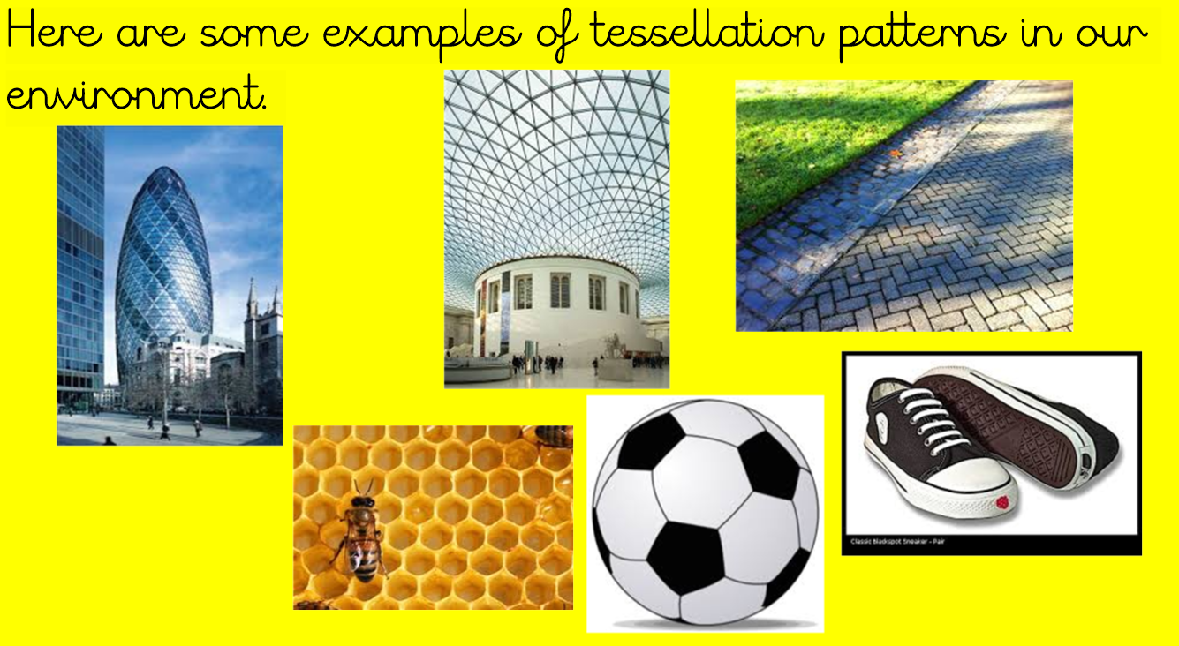
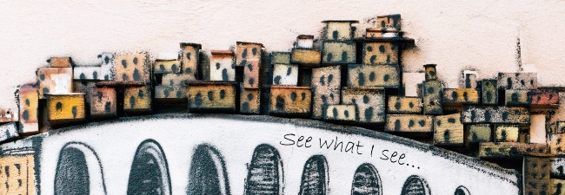

New competition helps children re-imagine the great outdoors
**’See What I See’ asks five to 16-year olds to set their imaginations free and
re-think their built environment**
**Prizes up to £600**
**Competition launched in partnership with
Bath Spa University and the Royal Fine Art Commission Trust**

A new competition for five to 16-year olds has been launched today to help children feel more connected to the outside world during the coronavirus lockdown.
See What I see, which has been created by the Royal Fine Art Commission Trust (RFACT) in partnership with Bath Spa University, asks children to think about what they miss most about their built environment, how it might be redesigned to bring people together and which place or building they’ll visit first once coronavirus restrictions have been lifted.
The competition activities have been designed for different age groups, each with a monetary prize attached (first prize £600, second prize £300 and third prize £100).

- Five to eight-year olds: an opportunity to show their artistic skills and creativity in the form of 3D models, drawings and any other formats they can think of
- Nine to 12-year olds: an opportunity to explore and creatively re-make the world around us by re-imagining their local community and use their imagination to design changes to the environment to make it a better place to live
- 13 to 16-year olds: a category for aspiring designers, those with unlimited imagination and critical eye for detail. Entrants might imagine themselves as an architect, an urban designer or a civil engineer exploring their built environment

Kyriaki Anagnostopoulou, Head of the School of Education at Bath Spa University, said: “Being made to stay indoors can often be associated with punishment for young children, so we wanted to give them something positive to think about that would let their imaginations run wild. At a time when we suddenly find ourselves separated from the outside world, our desire to engage with our environment has become stronger than ever, so this is a perfect opportunity for children to rethink the surroundings that we often take for granted and re-imagine bold, new solutions that inspire new ways of living together.”

Robert Bargery, Executive Director at RFACT, which promotes visual awareness and public appreciation of high-quality design, added: “We want children to use their endless creativity to imagine how they would transform and improve our built environment while we’re observing it from the outside in. We hope this competition acts as a helpful resource for teachers and parents to keep their children feeling engaged, happy and creative while the lockdown continues. The opportunities are endless and we can’t wait to see the entries as they come in!”

The entries will be judged by a high-profile judging panel comprising the esteemed design critic Stephen Bayley, the famous architect Sir Terry Farrell CBE, the award-winning exhibition designer Dinah Casson CBE and Professor Kyriaki Anagnostopoulou, Head of the School of Education at Bath Spa University.
Judges will be looking for three things: creativity, engagement with surroundings and imaginative design solutions that solve a problem or improve a local area. Winning entries will be showcased in an online gallery on the See What I See website.
The deadline for entries is 30 May 2020.
For more information visit: http://www.seewhatisee.me/
A parent, guardian, carer or teacher will need to enter on children’s’ behalf here: http://www.seewhatisee.me/the-competition/

Competition 2 PSHE-Saying thank you to the NHS
We are offering HPS children in KS2 the opportunity to take part in a competition to say THANK YOU to the NHS. This competition has been set for children to say “thank you” after learning about the job roles and opportunities available in the NHS.
Children will be exploring more than 350 different roles in the NHS – from non-clinical jobs such as gardener, chef, accountant and engineer, to wide-ranging roles in health and social care.
Step into the NHS aims to help children understand themselves better, explore a wide range of jobs, talk positively about what they might like to do, think about where different choices can take them and feel inspired about the world of work and their future.

The challenge is for pupils to:
- Think about the wide range of jobs they have learnt about in the NHS
- Surprising facts they have collected
- Think about how the NHS has helped them, one of their friends or family.

Competition Rules: Children will need to produce either:
Creative artwork: painting, drawing, temporary street artwork, performance, video or slideshow OR
Creative writing: a story, song, poem or thank you card
Entries must be submitted online via school. Pupils can enter individually or as a pair.
Prizes: This is a National Competition and the overall national winning student(s) will receive Amazon vouchers worth £50. Ten regional winners will each receive an Amazon voucher worth £25 and highly commended certificates will also be awarded. Whether you enter individually or as a pair, each pupil will receive a prize if your entry is chosen as a winner.
Judging Criteria 50%: Evidence of learning of NHS careers from the resources
- Are the pupils aware of a range of NHS careers and services and have the pupils explored the challenging of stereotypes?

50%: Creativity
- Is the design creative and eye-catching. Is there anything that demonstrates that they have gone the extra mile with their work?
Full terms and conditions can be found here: https://www.stepintothenhs.nhs.uk/primary-schools/KS2-competition?dm_i=5EPN,6ZOD,1WDL2B,QSMP,1

Entries must be received no later than 19 June 2020. All HPS children in KS2 can enter this competition, however your entry must be sent via school. You cannot send it straight to the judges yourself. Therefore, make sure you email your entry to your class teacher by 18th June 2020 so that they can forward it to the judges by 19th June 2020 (the closing date). Good luck!

