Year 5 Maths week beginning 18th May 2020
This week we are revisiting our knowledge and understanding of our place value up to a million:
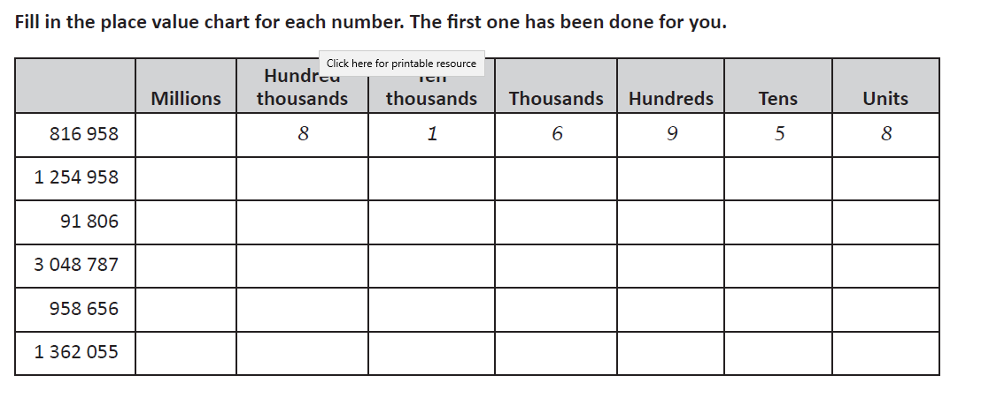
Day 1
Use the place value grid below to support you to help develop your understanding of the value each digit represents:
Millions | Hundred thousands | Ten thousands | Thousands | Hundreds | Tens | Ones
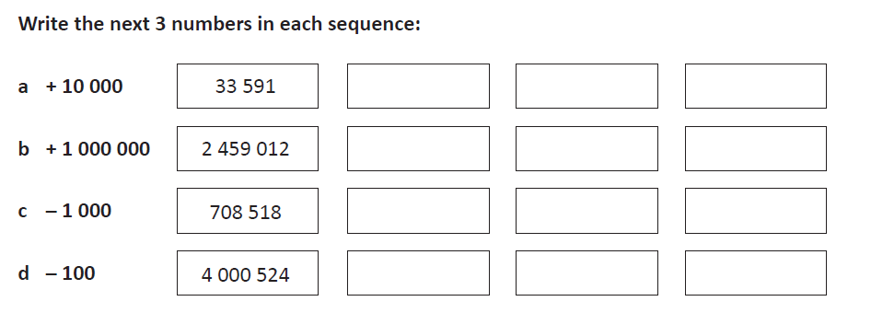
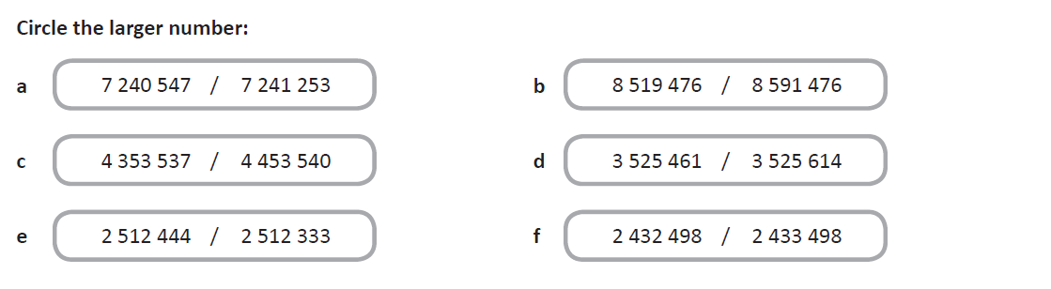
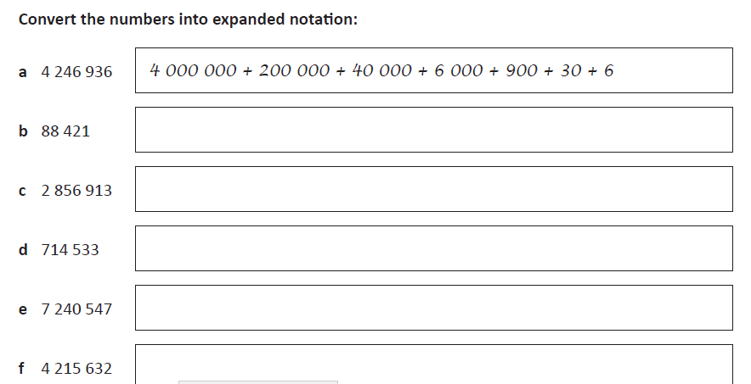

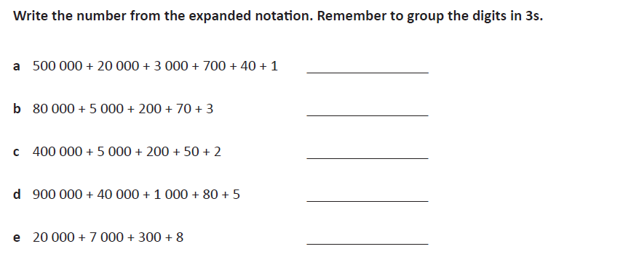

523741
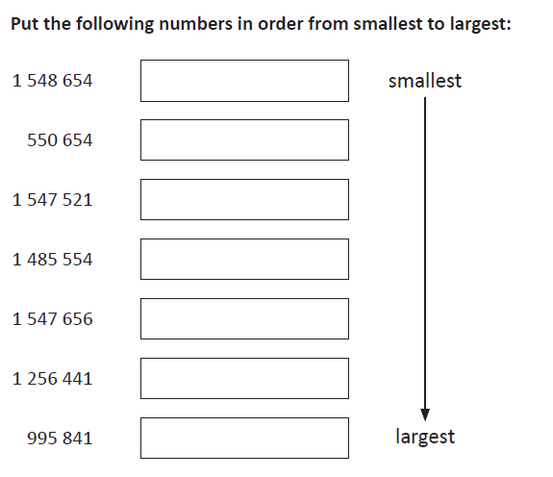

Day 2 Today we are going to focus on rounding any number up to a million to the nearest 10,100,1000,10000,100000.
Let’s remind ourselves of about how many digits represent which place value, use the grid below if you need to:
Millions | Hundred thousands | Ten thousands | Thousands | Hundreds | Tens | Ones

Look at the numbers below and tell me the value of the bold letter within the number:
1) 108673 = 70
2) 345690 =
3) 152348 =
4) 786506 =
5) 699325 =

Let’s remind ourselves of the rule of thumb when rounding numbers to a given place value:
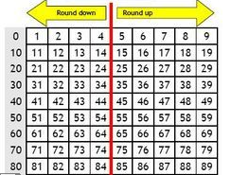
There are many rhymes to help you remember what to do
But the basic rule is numbers that end in 0,1,2,3,4 we round down to 0
Numbers ending with 5,6,7,8,9 we round up
Here are some other examples
37 rounded to the nearest ten as the number ends in 7 we round up so the answer is 40.
83 rounded to the nearest ten would be 80 as the number ends in a 3 so
we round down.
When rounding 382 to the nearest ten = 380 (you look in the tens column 8 then the neighbouring number is a 2 so the rule is to round down, so the ten we have just passed is 80 = 380 is the nearest ten.
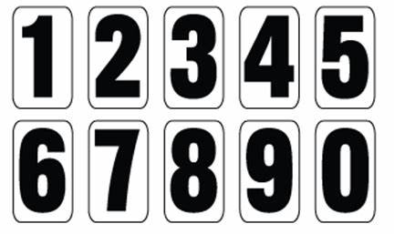
386 to the nearest hundred = look at the hundred = 300 but we need to look at the neighbouring number which is an 8 , rule is to round up so the next 100 from 300 = 400
Your Turn:
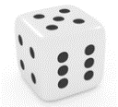
Using the digits 0 -9 or roll a dice to make:

1) a four-digit number _________________________ round to the nearest ten = ______________________
2) a five- digit number __________________________ round to the nearest hundred = __________________
3) a six-digit number ___________________________ round to the nearest ten thousand = _______________
4) a different 6-digit number _____________________ round to the nearest hundred thousand = ______________
5) make a seven-digit number ____________________ round to the nearest million _________________________
Millions | Hundred thousands | Ten thousands | Thousands | Hundreds | Tens | Ones

Rounding sentence match up
The sentences below have been muddled up, read them carefully then draw a line to match the correct answer:
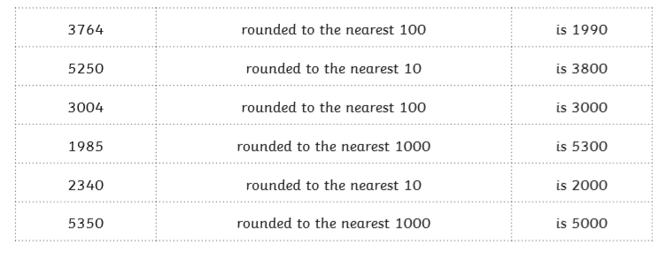
Set 2
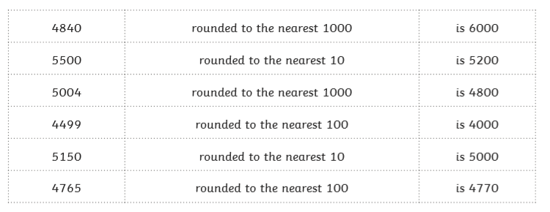
Set 3
64782 | rounded to the nearest 10000
903544 | rounded to the nearest 1000
352198 | rounded to the nearest 100
781094 | rounded to the nearest 10000
1672559 | rounded to the nearest 100000
Day 3 Today we will be looking at interpreting negative numbers in context, counting forwards and backwards with positive and negative whole numbers including through zero.
Negative numbers can be used in many different situation reading and recording temperatures, describing weather conditions and inform consumers how to store food on packaging to being in debt with money (owing money you don’t have).
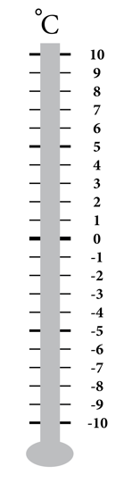
Negative numbers are less than zero and fall short or deficit of zero. They can be displayed along a number line (horizontally)
Or vertically
So how do we tell temperature?
What units of measurement do we use?
Are there different types of temperatures?
A thermometer records temperature both hot, cold and freezing conditions.
At what temperature is classified as freezing?

What temperature does each thermometer show?
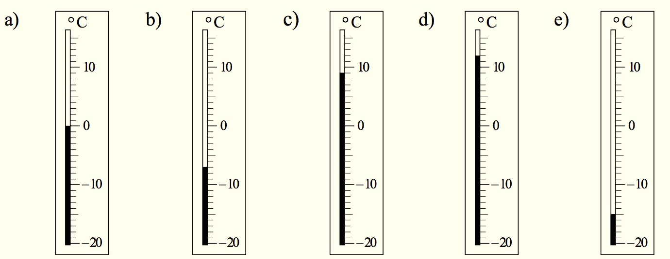

a) 0 °C
b) 7° C
c) 9 °C
d) 12° C
e) -15° C

How did you get on?
What did you notice about the numbers as we passed through zero?
The warmer the temperature the higher up the vertical thermometer, the colder the temperature the further down the thermometer.

I have five numbers -25, -30, -7, -10, -40
Can you write these in order of the least to the greatest? , , , , ,

You might have been tempted to say -40 was the greatest number because you know as a positive number 40 has the bigger place value. However, when working with negative numbers -40 is forty places away from zero, whereas -7 is only 7 less therefore the greatest bigger number.
Task 1 Use the number line to help you order and compare these numbers:

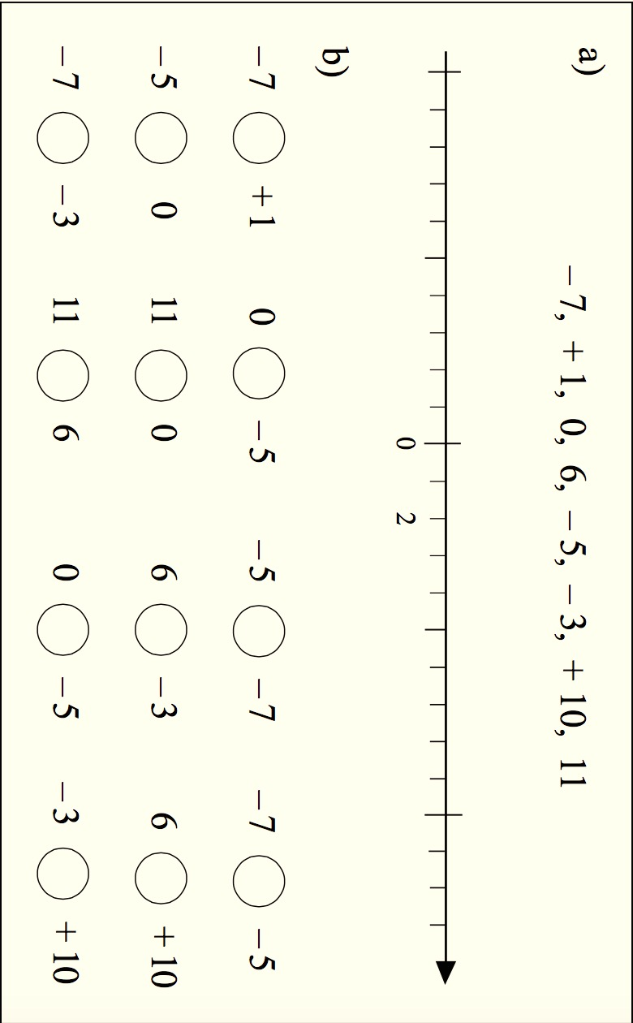
.
Use > or < to make the number sentence correct?

Task 2 Find the missing numbers in each sequence:
a) 1, 0, -1, ________, ________, ________
b) –2, –1, ________, 1, ________, _______
c) 4, 2, 0, ________, ________, ________
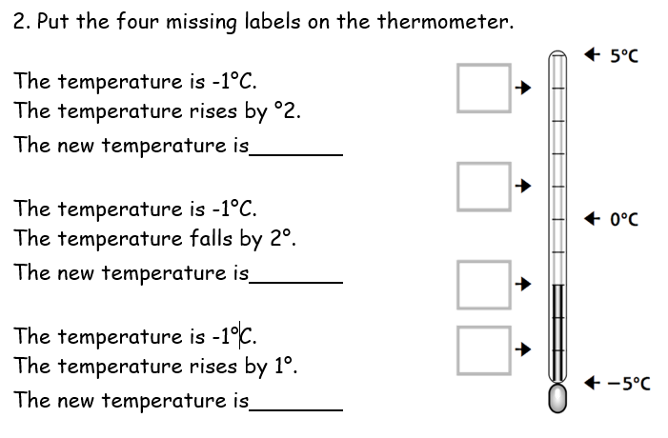
Task 3 Put the four missing
labels on the thermometer

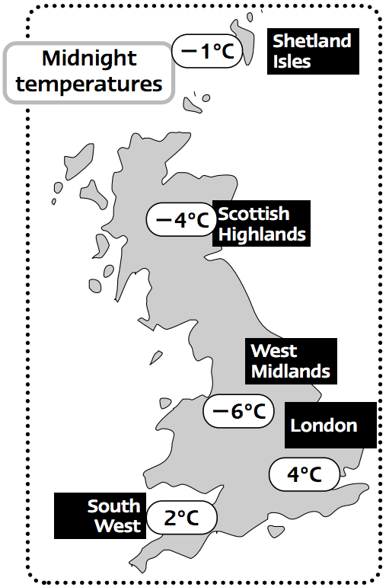
Day 4 Negative numbers continued

1) Look at the map showing temperatures at midnight.

Which place has the highest temperature?
…………………….

Which place has the lowest temperature?
…………………….

Which is colder, the Shetland isles or the West Midlands?
......................

Which is hotter, the Scottish Highlands or London?
…………………..
2) Using the temperatures on the map, place them on the number line below.

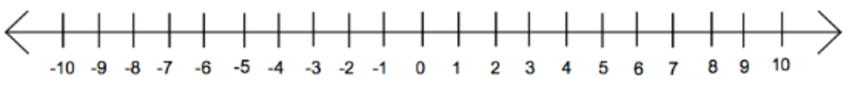

3) Complete the negative line
4) Elliot is counting forwards in twos. He starts at –9.
Does he say ‘2’? Explain how you know. ____________________________________________________________________________________________________________________________________________________________________________________________________________________________________________

5. Elliot is counting forwards in threes. He starts at –17.
Does he say ‘2’? Explain how you know.
____________________________________________________________________________________________________________________________________________________________________________________________________________

