Year 2 Home Learning – Week 5, week beginning 4.5.20
We have provided some guidelines for your child’s home learning. We appreciate that these are stressful times for all involved. Where possible, please encourage your child to complete the learning outlined below. We appreciate that in some cases this may not be possible. Please try your best and don’t get too worried about it. Most importantly stay safe and enjoy this time with your family.
English |  | Topic- History / Art
Reading- Please try to complete daily reading of 10 minutes. Children can read to parents, parents can read to children, parents and children can read a page each, whatever works for you! We would love to hear about any books that you’ve enjoyed or to see any pictures of you reading at home. Is there a special place in your home that you like to read?  Reading & Writing activities-  - Write a letter to your favourite author. Tell them why you enjoy their books so much. Are there any questions that you want to ask them? You may want to send the letter to them and see if you get a reply! |  | Last week, you learned about The Great Fire of London in 1666. This is an important event in London’s history.  In 1666, there were no cameras to take pictures of things that have happened. Instead, artists painted pictures that have survived today. These paintings are important evidence of historical events.  - At the bottom of this page, we have included some paintings that were made between 1667-1700.  - Take some time to look carefully at each painting.  - Talk about how strange it would have been and how it must have felt to set up your easel and paints to start painting while the city was burning because they could not take photographs.  - Have a go at recreating your own version of a Great Fire of London picture. There are some examples and ideas at the end of this document. You can also Google /Great Fire of London paintings KS1/ and you can see lots of other people’s attempts.  - You could try paint, tissue paper, marbling, pastel or chalks, crayon, colouring pencils, cut of strips of black paper or a full city-scape silhouette. It’s up to you. See what you can create!
Maths
- Daily maths lessons on the White Rose website. Go to https://whiterosemaths.com/ and click the Home Learning tab at the top of the page. Click on Year 2 or click on this link to take you straight there: https://whiterosemaths.com/homelearning/year-2/ The week’s learning is Summer Term Week 2, (w/c 27th April)- Lesson 1 is Compare Lengths. The learning then builds on knowledge from the previous week.
- There are lessons for you to follow, and optional worksheets to complete.
- If your child finds the work challenging, you can also access the Year 1 home learning.
- Two My Maths tasks have been set. Please remember to do the lesson before completing the activity. Repeat the lesson if you get less than 80% on the homework – see if you can work out where you went wrong.
- Maths Challenge: How many ways can you make 20? Use addition, subtraction, multiplication and division., Write your answers down as number sentences.
Science/Art | Spellings/Phonics | PE | PSHE
Skittles Rainbow Fun!  You will need:  - 1 packet Skittles  - 1/4 cup warm water  - white plate  - Arrange the Skittles in a single row coloured pattern around the edge of the plate.  - Pour over enough warm water to cover all the Skittles and the plate itself.  - Watch and wait as a rainbow appears on the plate, the colours will move towards the middle and create a whirl of colour. | Please continue to practise spelling the Year One and Year Two common exception words that were sent home in the Spring Term. Remember that little and often is best!  This week we have also given you some words to practise writing using the “ed” suffix.  These are written at the bottom of the sheet. With these words you can complete the following activities:  - Read all of the words and talk about their meanings.  - Practise using these words in a sentence, spelling them correctly.  - See if you can spot words in your reading books that contain the same graphemes.  - Add your own examples of words to the list that contain the graphemes. | - Joe Wicks, the Body Coach is providing daily, fun workouts for everyone to take part in, Visit https://www.youtube.com/user/thebodycoach1 and click on PE With Joe.  - Create an obstacle course in your garden. Ask someone to take photos of you completing the course. We would love to see your pictures! | Mindfulness  In our PSHE lessons, we have been learning all about mindfulness. Here is an activity for you to try:  - Listen carefully with your eyes closed to any sounds you can hear. After one minute, open your eyes and write down everything you heard.  - Challenge a member of your family to do the same thing. What sounds do they hear?

Phonics focus graphemes for the week- the “ed” suffix.
ed  help helped  jump jumped  rain rained  cook cooked  boil boiled  groan groaned | -e ed  bake baked  complete completed  joke joked  smile smiled  invite invited  dance danced | double consonant + ed  stop stopped  chat chatted  wrap wrapped  plan planned  hop hopped  admit admitted | -y ied  bury buried  carry carried  reply replied  scurry scurried  worry worried  hurry hurried

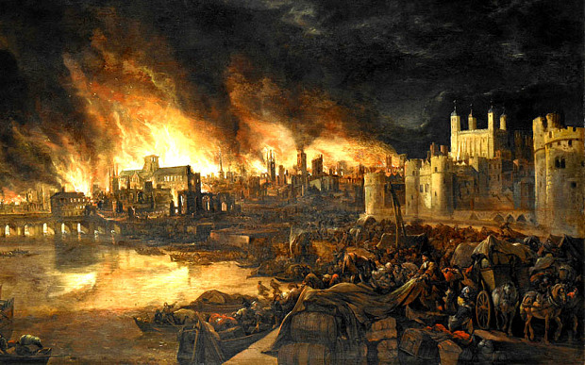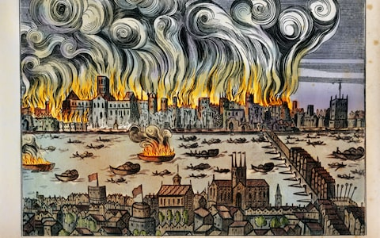
Paintings of The Great Fire of London

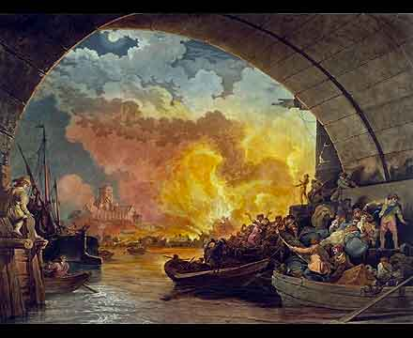
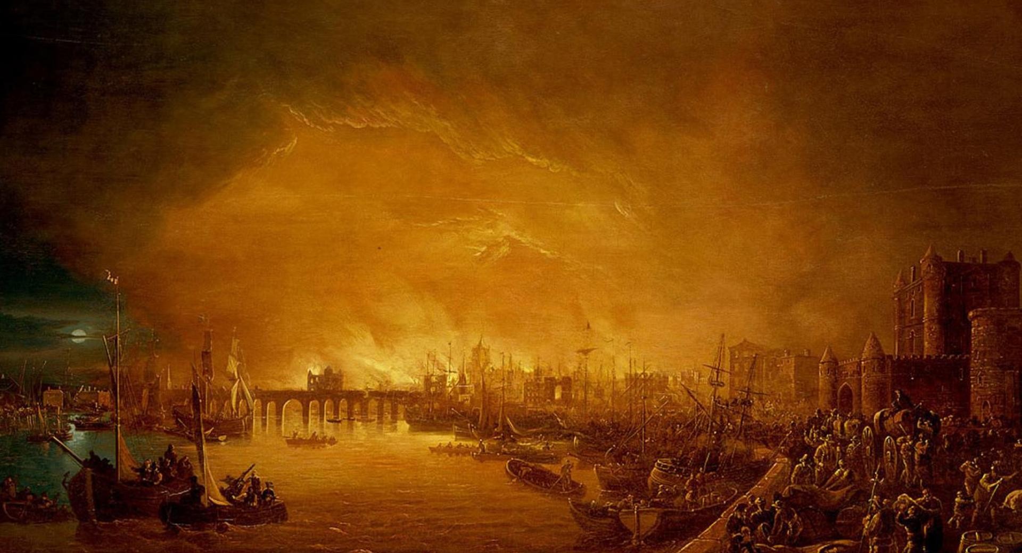

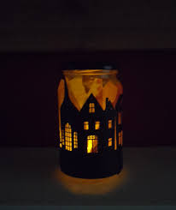
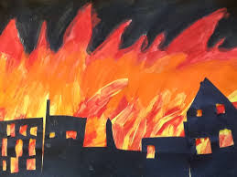
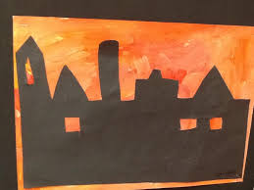
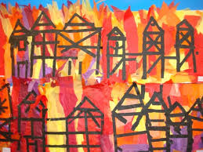
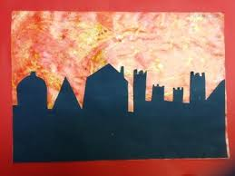
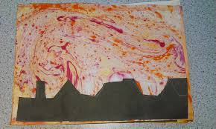
Here are some examples of ways that you might like to have a go at recreating a Great Fire of London picture. You could try paint, tissue paper, marbling, pastel or chalks, crayon, colouring pencils, cut of strips of black paper or a full city- scape silhouette. I love the idea of a cut out city scape around an old jar so that the candle makes it look like the buildings are burning. You could even try something on the computer. Have a go and see what you can create!

