Year 2 Home Learning – Week 6, week beginning 11.5.20
We have provided some guidelines for your child’s home learning. We appreciate that these are stressful times for all involved. Where possible, please encourage your child to complete the learning outlined below. We appreciate that in some cases this may not be possible. Please try your best and don’t get too worried about it. Most importantly stay safe and enjoy this time with your family. Don’t forget this week to look out for the Theatre Alibi Challenge – create your own dance! More information is on the school website and Facebook page. We would love to see what you can do!
English |  | Topic- History / DT
Reading-  - Tiverton Library have lots of online resources for members to access such as e-books, e-magazines and audiobooks. Have a look at their Facebook page and website for more information.  Writing activities-  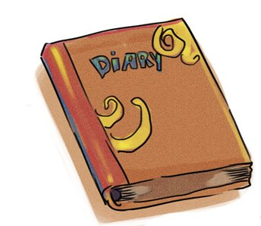  - We would like you to keep a diary of your week. For each day of the week, write down what you have done throughout the day and how you’ve been feeling. We are attaching an example diary for you to read before you write your own.  - Remember to use time conjunctions to help you to write events down in order. Examples of these words are: first, then, next, after, finally.  - Remember to write in the past tense, as these events have already happened. |  | Play the following game:  - http://www.fireoflondon.org.uk/game/  This will help you to learn more about The Great Fire of London and to think about how we know about the event today.  - Below is a recipe for 17th century bread. Have a go at making it! (I know some ingredients can be tricky to get hold of and other simple bread recipes are available online).  - Now you will need somewhere to sell your bread from! Build yourself a bakery shop! Use junk modelling or the print out below and turn it into a bakery.  - You could name your shop after yourself or your family. Add a name over the door or a sign that would hang outside. You could also add drawings of what you sell in the windows.
Maths
- Daily maths lessons on the White Rose website. Go to https://whiterosemaths.com/ and click the Home Learning tab at the top of the page. Click on Year 2. The week’s learning is Summer Term Week 3, (w/c 4th May)- Lesson 1 is Fact Families addition & Subtraction bonds to 20. The learning then builds on knowledge from the previous week.
- There are lessons for you to follow, and optional worksheets to complete. The worksheets (and answers) can be found on the HPS website for you to download.
- If your child finds the work challenging, you can also access the Year 1 home learning.
- A My Maths task has been set. Please remember to do the lesson before completing the activity.
- Maths Challenge: If you add 3 odd numbers together it will always make an odd number. True or false? Show how you know by writing down your calculations.
Science | Spellings/Phonics | PE | PSHE
Whiteboard Pen Fun!  You will need:  - A glass plate, bowl, or picture frame  - Dry erase marker (whiteboard pen)  - Water  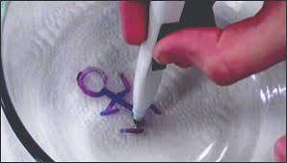  What to do:  - Draw a simple picture on the glass. A stick figure is a good one to start with  - Pour water onto the plate or into the bowl slowly to lift up the drawing  - Swirl the water around to make the picture dance and move. | This week we have given you some words to practise writing using the /j/ grapheme. These are written at the bottom of the sheet. With these words you can complete the following activities:  - Read all of the words and talk about their meanings.  - Practise using these words in a sentence, spelling them correctly.  - See if you can spot words in your reading books that contain the same graphemes.  - Add your own examples of words to the list that contain the graphemes.  - Challenge: Can you write a story using as many of the /j/ words as you can? | - Joe Wicks, the Body Coach is providing daily, fun workouts for everyone to take part in, Visit https://www.youtube.com/user/thebodycoach1 and click on PE With Joe.  - Throwing Skills: How many times can you throw a ball/ beanbag into a bucket in a minute? Can you beat your best score?  - What happens to your score when you move the bucket closer/ further away? | Mindfulness  In our PSHE lessons, we have been learning all about mindfulness. Here is an activity for you to try:  - Listen carefully to a piece of music with your eyes closed.  - Get a pencil and a piece of paper and listen to the music again. Take your pencil for a walk across the paper when listening to the music:  - How does the music make you feel?  - What shapes/ lines have you made on the paper?  - Colour your shapes in to create a colourful pattern.  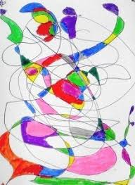

Phonics focus graphemes for the week /j/.
j  jam  Jim  Jack  Jill  jog  jet | g /j/  gentle  magic  energy  giraffe  giant  gem | ge /j/  age  large  change  charge  strange  bandage | dge /j/  badge  edge  bridge  dodge  fudge  sledge

