Nursery Home Learning – Week 9 8.6.20
We hope you have been finding the weekly home learning sheet useful. Please do not hesitate to contact us if there is anything in particular you would like us to cover or need support with. This week we are going to be learning another traditional tale which your child may already be familiar with; The Three Little Pigs. We hope you have fun with your child completing some of the activities below. If you have any questions, please do not hesitate to contact us.
Literacy |  | Topic – The Three Little Pigs
Story of the week: The Three Little Pigs  You can find an animated version on the Twinkl website – see link below:  https://www.twinkl.co.uk/resource/the-three-little-pigs-motion-story-tg-a-11  There are also PowerPoints and other resources on this site to explore the story.  - Explore the vocabulary to help your child learn a range of new words and their meaning (see attached sheet)  - Can you remember how many pigs there were? Can you show me 3 fingers?  - Why did the Three Little Pigs leave home?  - What type of house did the first little pig build?  - What happened to the first little pigs house?  - Can you remember what the wolf said to the first little pig when he would not let him in?  - How did the wolf feel when he had blown down the first pigs house?  - Why do you think the wolf wanted to get in the pig’s house?  - Where did the first little pig run to when his house had been blown down?  - What type of house did the second little pig build?  - What happened to the stick house?  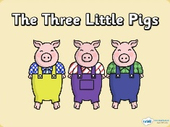  - What happened when the wolf got to the brick house? Why couldn’t he blow it down?  - Can you retell the story to someone using different voices?  - Learn the attached Three Little Pigs rap. You could wear some cool sunglasses to rap and make a video to share.  Phonics  N2 – (Pre-schoolers):  Continue to practise learning the phonemes (letter sounds): s / a / t / p / i / n / m / d / g /o/c/k/ using home-made flash cards. You can also watch the Jolly Phonics YouTube clips.  https://www.youtube.com/watch?v=1Qpn2839Kro  Introduce the next phoneme ‘ck’ – remember we are teaching the letter sound not the name at this stage. Explain that sometimes c and k work together in words and they also make the sound ck like at the end of duck, muck, tuck.  Jolly phonics song: ck - this is the same song as /c/ so it should be familiar.  Blending and segmenting activities:  Oral blending and segmenting is a vital skill when learning to read and write. Please have a go at some of the activities below which will help your child to develop these skills.  - Play ‘I spy with my little eye’ (with a selection of objects in front of them) I spy with my little eye a /f/ /i/ /sh/. What can I see?’ The next step is using a feely bag and asking your child to identify an object not visible.  - You will need to play this game with a few family members if possible.  Cross the river: Make a pretend river out of a blanket or chalk a river on the ground outside. Give each person an object or picture (try and keep these to 3 or 4 phonemes). All players stand on one side of the river. Call out one object – segmenting it aloud e.g. p-e-n. The person holding the pen, blends the sounds together and says pen. They can then cross the river. Maybe introduce a cheeky crocodile and chase them to make it fun! Can they get across safely?  - Reading words: Write some words that contain 3 letters onto individual pieces of paper and rather than asking your child to slide a finger under each sound, you might allow them to drive a small toy car below the boxes, saying the sounds, increasing the speed gradually.  - Talk to your child in ‘sound talk’ when giving instructions, e.g. “Please can you get me a c-u-p?” “Can you put your toys in the b-o-x?” “It’s time for a b-a-th.” “Can you h-o-p?” etc…  - You can also play ‘Simon says…’ giving your instructions in sound talk.  - Have a go at encouraging your child to spot some of the phonemes we have been learning in books, magazines and signs around the house. How many ‘s’ can you find? Can you find all of the ‘t’ on this page? You could make it fun by using a magnifying glass if you have one or in magazines get them to circle the letters they recognise.  - Online phonics games:  www.phonicsbloom.co.uk (phase 2 – set 1 and 2)  http://www.letters-and-sounds.com/phase-2-games.html (phase 2 - set 1 and 2)  https://new.phonicsplay.co.uk (phase 2 / set 1 & 2)  N1 – (younger nursery pupils)  This week we are going to be introducing alliteration through games. You will be encouraging your child to notice and have fun with words that begin with the same sound.  Have a go at some of the activities below:  - Firstly, put on some music with a good beat. Something that your child likes to listen to. Give your child a target sound. For example, say ‘Today we are going to say ‘s’ words.’ Then start chanting a ‘s’ word on the beat of the music, and it helps to invent a little action to go with the word. For example, chant ‘sun, sun, sun’ and as you say the word draw a round sun with your hands. I like to chant either four or eight times (it just goes well with the music). Then do another ‘s’ word, e.g. ‘slither’. Chant and do a slithery arm to go with it! Other good ‘s’ words would be ‘see’ (put your pretend glasses on your eyes), ‘sit’ (point to the floor), and ‘slide’ (make your arm go down a slide). However, the list really is endless and be as creative as you can! After a few ‘s’ words move on to another sound, for example ‘t’. An extension of this game, is for the children to suggest words to you.  - Tony Train: For this activity you will need a toy train, a few toy zoo animals, and a bag or box to hide them in. Introduce the train first. Say something like: ‘This is Tony Train. He goes through the jungle. What does he see? I like to get them to say a chant with actions: Tony Train! Tony Train! (With train arm actions) What did you see today? (With hands like spectacles). Then look secretly in the bag, and pick an animal. Give alliteration clues! Say things like ‘This animal is sssslippery! It is sssslimy. It is sssscaly! What do you think it is?’ Hopefully they might be able to guess it’s a snake, but don’t fear if they can’t! Show them the snake, and repeat some of the ‘s’ words, really emphasising that ‘s’ sound. Then try another animal, for example, ‘This animal is llllovely. It is llllaughing. It’s a lion!’  - Alliterative aliens: For this activity, make aliens in many different ways together– playdough, junk modelling, construction or you may choose to draw aliens. When you have created your aliens you simply give them alliterative names. Things like ‘Ziggy Zoggy Zoo.’ ‘Minny Manny Moo’. Can your child create their own alliterative names for their aliens? The funnier the better! These do not need to be ‘real’ words. |  | Activities:  - Make a house out of a construction toys like Duplo or Lego that stands up and has space inside.  - Have a go at making a house out of recycled materials (see the one below out of paper cups). You may choose to paint it the correct colour for straw or sticks. Try and blow it down with a hair dryer and say the words ‘I’ll huff and I’ll puff and I’ll blow the house down.’  - Use shaving foam as a sort of cement and wooden bricks or Jenga bricks. Can they build a wall? This is lots of fun!  - Create a collage of the story using the poster attached as an inspiration.  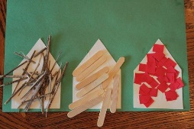  - Make a Pig mask or headband  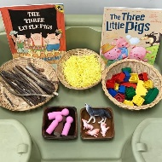  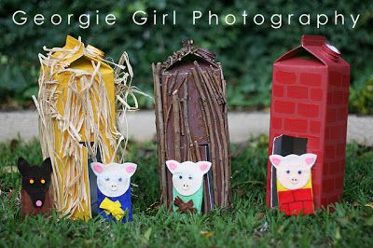  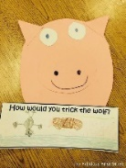  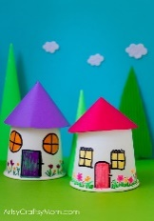
 |  | Maths
Lots of counting activities this week

Watch Numberblocks Season 2 episode 6 Just Add One
https://www.youtube.com/watch?v=IZsCuYJ-JJ0
Use bricks to create a staircase. Start with one, can your child add make another tower with one more brick to make 2 all the way to 10. Talk about one each tower being bigger than the last. Mix them up. Can they order them again finding the tower that has one more than the last one? Talk about each tower being bigger than the last. - Ask your child to close their eyes. Take one tower away from the sequence. Can your child tell you which number is missing? How do they know? E.g. (4 is one more than 3).
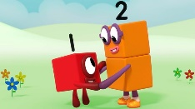
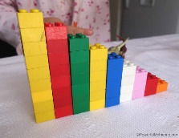

Choose a few activities this week to complete from the list below:
- There were 3 little pigs. Practise writing the number 3 in different sensory products such as sand, rice, shaving foam. Make sets of 3 things e.g. 3 spoons, 3 cups, 3 sticks.
- Make a hanging garland with pasta or beads or anything you can thread from 1 to 10 or make 10 strips of card and stick flowers or stickers on to represent the numbers from 1 to 10. Arrange them in the correct order.
- Using a dice roll the dice. Can they identify the number without counting the spots? Can they tell you what one more and one less would be? Find that number on the hanging garland or a number line.
- Can they draw that number of spots on a piece of paper and write the correct numeral next to it?
- Number some pegs from 1 to 10 and put them in order. Take one away. Can they work out which one has been taken away? Can they explain how they know?
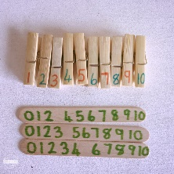
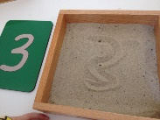

Physical Development |  | Music
Fine motor:  Practise cutting. Look at the little picture here.  Find a large paintbrush. Paint large shapes with water. Really stretch up tall. Make circles and zig zags.  Outdoors  Give your child some outdoor chalk to draw lines from one place to another. Encourage them to draw lines they could follow with their bike or scooter. Encourage them to draw arrows to show which way they could travel.  Or make a track for your large cars like the one in the photo.  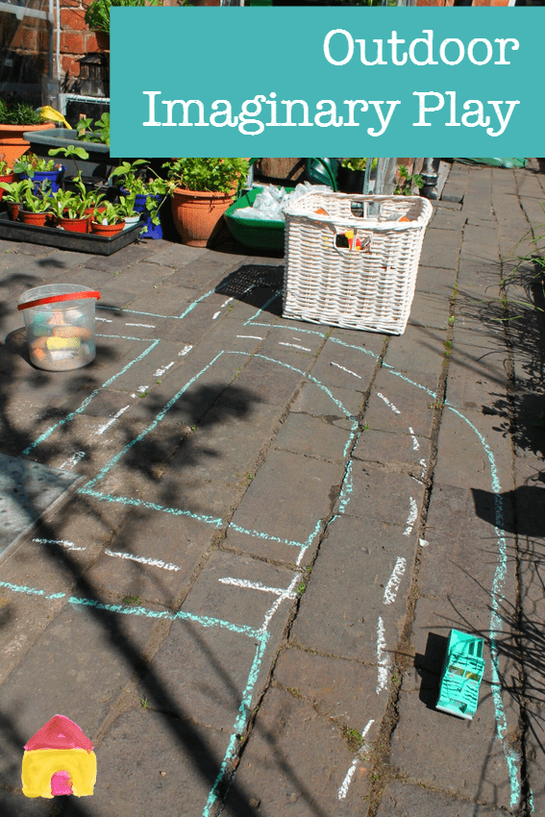 | 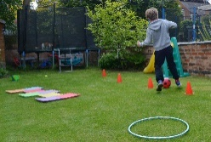  Gross Motor:  Obstacle course:  Create an obstacle course in your garden or inside if you don’t have an outdoor space. What could you use to create a tunnel? What could you balance on? With an adult make sure it is safe before you complete the course!  Can you complete the obstacle course holding something with one hand or balancing something on your head – hold a spoon with a ball on it or put a soft toy on your head.  If your obstacle course is outside add water to it! Place a bucket or bowl of water at the beginning of the course and a jug at the end of the course. Fill up a small cup and complete the course holding the cup of water. Pour the water you still have in your cup into the jug at the end of the course. How many times does it take you to fill up the jug? | - Learn the Three Little Pigs rap. You could wear some cool sunglasses to rap and make a video to share. (See attachement for larger print)  