Reception Home Learning – Week beg 8.6.2020 Focus: Under the sea
Literacy |  | Topic
Create a fact file about a creature of your choice that lives in the sea  e.g. A fish can swim. A fish is little. A fish has two eyes and a fin. Can you draw a picture of that creature? Can you include some of our common exception words within your sentences?  Practise reading and spelling the following tricky words: I, no, go, to the, into, he, she, we, be, me, you, all, are, her, my, was, they. Write an interesting sentence using at least one of them e.g.  I went to the park.  We are going to the shop.  Can you write a list of creatures or things that live in the sea?  Read the words and sentences below. Can you underline the digraphs, trigraphs, common exception words and circle the punctuation?  Keep practicing your phoneme flashcards, can you make some words with them? What is the longest word you can make?  Keep practice reading and writing your common exception words.  Watch the animated story of the ‘Snail and the Whale’ . Follow along with your book if you have a copy. Why not act out your favourite part.  https://www.bbc.co.uk/iplayer/episode/m000cslw/the-snail-and-the-whale  With an adult, look for a poem about the sea on the internet or in your books at home. Have a go at writing an acrostic poem about the ocean. This is an acrostic poem “ocean” example. Each line starts with the letter in the word “ocean”. Remember spelling doesn’t need to be perfect, just your best phonetically plausible effort! You could use any word linked to under the sea?  Octopus dance  Colourful coral  Eels wriggle  Angelfish glide  Nets capture  There are lots of fish under the sea. Can you think of 3 other words that end with “sh”? |  | 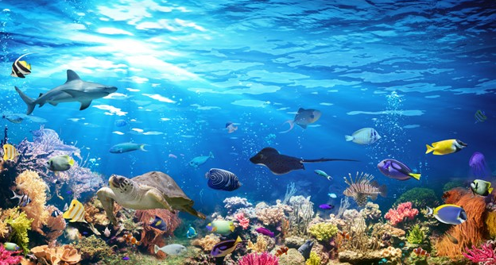  Have a look at this under the sea setting. Make a list of all of the things you can see. Choose two of them and write a sentence for each using the connective “and” eg. The shark is big and can swim fast.  Follow this link https://explore.org/livecams/under-the-water/pacific-aquarium-tropical-reef-camera to watch a live tropical reef in California. Pretend to put your under the sea goggles on and see how many different sea creatures you can spot. Choose one of them to sketch and label.  How do Humans Affect the Sea?  Is your child aware of all of the ways that humans affect the sea and the living things within it? Talk about and investigate the impact that human beings have on the sea. Think about fishing, transport and pollution.  The Oceans of the World  Using an atlas or the web work with your child to identify the world’s oceans. Can they find out what animals live in each ocean?  The National Marine Aquarium has released a number of videos on their YouTube channel, including live feeds of their sharks, turtles, rock pools, clownfish and octopus feeding. Every Saturday they are also releasing a 7-minute meditation, as a live-stream from in front of one of their tanks. The videos can be accessed here: National Marine Aquarium YouTube  Talk to a grown up about how to stay safe around water.  Find out 3 facts about a creature that lives under the sea.  Have a look around your home and find 2 things that you think will float and 2 things that you think will sink. Ask a grown up to help you test if you are right.  Some animals that live under the sea have fins to help them move around. Other animals have legs to move with. Can you think of some sea creatures that have fins and some that have legs?
Maths
This week we are exploring Odds and Evens.

We want your child to begin to understand that quantities which can be shared into 2 equal groups with no items left over are evens. Those which have one left over when they are shared into 2 equal are odd.
Encourage your child to notice this structure by building pair-wise patterns. They can explore odd and even by grouping quantities into pairs.

- Encourage your child to investigate whether small quantities are odd and even by sharing into 2 groups or by making pairs. Prompt them to recognise that some numbers can be halved or grouped into pairs and some will have one left over.

- Ask your child to build pair-wise patterns on a 10 frame and sort them into those which have 2 equal groups ( even numbers) and those which have 2 unequal groups (odd numbers). Make links to the earlier work on doubles and halves- which 10 frame patterns show doubles and halves and which do not?

- Provide pots of items containing from 1 to 10. Ask the children to count the items in each pot and decide if there is an odd or an even quantity. How could they check? Your child could make some odd and even sets of their own.
- Now ask your child to collect 1 more item and add it to their set. How many do you have now? Do you still have an even number of cubes? What has happened to your set? What is the largest odd number you can make in your set? How can you check it is odd?
- Provide 2 teddies and plates and a selection of items for halving. Ask your child to explore which quantities will halve exactly into 2 equal groups and which will have one left over.
If you have 6 , can you give both teddies the same?
What about if you start with 5?
Is this an even number or an odd number?
How do you know?
Encourage your child to draw pictures to record their findings.

- This time keep 12 items to share each time but vary the number of teddies and plates. Ask your child to explore sharing the 12 items into equal groups so that each teddy gets the same.
If there are 2 teddies will they each get the same?
How many are in each group?
Are there any items left over?
What about 3 teddies? 4 teddies? 5 teddies? 6 teddies?

- Go for a walk with your child to look at house numbers on a nearby street. What do you notice? You could make your own model houses and line them up in order on the odd and even sides of the street.

Other resources
Six dinner Sid- Inga Moore
Numberblocks series 2 episodes 11 odds and evens

Daily activities on – www. whiterose/home learning

Physical Development |  | Expressive Arts and Design
Gross Motor:  Here are a few activities to help-  (we use these in school)  https://family.gonoodle.com/activities/agility  https://family.gonoodle.com/channels/zumba-kids  https://family.gonoodle.com/activities/lets-unwind  https://family.gonoodle.com/activities/from-mindless-to-mindful  https://family.gonoodle.com/activities/melting  https://family.gonoodle.com/activities/rainbow-breath  What can your body do? Balance on one leg? Touch your nose with your tongue? Look at the body challenge cards and see how many you can do. Ask your family to join in and make your own body challenge cards.  https://www.stem.org.uk/system/files/elibrary-resources/legacy_files_migrated/29982-wellcometrust_primary_bb_bodychallengecards.pdf | Fine Motor:  Use a pencil to draw around your hands and feet on pieces of cardboard. Can you control your pencil in and out of each finger and between your toes?  Use scissors to cut out your hand and foot prints. Draw on your finger and toe nails. Borrow some nail varnish off Mummy, and under supervision, paint your cardboard finger and toe nails. Make sure you use the brush carefully and control the strokes to make it neat and tidy. Perhaps Mummy might let you paint her real finger and toe nails?  Practise wrapping wool or string around an empty toilet roll or kitchen roll tube. Can you make it as tight and neat with your other hand or is one hand stronger than the other?  Practise being independent and cutting your own food with a knife at meal times.  Can you make your own sandwich and control a knife to spread butter on the bread? Can you cut your sandwich in half?  Cut the front of a cereal packet. How many pegs can you attach around the edge in 1 minute? Can you beat your score a second time? Can you peg with the opposite hand and beat your score? | Draw or paint a picture of a sea creature or sea scene.  Create your own picture of rainbow fish (from the story book)  Use an old shoe box and items from the recycling to make your own aquarium like this one:  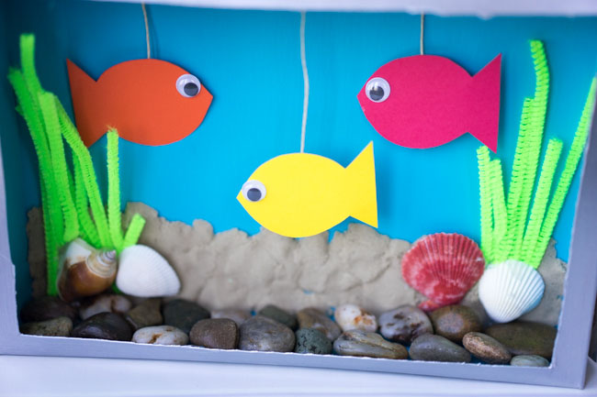  Make your own under the sea top trumps cards. You could simply divide a piece of A4 paper into 4 sections (or more if you want it to be more of a challenge!). Choose 4 sea creatures (for example: octopus, starfish, sea turtle, shark) Then choose 3 categories (the same for each!) Choose from: Strength, speed, danger, size.  Rate your sea creatures out of 10 for each category you choose. Make sure you include an image of your sea creature. An example card is below. Play your top trumps game with your family.  Shark  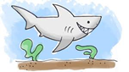  Size: 8  Strength: 9  Danger: 10  Imagine you have found a magic shell. You can have one wish. Draw a picture to show us what your wish would be.

Regular word reading | Sentence Reading
fish  swim  rock  starfish | The fish were swimming over the rocks.
rock pool  shark  clown fish  crab | The starfish was in the rock pool stuck to a rock.
urchin  dogfish  shipwreck  coast | What animal has lots of legs?
pufferfish  eel  shellfish  boat | The little fish can swim in and out of the rocks.

