Reception Home Learning – 15.06.2020 ‘The Snail and the Whale’ by Julia Donaldson
We have provided some guidelines for your child’s home learning. We appreciate that these are stressful times for all involved. Where possible, please encourage your child to complete the learning outlined below. We appreciate that in some cases this may not be possible. Please try your best and don’t get too worried about it. Most importantly stay safe and enjoy this time with your family.
Literacy |  | Topic
Writing  - Listen to the story ‘The Snail and the Whale’ by Julia Donaldson. https://www.youtube.com/watch?v=x887mPO9X9c  - How do you feel about the story? Does it have happy and sad parts to it? What is your favourite part of the story? And your least favourite part of the story?  - Describe the two main characters the snail and the whale. What do they look like (small, big)? How do they act and are they kind or mean?  - Create a postcard of a place you would like to go to if you were on the whale’s tail.  - Write a list of words that rhyme with snail. Underline the part of the word that makes them rhyme.  - Continue writing a diary entry, each day include a sentence about the weather, how you feel and something you have enjoyed. Include what day it is.  Reading  - Continue to read books from the Oxford owl website.  - When out on your daily exercise can you spot any signs and have a go at reading them.  Phonics  - Continue practicing your phonemes, digraphs & trigraphs and common exception words.  - Read the words and sentences below. Can you spot the digraphs, trigraphs and punctuation?  - Use the phonics play website to play a range of games (phase 2,3, and 4 games)  https://new.phonicsplay.co.uk/ |  | The story this week is: The Snail and the Whale  If you do not have the story, you could watch it on https://www.youtube.com/watch?v=hheolVGZVvs  Suggested activities:  - The snail and the whale have a great journey together, where would you like to go? Maybe you could draw a picture of a place you would like to visit; this could be a real or imaginary place.  - This story has lots of rhyming words within it, can you find any? You could have a go at the ‘Cake Bake’ rhyming activity here https://new.phonicsplay.co.uk/resources/phase/1 (Phonics Play username: march20, password: home). You could look for a selection of rhyming objects from around your home and ask your child to match rhyming ones together e.g. toy cat, hat, plug, mug, sock, clock. Toy animals usually make a good rhyming partner.  - You could find out more about where a whale and a snail live. How are they different? How are they similar?  - Science experiment  Can you help make Marisa the mermaids tail waterproof?  Explore different materials by placing them in a bowl of water. Which ones make the water run off and which  ones soak the water up?  A snail is in the “Mollusk” family and a whale is in the “mammal” family. Research these groups on the internet with an adult. What other animals are in the mollusk and mammal families?
Maths
This week we are looking at Topic maths using https://whiterosemaths.com/homelearning/early-years/ Summer term- week 6 (1.06.20) The Snail and the Whale.

- Complex patterns – making spirals. The snail has a very impressive shell with a spiral pattern on it. Practise drawing and recognising spirals.
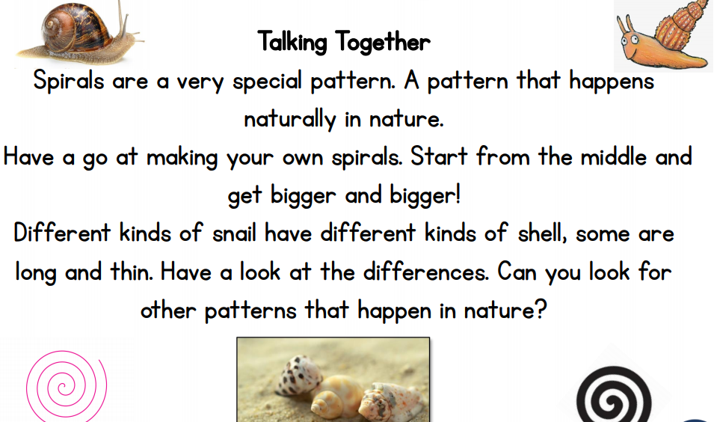

- Make your own spiral dangler.
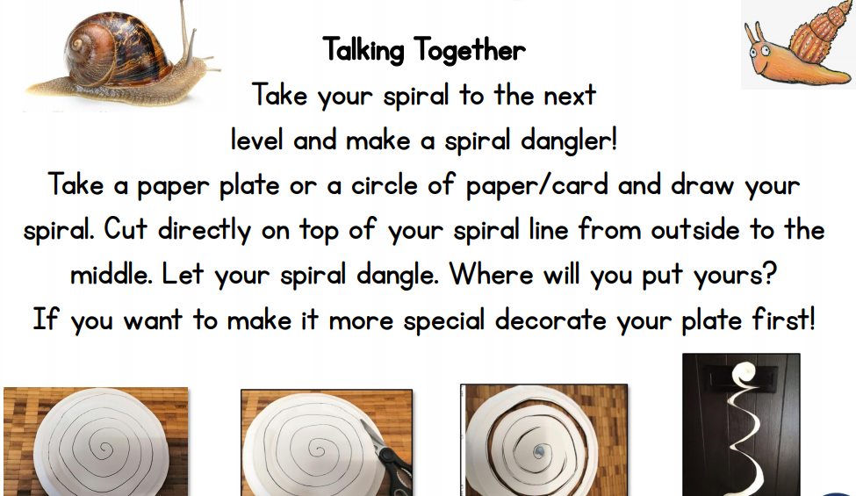

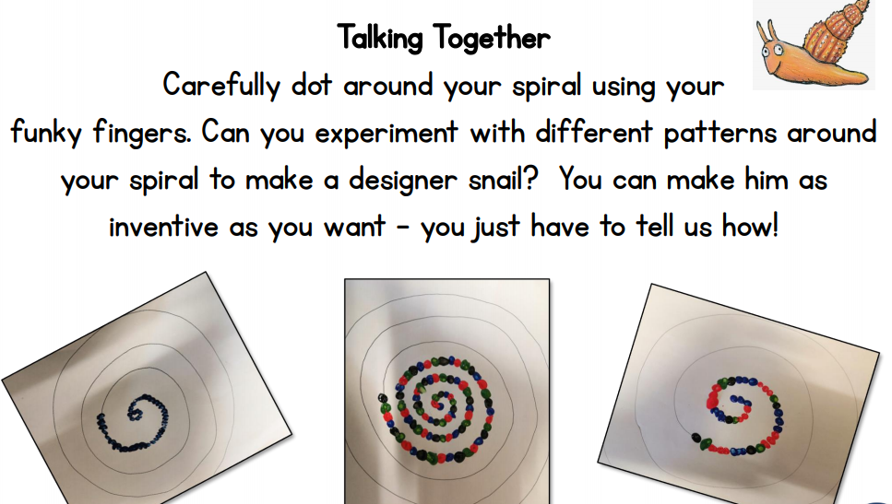

- Adding snails on whales and rocks and ?
See if you can work on your addition skills and tell us a first, then now story!
(see day 2 for further activities)

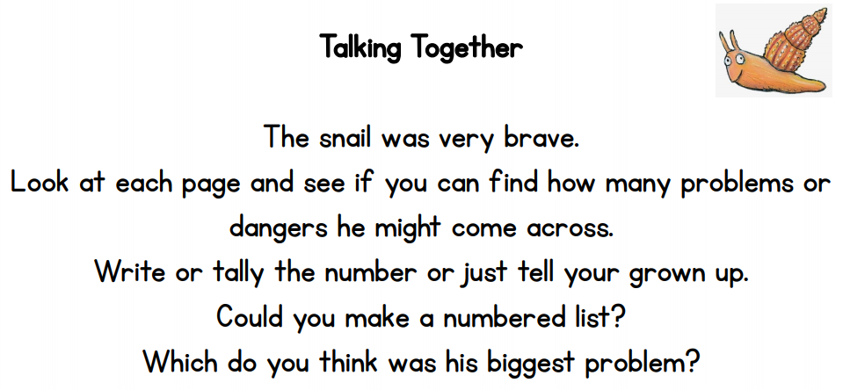

- (Day 4 activities) Snail Journey- The snail certainly has an adventurous journey! He is on another journey. Can you see where he goes, who he meets and if it is an odd or even number? Look at the different pictures.
- (Day 5 activities) Crawling up the wall – The snail does a lot of crawling. Is the snail higher up my wall than the worm or lower? Look at the different pictures.
- (Day 5 activities) Snail Trail- Snail leave a silvery trail where they have been. If you were a snail where would your trail have been today?
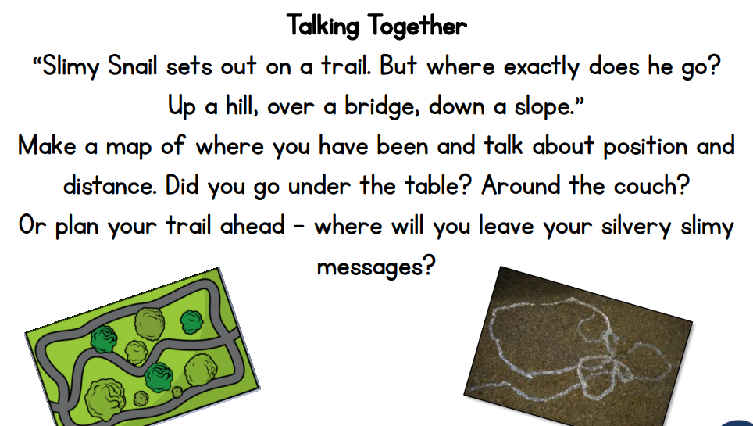

Physical Development |  | Expressive Arts and Design
Gross Motor:  Daily Joe Wicks work outs on Joe Wicks TV via youtube. Every day at 9am  Go Noodle  Pretend to be different sea creatures by moving in different ways can a family member guess what sea creature you are?  Every day carry out self-help tasks e.g. dressing themselves, matching pairs of socks when doing the laundry, pegging up laundry, laying the table for meals, sorting and tidying toys etc.  Try some Cosmic kids yoga:  https://www.cosmickids.com/category/watch/ | Fine Motor:  Use your letter formation sheet to practice writing your letters, this can be on paper or by drawing in sand, glitter or rice.  Draw some characters from the story of the snail and the whale cut them out and make them into puppets by sticking them on to lollipop sticks or straws.  Draw spirals on paper and practise your scissor control by cutting out the spirals carefully following the curvy line!  Help peg out the washing. Opening and closing the pegs is great for developing your fine motor control. | Create a picture of a place you would like to go to. You can use paints, pens, pencils or collage.  Act out the story of the snail and the whale using the puppets you made.  Can you make your own snail using playdough, clay or salt dough?  Can you create a spiral and colour it in?  Draw spirals using your fingertips in a little bit of paint and then press paper on top to print your pattern. When the paint has dried you could draw on a snail body, head and tentacles.  You could draw spirals using your fingertips or a stick in a variety of different sensory materials e.g. sand, mud, gloop (mix cornflour and water together to create an amazing solid/liquid texture!) or flour etc. You could create spirals outside using water and a brush or colourful spirals using chalk on the ground.  You could make a silvery snail trail using glittery glue on a piece of paper.  Make a paper plate whale:  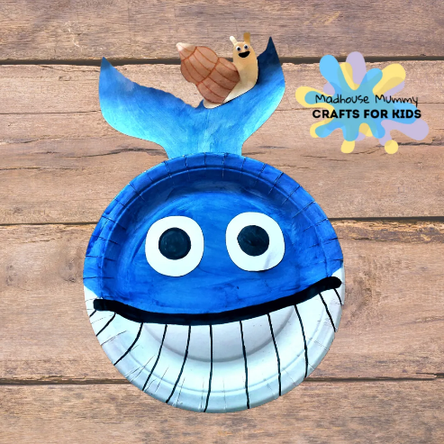  Have a go at these easy paper spiral snails:  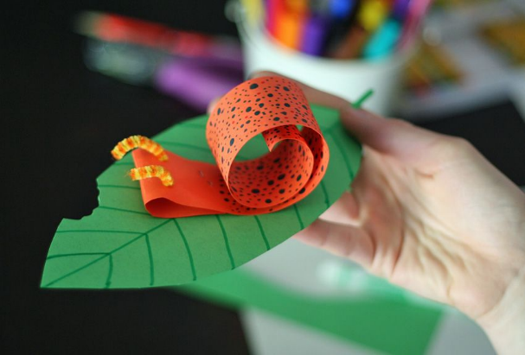  In the garden: go on a bug hunt, nature art (create pictures using things found outside), potion making (create ‘magic’ potions using leaves, grass, daisies etc. and water), make an obstacle course.

Every day:
- Share how you are feeling, what day of the week it is and talk about what you are doing that day
- Practise counting to 10 and then 20. Count objects around your home to practise your 1:1 counting and accuracy
- Read through your tricky words
- Daily reading (shared or independent)

Phonics
Regular word reading | Sentence reading
snail  rock  soot  thunderstorm | The snail said, ‘I feel so small’.
foot  slither  starlit  sail | Come sail with me.
bright  sniff  trail  crash | ‘I must not fail’ said the small snail.
stars  humpback  splash  sand | He sang a song to the snail.

