We have provided some guidelines for your child’s home learning. We appreciate that these are stressful times for all involved. Where possible, please encourage your child to complete the learning outlined below. We appreciate that in some cases this may not be possible. Please try your best and don’t get too worried about it. Most importantly stay safe and enjoy this time with your family.
Literacy |  | Topic: Animals - Rainforest
Writing  - Read or ask a family member to read you the story of ‘Ronald the rhino’ on the Twinkl website.  - Talk about the story and how all the animals were special in different ways. How are you special?  - Write about one of your friends and why they are special? You could make this into a card for them.  - Can you write a list of words about rainforests (your own word bank)?  - Look at the jungle animals what am I? PowerPoint on Twinkl.  - Can you write your own clues about some animals from the rainforest such as a gibbon, tiger, snake or parrot?  - Create your own A-Z of rainforest animals.  - Continue writing a diary entry, each day include a sentence about the weather, how you feel and something you have enjoyed. Include what day it is.  Reading  - Continue to read books from the Oxford owl website.  Phonics  - Continue practicing your phonemes, digraphs & trigraphs and common exception words.  - Read the words and sentences below. Can you spot the digraphs, trigraphs and punctuation?  - Practise spelling phase 2 & 3 tricky words (on the bookmarks in your child’s phonics pack)  - Use the phonics play website to play a range of games (phase 2,3, and 4 games)  https://new.phonicsplay.co.uk/ |  | - Create a fact file about an animal that lives in the rainforest.  What does it look like? What does it eat? Who does it live with? Does it live in a tree, river or on land? How big is it?  - Investigate which countries have rainforests, have a look on a world map where are those countries? What is the weather like in a rainforest?  - Watch the video clip on BBC about noisy rainforest animals https://www.bbc.co.uk/programmes/p011mwwt  - Which animal makes the most noise in the rainforest? Ask your child to record what sounds they can hear and to predict what animals the sounds have come from. Can your child replicate these sounds using objects from around the home?  - Design and create your own rainforest animal. Can it fly? Does it have legs? Can it climb? What colour is it? Can you name and label your creature?  - Some of the most common rainforest fruits are those with which people are quite familiar such as bananas, oranges, pineapple, papaya, tangerines, coconut, mangoes and lemons. The rainforest also gives us avocadoes, figs, dates, limes, grapefruit and passion fruit, among many others. If you have any of these at home, have a go at making your own rainforest fruit salad in a bowl or fruit kebabs.
Maths
This week we are continuing with Measurement

Create opportunities for comparing length and height, allowing your child to talk through their play e.g. They may compare the height of their towers or sandcastles, or see who has the longest scarf, or who can thread the longest string of beads.

- Ask your child to compare heights of people in their house. Can they find a person who is taller than them? Shorter than Them? About the same size as them? Can they measure their heights using cubes or blocks?

- Using construction – challenge your child to build towers the same height as themselves. How tall is the tallest tower they can build? Can they build a short tower?
- Can they build beds for Daddy Bear, Mummy Bear and Baby Bear?
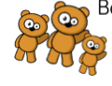
- Provide materials for your child to construct bridges for their cars. They will need to consider how long, how wide and how high they want their bridges to be and select which blocks to use.
Who can push their car the furthest? How will they measure this? 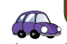

- Have a variety of pieces of ribbon, lace, string. Ask your child to make direct comparisons with a given length (e.g. A piece of ribbon taped to the table) and sort the lengths into the same as, longer than and shorter than the given length. They could also line the lengths up in order from longest to shortest.
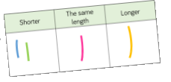
- Use playdough and ask your child to use mathematical language relating to length as they play.
Ask: Can you make a long snake? A short snake? A thick snake? A thin snake? Show me the longest snake you can make. How many blocks long is your snake?

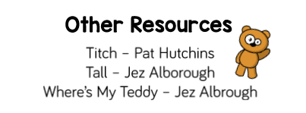

Physical Development |  | Expressive Arts and Design
Gross Motor:  Daily Joe Wicks work outs on Joe Wicks TV via YouTube. Every day at 9am.  Go Noodle  Try this “Jungle” game:  Children are running through the jungle and are given a series of commands to follow as they escape different animals:  • Jumping over logs  • Ducking under branches  • High knees  • Running from a given animal  • Tiptoeing past a given animal  • Swinging through the jungle like Tarzan | Fine Motor:  Continue to increase the strength in your hands, wrists and fingers by playing with playdough. Squash, squeeze, roll, splat!  Using pegs or tweezers to select small objects and transfer from one place to another without dropping them.  Paint outside using brushes and water. Practise circular movements, long and short up and down & side to side strokes with the brush. | Create your own picture based on the painting’ Tiger in a tropical storm’ by Henri Rousseau.  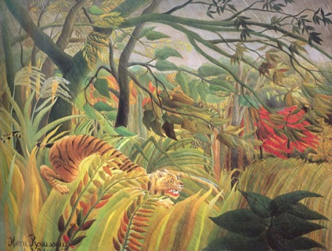  Can your child create their own replica forest floor? Task them with collecting materials from the garden or during your daily exercise.  Try following a “how to draw a.......” tutorial on you tube for a rainforest animal of your child’s choice. This activity is also good for following instructions and maintaining focus on an activity.  Here is a link for how to draw a parrot, but there are literally hundreds on there! https://www.youtube.com/watch?v=ukzU1Yu_DTM  Make your own rain stick using an empty toilet roll tube, baking paper, tape and rice.  Cut out a circle of baking paper and secure it over one of the open ends of the tube using Sellotape. Be sure to use plenty to ensure the rice can’t escape! Pour in some rice and then seal the other end of the tube in the same way as the first one. You now have your own rainforest stick to make some jungle music!  Make a rainforest animal mask. There are lots of printable ones on Twinkl, or you could draw your own!  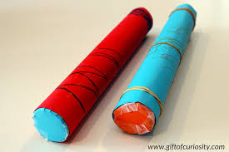

Every day:
- Share how you are feeling, what day of the week it is and talk about what you are doing that day
- Practise counting to 10 and then 20. Count objects around your home to practise your 1:1 counting and accuracy
- Read through your tricky words
- Daily reading (shared or independent)

Phonics
Regular word reading | Sentence reading
sloth  green  humid  tropical | I am big and have a long horn. What am I?
tree  hippo  damp  vast | I have a trunk and tusks.  What am I?
plant  rich soil  harvest  bright | I am yellow with black spots. What am I?
fresh  sharp  smooth  screech | I live and sleep in the tress. I like to sleep a lot.  What am I?

