Reception Home Learning – Week 11 - 22.06.2020 ’Sports’
We have provided some guidelines for your child’s home learning. We appreciate that these are stressful times for all involved. Where possible, please encourage your child to complete the learning outlined below. We appreciate that in some cases this may not be possible. Please try your best and don’t get too worried about it. Most importantly stay safe and enjoy this time with your family.
Literacy |  | Topic
Writing  - Write a list of all the sports you know.  - Write about your favourite sport. Why do you like it?  - Draw a picture of you doing your favourite sport and label it.  - Look at this busy stadium scene. Write a list of all the things you can see. Choose 3 things and write 3 simple sentences about the picture. E.g. The crowd are cheering. The flames are hot. I can see flags.  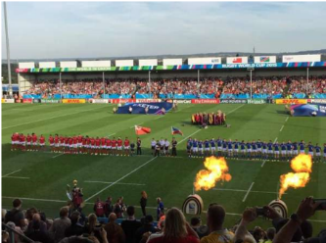  - Continue writing a diary entry, each day include a sentence about the weather, how you feel and something you have enjoyed. Include what day it is.  Reading  - Continue to read books from the Oxford owl website.  Phonics  - Continue practicing your phonemes, digraphs & trigraphs and common exception words.  - Practise spelling the following tricky words: I, no, go, to, the, into, he, she, we, me  - Read the words and sentences below. Can you spot the digraphs, trigraphs and punctuation?  - Use the phonics play website to play a range of games (phase 2,3, and 4 games)  https://new.phonicsplay.co.uk/ |  | - Draw your favourite famous sports star and write why he/she is your favourite.  - Can you invent your own game or sport using objects from home?  - Talk to a member of your family about how you feel when you’ve taken part in a sports activity. Why is it good to take part in it?  - Design a gold medal and present it to somebody deserving within the household. Why have you chosen this person?  - Design a poster all about teamwork. This could be linked to your family and how you all must work together as a team.  - What can your body do? Balance on one leg? Touch your nose with your tongue? Look at the body challenge cards (see link below) and see how many you can do. Ask your family to join in and make your own body challenge cards.  https://www.stem.org.uk/system/files/elibrary-resources/legacy_files_migrated/29982-wellcometrust_primary_bb_bodychallengecards.pdf  Can you create a new Olympic game? What are the rules of the game? Have a look at some of the existing Olympic sports to give you some ideas. https://www.olympic.org/sports  - Ask your child which parts of their body they use to run? To do a handstand? Draw the parts of the body and for a challenge ask them to label them using their phonic knowledge.
Maths
This week we are looking at length, height and distance (measurement).

- Begin the week by using language to describe length and height e.g. The tree is tall, the pencil is short.
When making direct comparisons, they may initially say something is big or bigger than something else. Begin to encourage them to use more specific mathematical vocabulary relating to length - longer, shorter. Height – taller, shorter. Breadth - wider, narrower.

- Next begin to move onto making indirect comparisons using identical objects such as blocks or cubes to measure each item, e.g. the table is 5 bricks long, the chair is 8 blocks high.

- Begin to compare distances to see which is further or nearer.
Daily distance challenge- competition between family members. Record your results.
1. How far can you jump? From the same starting position make 5 jumps. Who
has jumped the furthest? How do you know who has won? How could you measure? Try different numbers of jumps.
2. Who has the longest jump? Have a go at the long jump with someone from your household. Measure the length of each jump using a measuring tape and record the lengths (or use objects as markers if you don’t have a measuring tape). Who’s jump was the longest? Who had the shortest jump? Compare with yesterday’s results.
3. How far can you throw? Using beanbags or small balls. Mark on the ground with chalk. Who has thrown the ball the furthest?
4. How far can you roll? Using different size balls. Mark on the ground with chalk. Who has rolled the ball the furthest or shortest distance?
5. How high or how far can you hit the ball? Using a bat and ball. How could you measure how high?

- Play Skittles
If you have a set of skittles, you’re ready to go, if not you can make your own skittles using plastic bottles. Take a plastic bottle and partly fill with soil/ stones or sand to weigh it down. If you don’t have plastic bottles available, you could use tin cans for an alternative version. Ask your child to count how many skittles there are to begin with. Roll the ball at the skittles and ask your child to count how many they have knocked over. Can they work out how many are left?
- CHALLENGE: You could write this out as a subtraction number sentence e.g. if you start with 5 skittles and knock over 2 your child would write
5 - 2. Ask them to count how many are left to find the answer 5 - 2 = 3

www.whiterose/daily home learning

Physical Development |  | Expressive Arts and Design
Gross Motor:  Daily Joe Wicks work outs on Joe Wicks TV via youtube. Every day at 9am  Go Noodle  Create your own family Olympics.  Design your own obstacle course. Get your whole family to have a go at taking part. You could make some medals from card and tin foil and have an award ceremony? | Fine Motor:  Create a playdough home tool kit similar to the one below:  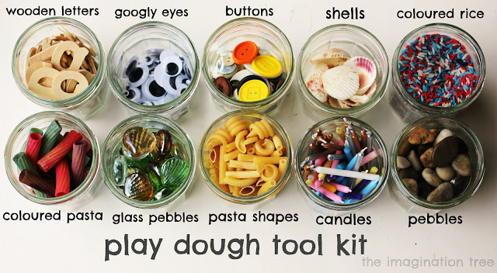  Use the objects with playdough to practise your fine motor skills. You can press them into the dough, create things like funny creatures, make patterns or holes etc  If you don’t have your own play dough at home, this simple microwave recipe below is easy to make:  1 cup plain flour  1 tbsp. oil  1 cup water  ½ cup salt  2 tbsp. cream of tartar  Food colouring  - Pour all dry ingredients, flour, salt and cream of tartar together into a microwave heat proof container, casserole dish or bowl.  - Add water and oil to dry ingredients. Add food colouring until desired colour is achieved.  - Mix together using a whisk to remove lumps and blend the ingredients well.  - Cover and place in the microwave for 2 minutes on high.  - Remove from microwave and stir with a wooden spoon.  - Place in the microwave for 1 min, remove and stir to combine. Cook for a further minute if the play dough is still runny.  - Then turn out onto a clean surface and knead into a smooth ball. Be careful the play dough will be very hot! Use a little bit of flour if the play dough is sticky.  - Allow the play dough to cool before playing with it.  - Store in a plastic zip lock bag or air tight container. | Create your own flag, bunting or medal  Design your very own mascot for the next Olympics. First of all, visit the Olympic Mascot Official list (see link below) and look at the past mascots. What makes a good mascot? Why should your new design be made into the new mascot?  https://www.olympic.org/mascots  Ask your child to design their very own team kit. They should consider the flag of the country that they would represent and how to incorporate these colours into the design. They could draw the design with a pencil or use a computer program to do this.  Create your own Junk Modelled Football Pitch  ● Using a lid of a shoe box or similar container, help your child to cut out two holes on each end as the goals. If you have green  card or paper, stick this in the base, if not you can colour in plain paper using a crayon. Draw out the marking on the pitch  using crayons or felt tips. When finished, stand your football pitch on a box on the table. Using something ball-like (e.g. a  sweet), take turns aiming at your partner’s goal whilst the other tries to save the goal. If you score you get to eat the sweet!  CHALLENGE: Write instructions to play your game e.g. 1. Put the ball in. 2. Flick at the goal. 3. Eat the sweet!  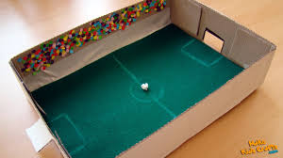

Every day:
- Share how you are feeling, what day of the week it is and talk about what you are doing that day
- Practise counting to 10 and then 20. Count objects around your home to practise your 1:1 counting and accuracy
- Read through your tricky words
- Daily reading (shared or independent)

Mindfulness activity:
Teddy bear breathing
Lie with your back on the floor and place a soft toy on your tummy. Breathe in and out slowly and deeply and try to concentrate on the way your toy rises and falls with your breathing. This is a good activity to help you feel relaxed and calm.
Phonics
Regular word reading | Reading
running  sprint  finish  start | Tom likes to play tennis.
catch  Ball  champion  goal | He can run faster than Max.
sport  referee  surf  ping pong | He hit the ball into the goal.
bobsled  snow  hill  speed | The bobsled sped down the run.

