Reception Home Learning –06.07.2020 ’Food and farming’
We have provided some guidelines for your child’s home learning. We appreciate that these are stressful times for all involved. Where possible, please encourage your child to complete the learning outlined below. We appreciate that in some cases this may not be possible. Please try your best and don’t get too worried about it. Most importantly stay safe and enjoy this time with your family.
Literacy |  | Topic
Writing  (There are several writing based activities in the topic section for you to try)  - Create rhyming strings for the following words cat, pig, dog, cow,  - Write about farm animal/s of your choice. Can you create a fact file on them? e.g. Sheep are white. Their babies are called lambs. They eat grass. They give us wool.  - Continue writing a diary entry, each day include a sentence about the weather, how you feel and something you have enjoyed. Include what day it is.  Reading  - Continue to read books from the Oxford owl website.  - Have a go at reading some of your story books with the help of your family. Can you spot any words that you know?  Phonics  - Continue practicing your phonemes, digraphs & trigraphs and common exception words.  - Read the words and sentences below. Can you spot the digraphs, trigraphs and punctuation?  - Practise spelling phase 2 & 3 tricky words (on the bookmarks in your child’s phonics pack)  - Use the phonics play website to play a range of games (phase 2,3, and 4 games)  https://new.phonicsplay.co.uk/  - Listen to the tricky word songs on YouTube (see links below). Children should ideally be revising phase 2,3 and 4 tricky words and familiarising themselves with how to recognise, read and spell them.  - https://www.youtube.com/watch?v=TvMyssfAUx0 Phase 2  - https://www.youtube.com/watch?v=R087lYrRpgY Phase 3  - https://www.youtube.com/watch?v=3NOzgR1ANc4 Phase 4 |  | - Draw a picture of some foods that farmers grow in their fields – can you label them too?  - Write a list of farm animals – Do you know the correct name for their babies? If not, research them with an adult and learn them  - Write down 3 words that rhyme with “Pig”  - Where does food come from? Can you find out where the following foods come from? Some come from animals, others don’t!  - Milk, cheese, eggs, ham, leather, tomato ketchup, bread, bacon, beef burgers, chips  - Make a fruit or meat kebab and discuss where each food comes from  - Cut some fruit in half and draw the inside  - Write or draw a recipe that includes some farm produce  - Help prepare some ingredients for a family meal  - Use ICT to research different types of farms  - Explore the food labels on supermarket packaging  - Try planting and growing some seeds in the garden. You could just try something as simple as cress? Look after your seed and monitor its growth progress  - Do a fruit and vegetable taste test with an adult? Can you correctly identify the food from its taste?  - If you go for a nice walk in the country with your family, see if you can spot any farm animals? Sheep, cows etc.  - Find out what animals live in the following places: stable, pig sty, kennel, barn, coop, pond, hutch, bee hive
Maths
This week we are continuing with Measure and concentrating in investigating Weight.

Your child will have some experience of weight through carrying heavy and light items. Encourage them to make direct comparisons using their hands to estimate which item feels the heaviest and then use a balance scale to check.
Prompt them to use the language of heavy, heavier, heaviest, light, lighter, lightest to compare items starting with items which have an obvious difference in weight.
Avoid the common misconception that bigger items are heavier by providing some small, heavier items and some large, lighter ones.

- Ask your child to be a human balance scales- place an item on each hand and ask them to tip to show which item is heavier and which is lighter. Use a balance scales to check the estimations.
- They could also hold buckets or bags in each hand and place items inside to feel which has the stronger downward pull. E.g. give your child an apple. Challenge them to find things which feel heavier and lighter than the apple and sort them into sets. Use a balance scales to check their estimation. Are all the heavier things larger than the apple? Can they find anything which is larger than the apple but is lighter?
- Ask your child to use cubes or similar objects to balance an item by placing the item on one side and adding cubes until the scales balance. They may want to count how many cubes balanced the item in question.
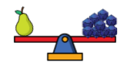

- Provide a selection of wrapped parcels of various shapes and sizes. Ask your child to compare parcels to see which are heavier and lighter than others. Can they find the heaviest parcel? Can they find the lightest? Are larger parcels always heavier?
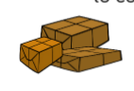

Daily activities on www.whiterose/homelearning

Physical Development |  | Expressive Arts and Design
Gross Motor:  Daily Joe Wicks work outs on Joe Wicks TV via youtube. Every day at 9am  Go Noodle  Try some of these games at home – they have been popular in school!  Video Game  • Play - walking • Pause - stop • Fast forward – jogging/running • Rewind – walking backwards • Record – walking using silly actions or faces  Traffic Lights  • Red – stop • Amber – jogging on spot • Green – jogging/running • Move lanes – changing direction  Bean game  • Runner beans – jogging on the spot • Broad beans – standing tall and walking on tiptoes • Jumping beans – jumping on the spot • Jelly beans – moving around like jelly • Kidney beans – hopping on the spot and holding on to one knee • Baked beans – crouching down and curling up very small  Also, Simon Says is great for the children to brush up on their listening and attention skills! | Fine Motor:  Continue to increase the strength in your hands, wrists and fingers by playing with playdough. Squash, squeeze, roll, splat!  Using pegs or tweezers to select small objects and transfer from one place to another without dropping them.  Paint outside using brushes and water. Practise circular movements, long and short up and down & side to side strokes with the brush. | Try some of these simple farm craft ideas at home:  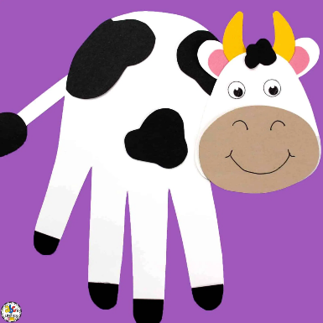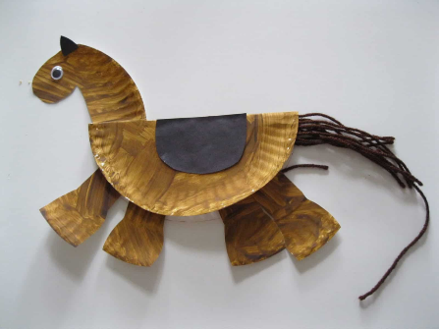  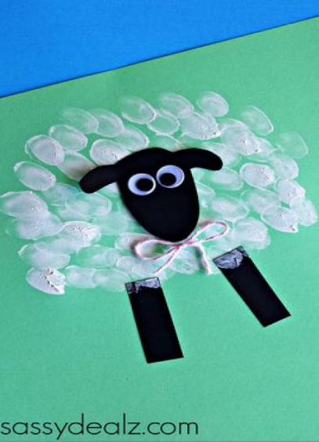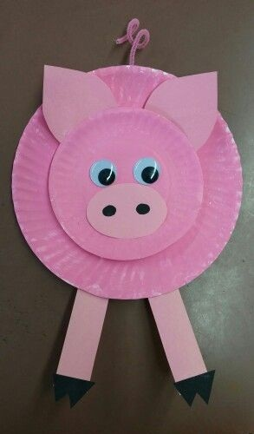  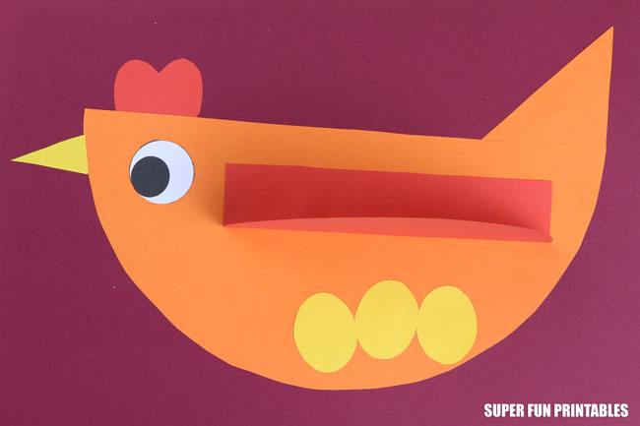

Every day:
- Share how you are feeling, what day of the week it is and talk about what you are doing that day
- Practise counting to 10 and then 20. Count objects around your home to practise your 1:1 counting and accuracy
- Read through your tricky words
- Daily reading (shared or independent)

Phonics
manure  oink  horse  beehive | The sheep are asleep on the grass.
farmer  cluck  quack  swimming | The cows are being milked by the farmer.
pondweed  wool  sheep  kennel | The chickens are pecking the corn off the paths.
barn  tractor  piglet  foal | The pigs like rolling in the mud.

