Reception Home Learning –13.7.20 ‘Our reception year’
We have provided some guidelines for your child’s home learning. We appreciate that these are stressful times for all involved. Where possible, please encourage your child to complete the learning outlined below. We appreciate that in some cases this may not be possible. Please try your best and don’t get too worried about it. Most importantly stay safe and enjoy this time with your family.
Literacy |  | Topic
Writing  Complete the attached sheet ‘My reception memories’. Think about what you have enjoyed doing at school this year, what you feel you are good at or have achieved and what you would like to get better at in year 1. We realise some children may be worried about moving into a new class, so please let us know those worries and we may be able to help ease those worries. The transition videos on the school website of all the teachers may help children know a little more about their new teacher.  Reading  - Continue to read books from the Oxford owl website.  - Have a go at reading some of your story books with the help of your family. Can you spot any words that you know?  Phonics  - Continue practicing your phonemes, digraphs & trigraphs and common exception words.  - Practise spelling phase 2 & 3 tricky words (on the bookmarks in your child’s phonics pack)  - Use the phonics play website to play a range of games (phase 2,3, and 4 games)  https://new.phonicsplay.co.uk/  - Listen to the tricky word songs on youtube (see links below). Children should ideally be revising phase 2,3 and 4 tricky words and familiarising themselves with how to recognise, read and spell them.  - https://www.youtube.com/watch?v=TvMyssfAUx0 Phase 2  - https://www.youtube.com/watch?v=R087lYrRpgY Phase 3  - https://www.youtube.com/watch?v=3NOzgR1ANc4 Phase 4 |  | Create a memory jar of your favourite times from your reception year. Write your ideas on post it notes or small pieces of paper. Fold them and put them in a jar. When the jar is full, close the lid. Over the summer you can reminisce on all the good times by opening the jar, pulling out a memory and talking about it with your family.  Make a paper chain and each time you add a link, tell your grown up about something you are excited about for year 1.
Maths
This week we will be contiuing with Measure and looking at Capacity.

Your child will already have some experience of full and empty. Encourage them to extend their understanding to show half full, nearly full and nearly empty. Prompt them to use language of tall, thin, narrow, wide and shallow.

- Provide your child with a container. Ask them to make their container full, make it empty, nearly full, nearly empty, about half full. Can they find a container which holds more than their container? Can they find one which holds less?

- Provide a selection of containers and ask your child to investigate which holds the most. They may do this by pouring directly from one container to another. They could also use a small cup to fill each container, counting how many small cup-fulls the container holds. Encourage them to record their results using their own methods of recording.
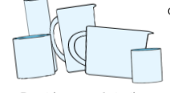
- Provide sets of similar containers in different sizes such as sets of nesting bowls or boxes. Encourage your child to compare and ordering them and seeing how many loose parts such as beads, cubes or corks they will hold.

- Provide your child with a bowl or cup and a selection of different sized spoons and ladles. Ask them to investigate how many small spoons it takes to fill their container. How many large spoons/ how many ladles? Which sized spoon was the best? Why?

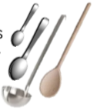

- Ask your child to estimate first before filling containers and counting to check. Larger quantities can be arranged onto 10 frames so your child can count how many 10’s the containers hold.

Other resources:
Goldilocks and the 3 bears.
There’s a hole in my bucket

Daily activities on www.whiterose/homelearning

Physical Development |  | Expressive Arts and Design
Gross Motor:  Practise throwing and catching a ball. Try it on your own, then with either a sibling or parent. Start by standing quite close together and then as you gain confidence catching the ball, take a step back. Each time the ball is dropped, take a step closer again etc  Ply the baked bean game with your family. Use the prompts:  Baked bean (curl up into a ball), broad bean (make yourself as wide as you can), stringy bean (stretch up tall and thin), jumping bean (jump up and down), chilly bean (hug yourself as if feeling the cold), beans on toast (lie flat on the floor on your back)  Practise walking whilst balancing a small object on your head. Aa small teddy or similar is perfect. Try to keep your eyes up and facing ahead. Stretch out your arms to maintain good balance.  Develop your skipping and hopping skills by practising at home. Lots of children find these concepts really tricky!  Go Noodle  Cosmic kids Yoga  Joe Wicks | Fine Motor:  Playdough – squash, squeeze, roll, splat, prod  Tweezers – pick up and move small objects with one hand using tweezers  Practise your scissor control by drawing lines on paper and cutting along them as accurately as you can.  Thread string through cooling racks or make your own weave frame using cardboard and some wool  Continue to practise good pencil grip and cursive letter formation. | Make your own reception graduation cap  Wave goodbye to reception finger paint picture  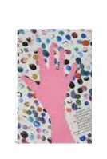  Finger paint rainbow  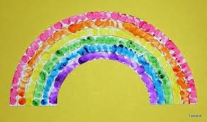  Vase natural art pictures – draw a vase on card then collect flowers or natural objects to make an arrangement  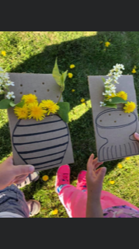

Every day:
- Share how you are feeling, what day of the week it is and talk about what you are doing that day
- Practise counting to 10 and then 20. Count objects around your home to practise your 1:1 counting and accuracy
- Read through your tricky words
- Daily reading (shared or independent)

My Reception memories
I enjoyed……… | I learnt…….
I would like to get better  at….......... in Year 1. | I’m looking forward to….
I feel ……… about year 1. | I would like to tell my new teacher……..

