Heathcoat Primary School
Computing Curriculum – Progression of Key Skills and Knowledge
Date | Review date | Subject leaders
25.6.21 | July 2022 | Elise Holman & Dana Pickford
It is our intention that pupils will be taught a curriculum:
- where they can use their computational thinking and digital literacy to understand the digital world they live in, and use it to enrich their lives in a positive way to achieve a greater depth of knowledge in how technology can benefit them in the future.
- where children are able to use their creativity to express themselves and develop their ideas through information and communication technology as they become more confident to become active participants in the digital world.
- including essential elements and concepts of computer science, programming and data handling as well as building on the children’s research, communication and presentation skills.
- Computing encourages creativity, logical thinking and problem solving and has strong cross curricular links to Literacy, Maths, Science and Design Technology. We want our children to be confident in their use of various types of computing.

We intend that all pupils:
- are confident in using code and can understand and apply the fundamental principles and concepts of computer science, including logic, algorithms and data representation.
- can analyse problems when coding, in computational terms, and have repeated practical experience of writing computer programs in order to solve such problems.
- effectively communicate and can evaluate and apply information technology, including new or unfamiliar technologies, analytically to solve problems.
- are able to connect with others responsibly and are competent, confident and creative users of information and communication technology.

HPS use the Switched On computing scheme of work, but implement a mixture of specific units from the scheme that fits the needs of each year group, alongside our own units of work that ensures all aspects of the curriculum is covered and that skills are progressively taught..

This document shows the planned progression of computing knowledge and skills across the year groups. It can also be used to differentiate work appropriately for pupils working above and below age-related expectations (particularly SEND pupils and Greater Depth pupils). Potential Greater Depth pupils are encouraged to make more consistent and confident reference to the connections between Computing and their digital world outside of school. When deepening their skills and knowledge, they are encouraged to work with greater independence and with a clear context.

Curriculum Organisation

Year / Term | Autumn 1 | Autumn 2 | Spring 1 | Spring 2 | Summer 1 | Summer 2
1 | Logging on to Laptops once the children have been set up with a log on details. Accessing online games such as Phonics Play, ICT games and Top Marks. | Logging on, internet safety via Think You Know website for age range. | Switched on computing 1.1 We are Treasure Hunters.  Celebrate Safer Internet Day. | Switched on computing 1.3 ‘We are painters’ | Switched on Computing. 1.5 ‘We are storytellers’. | Switched on Computing. 1.6 ‘We are celebrating’.
2 | Mouse skills, logging on, introduce digital literacy for using the computer with simply programmes. Dance mat typing. ICT games, feel confident logging on and accessing software on both laptops and ICT suite.  Feel confident logging on and accessing software on both laptops and ICT suite. |  | Switched on computing. We are Scratch Animators.  Celebrate Safer Internet Day. | We are building our digital literacy. Explore all elements of internet safety, including our online identity and how we use social networking and online gaming.  -thinkuknow, safer internet centre, NSPCC  For age range | Switched on computing. We are game testers
3 | To re-cap on programming that may have been missed in Year 2, Beebots, simple algorithms and using software like code city.  Creating a scratch animation linked to their topic of Ancient Egypt. | Switched On Computing; We are programmers- | Switched on computing.  We are presenters  Celebrate Safer Internet Day. | We are building our digital literacy. Explore all elements of internet safety, including our online identity and how we use social networking and online gaming.  -thinkuknow, safer internet centre, NSPCC  For age range | Switched On Computing: We are bug fixers | ‘We are code explorers’.
4 | Switched On Computing We are software developers- | Christmas Activities – create colour digital Christmas cards on Publisher to print and send home. | Celebrate Safer Internet Day.  Switched On Computing– we are toy designers | Switched On Computing– we are toy designers | Switched On Computing - we are musicians  (Both classes switch with another non core subject) | Switched On Computing - we are musicians  Both classes switch with another non core subject)
5 | Leading on from Year 4 SOC unit.  We are game developers | Switched On Computing  We are cryptographers.  Christmas Activities – create colour digital Christmas cards on Publisher to print and send home. | Celebrate Safer Internet Day.  Switched On Computing  We are advertisers | Design and create a comparison presentation - | Switched on to computing. We are bloggers. | Switched on to computing We are artists.
6 | Internet Safety. (NSPCC & UK Safer Internet Centre) Thinkuknow. For age range.  Switched on to Computing. We are App Planners  (Alternates with another non-core subject) | Internet Safety. (NSPCC & UK Safer Internet Centre) Thinkuknow. For age range.  Switched on to Computing. We are App Planners  (Alternates with another non-core subject) | Celebrate Safer Internet Day.  Coding skills - | Create an Animal fact file.  Create a digital graph based on what their favourite sport is in French. (one off)  (Alternates with another non-core subject) | Create an Animal fact file.  Create a digital graph based on what their favourite sport is in French. (one off)  (Alternates with another non-core subject) | Prepare Digital Literacy skills for high school.  Improving digital literacy through a variety of software in line with the check list provided by THS for what each pupil needs to be confident with in Computing by the time they reach Year 7.

Progression Map
Year 1 | Year 2 | Year 3 | Year 4 | Year 5 | Year 6
Code
This concept involves developing an understanding of instructions, logic and sequences.
We are Treasure Hunters.  Using Beebots and simple programable toys to make a simple code or algorithm.  - create and debug simple programs.  - use logical reasoning to predict the behaviour of simple programs.  We are painters – create simple digital pictures using Microsoft Paint.  Motion –  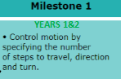  Looks –  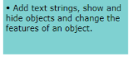  Sound –  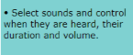  Draw –  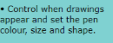  Events –  Control –  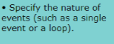  Sensing –  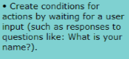  Variables & Lists – | We are Scratch Animators.  Using Paint to create a picture digitally, then move onto Scratch to learn through tutorials how to create a scene and animate a project of their choice.  We are game testers – exploring how computer games work.  Motion –  Looks –  Sound –  Draw –  Events –  Control –  Sensing –  Variables & Lists - | We are programmers- children learn to plan, create, program and run a short animation.  We are bug fixers - children will use the program ‘Scratch’ to find errors in a script and correct them.  Use logical reasoning to explain how some simple algorithms work and to detect and correct errors in algorithms and programs.  We are Code Explorers –Using a variety of coding software to explore algorithms.  Motion –  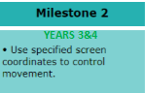  Looks –  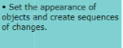  Sound –  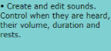  Draw -  Events –  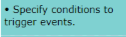  Control –  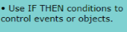  Sensing – 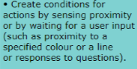  Variables & Lists -  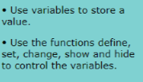 | We are software developers- Programming simple educational games using Scratch.  We are toy designers - Programming simple interactive toys that operate on a computer and are controllable.  We are musicians –  Use sequence, selection, and repetition in programs; work with variables and various forms of input and output.  Motion –  Looks –  Sound –  Draw –  Events –  Control –  Sensing –  Variables & Lists - | We are artists -  Fusing geometry and art. Pattern making using Islamic decorations. Linked to their topic.  We are game developers – Creating and making games (with a Topic focus/theme) using Scratch or hour of code software/projects.  Motion –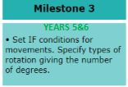  Looks -  Sound –  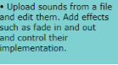  Draw –  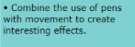  Events – 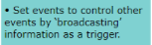  Control –  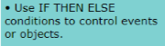  Sensing –  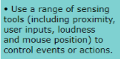  Variables & Lists –  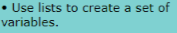 | Coding skills -  Hour of code activities to revise and reinforce coding from Year 5.  Motion –  Looks –  Sound –  Draw –  Events –  Control –  Sensing –  Variables & Lists -
Connect & Protect
This concept involves developing an understanding of how to safely connect with others.
Celebrate Safer Internet Day  Internet Safety. (NSPCC & UK Safer Internet Centre) Thinkuknow. For age range.  - identify where to go for help and support when they have concerns about content or contact on the internet or other online technologies.  GOOGLE CLASSROOM  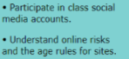 | Celebrate Safer Internet Day  Internet Safety. (NSPCC & UK Safer Internet Centre) Thinkuknow. For age range.  - identify where to go for help and support when they have concerns about content or contact on the internet or other online technologies.  GOOGLE CLASSROOM | Celebrate Safer Internet Day  Internet Safety. (NSPCC & UK Safer Internet Centre) Thinkuknow. For age range.  - identify where to go for help and support when they have concerns about content or contact on the internet or other online technologies.  GOOGLE CLASSROOM  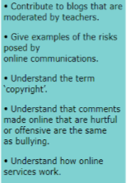 | Celebrate Safer Internet Day  Internet Safety. (NSPCC & UK Safer Internet Centre) Thinkuknow. For age range.  - identify where to go for help and support when they have concerns about content or contact on the internet or other online technologies.  GOOGLE CLASSROOM | Celebrate Safer Internet Day  We are advertisers. Creating and developing cyber safety presentation. Using ppt, scratch or publisher.  Design and create a comparison presentation - using PowerPoint to compare two planets linked with science Earth, sun and Moon topic. Linked with their Science Topic and Literacy unit of comparison texts.  GOOGLE CLASSROOM  We are bloggers.  - Be discerning in evaluating digital content.  - Use technology safely, respectfully and responsibly; recognise acceptable/unacceptable behaviour; identify a range of ways to report concerns about content and contact.  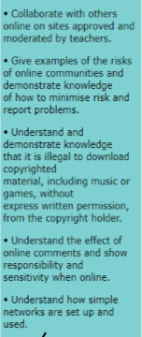 | Celebrate Safer Internet Day  Internet Safety. (NSPCC & UK Safer Internet Centre) Thinkuknow. For age range.  - identify where to go for help and support when they have concerns about content or contact on the internet or other online technologies.  GOOGLE CLASSROOM
Communicate & Collect
This concept involves using App’s to communicate one’s ideas and developing an understanding of databases and their uses to express their digital literacy.
Building digital literacy -  Logging on to Laptops once the chn have been set up with a log on details. Accessing online games such as Phonics Play, ICT games and Top Marks.  We are celebrating -  Creating a card digitally.  ‘We are storytellers’.  Produce a talking book.  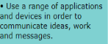  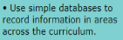 | Building digital literacy part 2-  Mouse skills, logging on, introduce digital literacy for using the computer with simply programmes. Dance mat typing. ICT games, Feel confident logging on and accessing software on both laptops and ICT suite.  Feel confident logging on and accessing software on both laptops and ICT suite. | We are presenters – children will learn to use Powerpoint and similar programs to present information and report on a topic to an audience  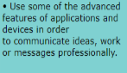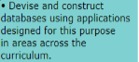 | We are toy designers – Create a digital brainstorm on Publisher.  Create a database for which toy will be the best? | We are cryptographers.  Using binary code to solve mysteries.  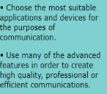 | Create a digital graph based on what their favourite sport is in French.  Create a fact file for an animal of their choice using Publisher. Focus on their habitat, facts and information, their species, their sub-division and why they are there. Link to their topic of Living things and Animals. (Science)  Prepare Digital Literacy skills for high school.  Touch typing skills, speeds and keyboard literacy – 10 Fat fingers - assess  Nitro Type, Dance Mat. (To be practiced in the first 15 minutes of each lesson.)  We are App Planners – Exploring a variety of programmes to manage an App design to solve a problem and market it.
Vocabulary
Vocab per topic
We are treasure hunters -algorithm debug instructions predict programming robot treasure  We are painters -character eBook edit illustration traditional tale  We are storytellers –  audio book copyright microphone recording sound effects talking book  We are celebrating - copyright edit greeting keyboard save type | We are game testers –  algorithm predict rules Scratch test  We are scratch animators-  Bug, debug, algorithm, code, scratch, sprite, animate. | We are programmers -algorithm animation input output program script storyboard  We are bug fixers - algorithm bugs debug instruction program scrip | We are toy designers-  Sensors, monitors, algorithm, interactive, simulation, prototype, Switches, motors, speakers, debug, input, output, pitch, scratch, switch, Computer, Ipad, lights, sounds, music, toy, Pseudocode.  We are software developers - debug input interface output program prototype repetition variable  We are musicians –  audio composition copyright digital instruments pitch sample sequencing software | We are game developers - programming sprites storyboard, code, debugging, algorithm, loop, variable  We are artists -  geometric landscape op art sprite symmetry tessellations | We are App Planners:  App, Software, Smartphone,  Mircophone, GPS, Touch sensitive screen, Camera, satnav, network, Google Earth, Format, Pitch, Interface, Audience, Flyer, Promote, platform,

