Heathcoat Primary School Curriculum Map: EYFS 2021 - 2022
Language at the Heart of the EYFS Curriculum - “Model new words every day as we talk, read and play.”
Characteristics of Effective Teaching and Learning:
Playing and Exploring  Children investigate and experience things and ‘have a go’. |  | Active Learning  Children concentrate and keep on trying if they encounter difficulties, and enjoy achievements. |  | Creating and Thinking Critically  Children have and develop their own ideas, make links, and develop strategies for doing things.
Year Reception | Autumn Term
 | 1 |  | 2
General themes, topics and texts.  NB: These themes may be adapted at various points to allow children’s interests to flow through the provision.  Topics TBC as children’s interests develop | Weeks 1-2 All about me  Families  Who lives in our house  People who are special to us  Pets  Hobbies and interests  Weeks 3-4 Creature Features – Dinosaurs  Understanding past and present  Alliteration  Weeks 5-7 Autumn and Harvest  Seasons  Changes all around us  Food and healthy eating |  | Week 1-2 Fireworks & Diwali  Night and day  Fire safety  Exploring senses  Celebrations  Exploring traditions  Weeks 3-4 Anti-Bullying and Road safety  Super Cat stories  Weeks 5-7 Christmas and Light and Dark  How do we celebrate Christmas?  The Christmas story  People who are special to them  Traditions
Key texts | 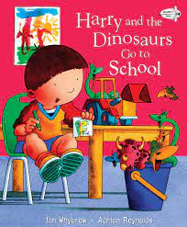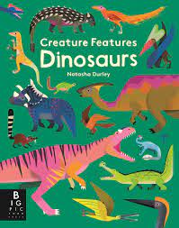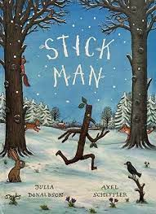 |  | 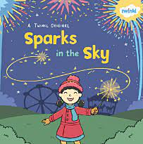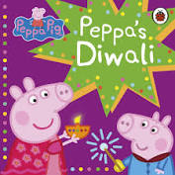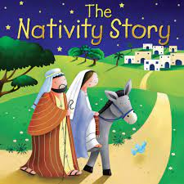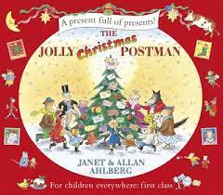
Communication and Language | We will share a wide range of different books with our children and encourage the children to understand the stories, form ideas and opinions about what they have heard. The children will be given opportunities to ask and answer questions.  We will explore a wide range of topic vocabulary which will be displayed on a vocabulary triangle next to the topic board.  The Role play areas will be changed every 2 to 3 weeks according to topics and the childrens interests. We will begin the year with a family home Role Play area. |  | We will share a wide range of different books with our children and encourage the children to understand the stories, form ideas and opinions about what they have heard. We will share a wide range of non-fiction texts and explore differences between non-fiction and fiction books. The children will be encouraged to learn new facts around the topic and share their prior knowledge with each other. The children will be given opportunities to ask and answer questions.  We will explore a wide range of topic vocabulary which will be displayed on a vocabulary triangle next to the topic board.  The Role play areas will be changed every 2 to 3 weeks according to topics and the childrens interests.
Personal, Social and Emotional Development | During this half the children will settle into the Reception classes and become familiar with their new learning environment. Through the Jigsaw puzzle piece Being me in my world they will develop :  A sense of belonging.  Recognise and manage their feelings.  Follow routines and understand class rules.  Be responsible for their behaviour and belongings.  Through the RE topic Being Special – Where do we belong? the children will share when things have happened in their lives that have made them feel special. They will also make connections with personal experiences.  This will be taught through daily experiences and regular circle times. |  | During this half the children will settle into the Reception classes and become familiar with their new learning environment. Through the Jigsaw puzzle piece Celebrating difference they will develop:  An understanding that we are all special and that we have similarities and differences.  An understanding how to have good interactions with each other and what to do in a tricky situation.  Develop friendships and being kind to each other.  Through the RE topic Why is Christmas special for Christians? the children will talk about people special to them. They will also discuss What makes their friends and family special? And how they celebrate Christmas. The children will be emmerised in The Natvity story and will act out for their families.  This will be taught through daily experiences and regular circle times.
Physical Development | The children will be provided with a wide range of daily learning opportunities that will develop both their Gross and Fine motor skills.  The children will participate in Daily Finger gym activities and Dough Disco as well as a Gross motor activity.. Gross motor skills will be explicitly taught through Real PE - every Tuesday and Thursday.  Weeks 1-3 (personal)  The Birthday Bike Surprise – Coordination & footwork.  Weeks 4-6 (personal)  Pirate Pranks – Static balance on one leg. |  | The children will be provided with a wide range of daily learning opportunities that will develop both their Gross and Fine motor skills.  The children will participate in Daily Finger gym activities and Dough Disco as well as a Gross motor activity. Gross motor skills will be explicitly taught through Real PE - every Tuesday and Thursday.  Weeks 7-9 (social)  Journey to the Blue planet – Dynamic balance to agility. Jumping and landing.  Weeks 10-12 (Social)  Monkey business – Seated static balance
Literacy | Alongside Read, Write, Inc, children will explore the topic texts above and learn repeated phrases and act out using the texts that teach model. Daily mark making opportunities will consolidate Read, write, Inc, handwriting and letter formation. |  | Alongside Read, Write, Inc, children will explore the topic texts above and learn repeated phrases and act out using the texts that teach model. Daily mark making opportunities will consolidate Read, write, Inc, handwriting and letter formation.
Mathematical Development | The children will participate in daily mathematical activities using ‘White Rose’ maths approach. We will provide the children a variety of daily opportunities to develop their understanding of number, shape, measure and spatial thinking. The children will use a variety of manipulates to continue to embed mathematical thinking and talk. We will provide opportunities to enable the children to explore, question, visualise, explain and prove their thinking. Mathematical vocabulary will be taught explicitly and displayed on the working wall.  We will use a variety of different stories to explore mathematical concepts and understanding.  Mathematical skills will be developed through different mathematical topics:  Getting to know you.  Key times of the day, class routines and positional language.  Just like me!  Match and sort, compare amounts, compare size, mass and capacity and exploring pattern.  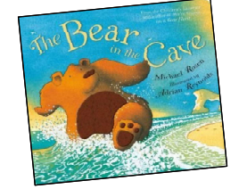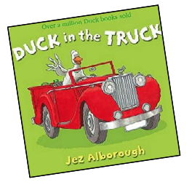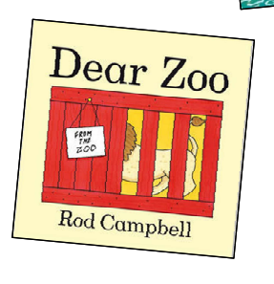 |  | The children will participate in daily mathematical activities using ‘White Rose’ maths approach. We will provide the children a variety of daily opportunities to develop their understanding of number, shape, measure and spatial thinking. The children will use a variety of manipulates to continue to embed mathematical thinking and talk. We will provide opportunities to enable the children to explore, question, visualise, explain and prove their thinking. Mathematical vocabulary will be taught explicitly and displayed on the working wall.  We will use a variety of different stories to explore mathematical concepts and understanding.  Mathematical skills will be developed through different mathematical topics:  It’s me 1,2,3!  Representing, comparing and composition of 1,2 and 3.  Circles and triangles and positional language.  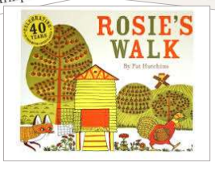  Light and Dark  Representing numbers to 5. 1 more and 1 less.  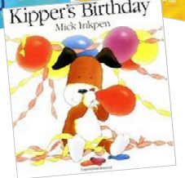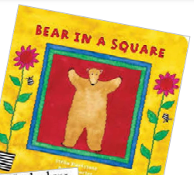  Shapes with 4 sides and time.
Understanding the World | Through the overriding geography topic, “A sense of place” by David Weatherley, the children will develop skills that will enable them to gather information from maps, simple plans/street maps, photographs and field work.  Children will have the opportunity to use and explore Google maps pro to study their local environment in the present and as it was in the past.  Children will become familiar with recognising features of their immediate and local environment and be able to plot them on a simple map.  Children will participate in “Go find it games” to use their orienteering skills to locate landmarks within the school grounds.  Children will consolidate their skills to create and read simple maps of the school grounds |  | Through the overriding geography topic, “A sense of place” by David Weatherley, the children will develop skills that will enable them to gather information from maps, simple plans/street maps, photographs and field work.  Children will have the opportunity to use and explore Google maps pro to study their local environment in the present and as it was in the past.  Children will become familiar with recognising features of their immediate and local environment and be able to plot them on a simple map.  Children will participate in “Go find it games” to use their orienteering skills to locate landmarks within the school grounds.  Children will consolidate their skills to create and read simple maps of the school grounds
Expressive Arts and Design | Music  Celebration music (KaPow)  Children will explore music from around the world through focusing on winter celebrations. They will listen to music, experiment with playing percussion instruments and develop skills to move in time to music.  Children will learn and sing short songs from memory, adding in simple dynamics. They will learn to play un-tuned instruments to play alongside and in response to different types of music. Children will develop a love for listening to and be able to comment on the descriptive features of music. Children will use their bodies to move expressively to music. Children will respond to music through expressive and appropriate movement.  Art  Children will experiment with mixing colours and create their own colour mixing palettes.  Children will explore the different types of pressure marks they can make with their pencils by taking their pencil on an exploratory walk around their page.  Throughout the topic “All about me” children will use a range of media and textiles to create observational drawings and collages of themselves.  Children will explore textures and methods of fixing and joining materials. |  | Music  Nativity  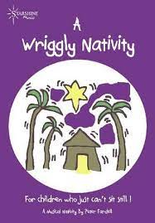  All children will sing songs and participate in a live performance in the presence of an audience.  Art  Jackson Pollock inspired art (paint)  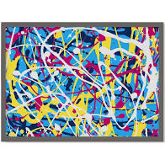  Children will study the artist, Jackson Pollock and look at the range of techniques he used to create his masterpieces. Children will then magpie his ideas to create their own Jackson Pollock inspired artwork.  Kandinsky (shapes) with a cross curricular maths focus on shape  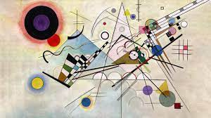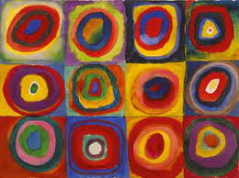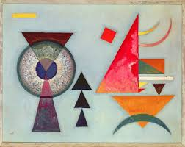  Children will study the artist, Kandinsky and explore his style of artwork to recreate their own Kandinsky inspired masterpieces.  Christmas art and decorations  Children will use a range of media and materials to create a festive centrepiece.
Performance opportunities | Children will have the opportunity to perform through independent learning – role play (using their imagination to re create roles and experiences)  They will have opportunities to perform songs throughout the term linked to their topics. |  | Children will participate in weekly musical activities and have opportunities to perform to their peers and the adults in class.  The Nativity performance will allow children to learn a range of songs and actions to perform to the whole school and their families.  They will learn to act out the Christmas story and some will become narrators and will have speaking parts.  Some children will participate in a dance sequence within the retelling of the story.
Other including trips or visitors
British values  Rule of law  Democracy  Tolerance of different cultures and religions  Mutual respect  Individual liberty | Children will learn to follow the school and class rules.  They will discuss their families and learn to celebrate and respect differences. |  | Children will explore how people celebrate with their families and be able to talk about similarities and differences.

