Heathcoat Primary School
Year 3 Autumn Term Newsletter
September 2021
Dear Parents/Carers,

We are delighted to welcome all of the children back to school. We hope that you have all had a really relaxing and enjoyable summer holiday. Here are the exciting new topics that the children will be exploring in Year 3 this term.

Autumn Term 2021
Subject | 1st half term | 2nd half term
English | The Disgusting Sandwich- is a narrative text based on a hungry badger’s journey around the park looking for something to eat.  Outdoor wonderland – non-fiction, instruction writing. | A river - fiction, looking at the journey of a winding river in poetry form.  How Santa really works - Instruction writing.
Mathematics | Number sense - recognise place value of 3 digit numbers and understand that zero is needed in 203 to make sure it isn’t written as 23. Be able to count in jumps of 1, 10 and 100 up and back the number line.  Additive reasoning – be able to add and subtract 2 and 3 digit numbers using known number facts to help me. place value and the number system. Using 100’s, 10’s and 1’s. | Multiplicative reasoning – learn the multiplication and division facts for the 2, 5 and 10 times tables.  Geometric reasoning – learn the names and properties of 2D and 3D shapes. Begin to look at different types of angles, including right angles in shapes.
Science | Light- light sources and how a shadow is formed. Reflection; the dangers of the sun and that the absence of light is dark. | Rocks and Soils- we will study various types of rocks, discuss their properties and uses.
PE | Learning Focus – Personal  FUNS station –  10, Coordination / footwork  1, static balance / one leg. | Learning Focus – Social  FUNS station –  6, Dynamic Balance to agility, jumping and landing  2, static balance / seated
ICT | Switched On Computing; We are programmers- Creating a scratch animation linked to their topic | Switched On Computing; We are programmers- Creating a scratch animation linked to their topic
DT |  | Electrical systems: Static Electricity.  Children are introduced to static electricity based on scientific understanding of positive and negative charges. They will observe the effects of static electricity on objects such as plastic straws, tissue paper and glitter. They will then consider ways of using static electricity as part of a simple game that they will make.
Geography |  | Why do some earthquakes cause more damage than others? We will be learning about earthquakes and volcanoes in New Zealand.
History | Stone Age  How did the lives of ancient Britons change during the Stone Age?
French | Phonetics lesson 1 & I'm Learning French  Learning simple French phrases, greetings and questions. Understanding that French is a spoken around the world in different countries, and in this country. Know how to introduce themselves in French. | Phonetics lesson 1 & I'm Learning French  Building on their known French vocabulary and conversations. Learning numbers to 10 and how to pronounce the colours in French.
Music | Ballads  Listening to examples of ballads, developing understanding of ballads as a form of storytelling, and writing lyrics for their own ballad in response to an animation. | Creating compositions in response to an animation: Mountains  Building on their knowledge of soundscapes, pupils create compositions in response to an animation, building up layers of texture considering dynamics, pitch and tempo throughout.
Art | Painting – improving brush control and colour mixing skills. Linked to cave paintings from the stone age.
RE | What do Christians learn from the Creation story?  The Bible shows that God wants to help people to be close to him – he keeps his relationship with them, gives them guidance on good ways to live (such as the 10 commandments),  Christians believe God made our wonderful world and so we should look after it. | What is it like for someone to follow God?  Introduce pupils to the Bible – Old Testament and New Testament, books, chapters and verses.
PSHE | Being me in my world  I recognise my worth and can identify positive things about myself and my achievements  I can face new challenges positively, make responsible choices and ask for help when I need it  I can make responsible choices and take action | Celebrating difference  I understand that everybody’s family is different and important to them  I know what it means to be a witness to bullying  I recognise that some words are used in hurtful ways

Trips / visits: | Kents cavern – linked to History | Christmas performances.
Dates for your diary: | Half term: 25 – 29 October | 8 November – Parent consultations  10 November – Parent consultations  End of term: 17th December

READING: It is really important that children read their books every night for at least 20 mins.
Any reading needs to be recorded in the child’s reading record book. Please ask your child questions about what they have read or to summarise/explain what they have read to check their understanding.

Here are 3 example questions that you could ask about their reading:
- Tell me about what you have just read (summarise). Can they clearly explain to you what has just happened?
- What do you think is going to happen next? Why? Explain why you think this. A good example of an answer would be: I think the main character will go back to the bike track because he was so excited last time, and even though he fell off, he wants to race because he said “I wish I could race my bike like those fast kids”. (The child is using what they have read, including quotes, to explain their ideas – even if they are not right about what happens next. They are showing a good guess based on what they have read).
- Which words do you not understand? Ask them to try to work out what the word means from the rest of the sentence. Then look up the word on a computer/tablet or in a dictionary.

Homework: Maths and English homework will be set each week on a Friday via Google Classrooms. This is to be completed and handed in online by Wednesday. If you have any problems accessing the homework, please get in touch with us.

MyMaths: It is important for children to complete the lesson and practise tasks as well as the homework section. This enables them to reinforce learning and see fun graphics which explain topics. Lots of these lessons are fun games that you can play together. The games help to remind children of efficient ways of working and will also show you how the maths topic is being taught. When they finish their homework, your child can rate how well they did – e.g. did they feel a bit unsure? Did they totally understand it? Click on the tab marked SCORE and then the relevant statement and face to show how they feel they did.
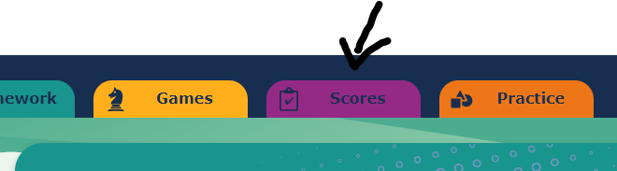

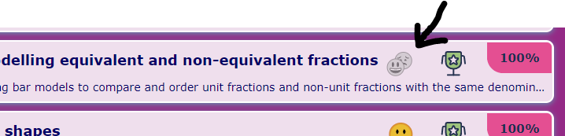

Useful websites:
Topmarks | fun maths games | https://www.topmarks.co.uk/
Scratch | a fun coding ICT site where children can create their own animations | https://scratch.mit.edu/

You can help your child at home by using the above websites and encouraging them to learn through play.
You can also help them to research facts about ‘The Stone Age’ for History.
If you aren’t a member already, the local library in town is free to join and is a great place to visit with your children so they can do research or borrow books to read at home.

PE: Our PE days are Monday and Thursday. Children should come to school wearing their school PE kit on these days. This includes a white PE shirt or t-shirt in their house colour, plus their school jumper. They must wear sensible trainers. Earrings must be removed or covered with tape for safety.

Outside learning: Please remember that children will often be going outside to learn. They will need waterproof coats in school each day- as you know our English weather can be unpredictable!

We hope this information is helpful. Please do not hesitate to email us if you require any further guidance. We now have a year group email: year6@heathcoat.devon.sch.uk This will be checked on a Monday, Wednesday and Friday. If you need to get an important message to us urgently, please contact the office on 01884 252445 or email them on admin@heathcoat.devon.sch.uk

We are looking forward to a really exciting term of learning.

Yours sincerely,

Mrs Evans, Mrs Emanuel and Mr Payne (Year 3 Class Teachers)
Mrs Firth (Team Leader)

