Heathcoat Primary School
Year 4 Autumn Term Newsletter
September 2021
Dear Parents/Carers,
We are delighted to welcome all of the children back to school. We hope that you have all had a really relaxing and enjoyable summer holiday. Here are the exciting new topics that the children will be exploring in Year 4 this term.
Autumn Term 2021
Subject | 1st half term | 2nd half term
English | Doctor K Fisher (non-fiction) (3 weeks)  Teacher focus with be recapping:  - Sentence Structures  - Main and Subordinating Clauses  - Basic Punctuation  - Ambitious Vocabulary and Humour  Paint me a poem by Grace Nichols. Focusing on the Poem ‘Weeping Woman’ (Fiction). (3 weeks)  Teacher Focus:  - Expanded Noun Phrases  - Alliteration  Throughout our sequences the children will practise using joined hand writing | Leon and the Place Between (fiction) (3 weeks)  Teacher Focus:  - Speech  - Adverbials  - Expanded Noun Phrases  Fantastically Great Women who changed the world (non-fiction) (3 weeks)  Teacher Focus:  - Expanded Noun phrases  - Adverbials of time and place including prepositional phrases.  - Paragraphing
Maths | Number Sense (2 weeks)  Understanding and comparing the value of numbers. Rounding to the nearest 10, 100, 1000  Additive reasoning (2 weeks) column addition and subtraction methods. Efficient mental calculation  Multiplicative reasoning (2 weeks) learning efficient multiplication and division methods | Geometric reasoning (2 weeks) exploring properties of shape.  Number sense (2 weeks) Recapping our knowledge of place value.
Science | Habitats and Classification 1  We will look at different organisms from around the plant and animal kingdoms whilst grouping them by their features.  We will study their habitats and look at how they organisms are adapted to them.  We will look at different organisms from around the plant and animal kingdoms. Grouping animals by their features – Vertebrates and Invertebrate. Including a minibeast hunt. | Habitats and Classification 2.  We will continue learning about different habitats, focusing specifically on local habitats and the animals that live there.  We will explore and carry out research into how habitats change and investigate what could be the cause, inc climate change and global warming.  This will encourage the children to think about the habitats around us and what they could do to support the local animals linking closely to our English sequence in the Spring term 1.
PE | Real PE Unit 1  Funs 10 and 1  4W will be swimming every Friday this half term | Real PE Unit 2  Funs 6 and 2  4K will be swimming every Friday this half term
ICT |  | Switched On Computing We are software developers- Programming simple educational games using Scratch.
DT |  | Mechanical Systems: Making a slingshot car: Children transform lollipop sticks, wheels, dowels and straws into a moving car. They will be using a glue gun to construct the materials, making the launch mechanism, designing and also making the body of the vehicle using nets and assembling these to the chassis
Geography |  | How and why is my local environment changing?  Lesson Focuses:  Why do places change?  How has my local area changed in the past?  How did my local area change as a result of World War I?  How and why does the quality of the environment change in my local area?  How do NASA satellite images inform us of environmental change on a global scale?
History | Romans  Lesson Focus:  Why did Emperor Claudius invade Britain?  Why did the Romans almost lose control of Britain?  Why was it so important to Claudia Severa that her friend Sulpicia Lepidina came to visit her?  Why were Claudia and Sulpicia living at Vindolanda? (Hadrian’s Wall)  How do we know so much about the towns the Romans built in Britain?  Why did the Romans organise gladiatorial games?
French | Language Angels: Presenting me  Revising France & French speaking countries, numbers 1-10 and 'how are you?'  Saying your name & asking someone their name. Numbers 11 to 20.  Numbers 10 to 20 listening exercise and 'how old are you?  'Where do you live?' and further number work  Nationality, je suis..., individual presentations, Class French ID cards activity
Music | Body and tuned percussion: Rainforests Exploring the rainforest through music. Using a mixture of body percussion and tuned percussion instruments, pupils create their own rhythms of the rainforest, layer by layer. Accurately performing a composition as part of a group. Identifying scaled dynamics (crescendo / decrescendo) within a piece of music. Creating body percussion rhythms. Creating a melody loop on tuned percussion. | Rock and Roll : Learn about the significance of dancing within the evolution of music and learning to play a walking bass line, which is characteristic of this genre of music. Performing a walking bass line. Singing in time and in tune. Recognising the features of rock and roll music. Identifying the links between this and other genres of music.
Art | Painting  Specific art pieces inspired by Art-  An Artist’s Study of Picasso.  To be able to research and the life of Pablo Picasso.  To look at the work of Picasso and the different styles of painting he did during his life  To understand the term Cubism and draw in a similar style  To compose and draw a still life  Look at some examples of collage inspired by Picasso and discuss
RE | Unit L2.3 What is the ‘Trinity’ and why is it important for Christians? [God/Incarnation]  Unit L2.7 What do Hindus believe that God is like? [Brahman/atman]
PSHE | Jigsaw- being me in my world  - Becoming a Class ‘Team’.  - Being a School Citizen  - Rights, Responsibilities  - Rewards and Consequences  - Our Learning Charter  - Owning our learning charter | Jigsaw- celebrating differences.  - Judging by Appearances  - Understanding influences  - Understanding Bullying  - Problem Solving  - Special Me  - Celebrating Difference: how we look

Trips / visits: | Roman Day 22nd October – Letter to Follow
Dates for your diary: | Half term: 25 – 29 October | End of term: 17th December

HOW CAN YOU HELP?
READING: It is really important that children read their books every night for at least 20 mins.
Any reading needs to be recorded in your child’s reading record book. Please ask your child questions about what they have read or to summarise/explain what they have read to check their understanding.
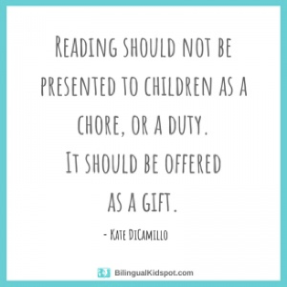

Here are 3 example questions that you could ask about their reading:
- Tell me about what you have just read (summarise). Can they clearly explain to you what has just happened?
- What do you think is going to happen next? Why? Explain why you think this. A good example of an answer would be: I think the main character will go back to the bike track because he was so excited last time, and even though he fell off, he wants to race because he said “I wish I could race my bike like those fast kids”. (The child is using what they have read, including quotes, to explain their ideas – even if they are not right about what happens next. They are showing a good guess based on what they have read).
- Which words do you not understand? Ask them to try to work out what the word means from the rest of the sentence. Then look up the word on a computer/tablet or in a dictionary.
Here is an example of what might be written in a reading record:
I could summarise what I read to my Dad or I really enjoyed the exciting opening. Got stuck on reading the word ‘route’. Pg 12 next.
Homework: Maths and English homework will be set each week on a Friday via Google Classrooms. This is to be completed and handed in online by Wednesday. If you have any problems accessing the homework, please get in touch with us.
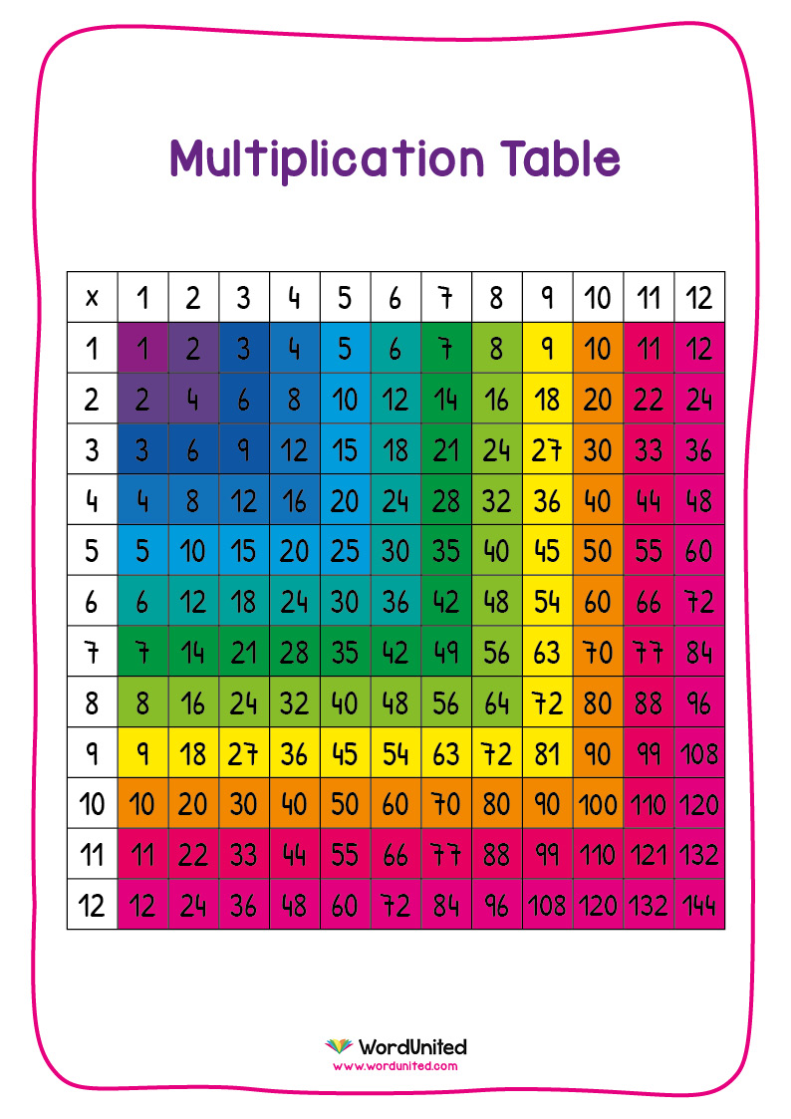
Timetables
Knowledge and understanding of their times tables provides the building blocks for further maths at Primary School.
Please support us with continued practice and recall of 1-12 times tables facts, as much as possible! We know you all have busy lives too but just 1 minute every day makes a difference!
MyMaths: It is important for children to complete the lesson and practise tasks as well as the homework section. This enables them to reinforce learning and see fun graphics which explain topics. Lots of these lessons are fun games that you can play together. The games help to remind children of efficient ways of working and will also show you how the maths topic is being taught. When they finish their homework, your child can rate how well they did – e.g. did they feel a bit unsure? Did they totally understand it? Click on the tab marked SCORE and then the relevant statement and face to show how they feel they did.
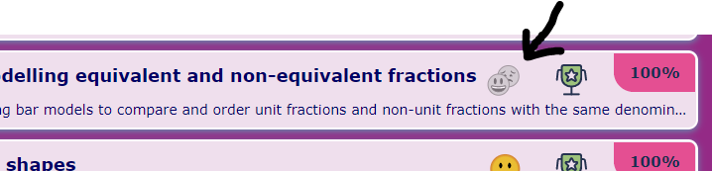
Useful websites:
Topmarks | fun maths games | https://www.topmarks.co.uk/
Scratch | a fun coding ICT site where children can create their own animations | https://scratch.mit.edu/

You can help your child at home by using the above websites and encouraging them to learn through play. You can also help them to research interesting facts about the Romans or Living things to support them in class discussion.
If you aren’t a member already, the local library in town is free to join and is a great place to visit with your children so they can do research or borrow books to read at home.
PE: Our PE days are Wednesday and Friday. Children should come to school wearing their school PE kit on these days. This includes a white PE shirt or t-shirt in their house colour, plus their school jumper. They must wear sensible trainers. Earrings must be removed or covered with tape for safety.
Outside learning: Please remember that children will often be going outside to learn. They will need waterproof coats in school each day- as you know our English weather can be unpredictable!
We hope this information is helpful. Please do not hesitate to email us if you require any further guidance. We now have a year group email: year4@heathcoat.devon.sch.uk This will be checked on a Monday, Wednesday and Friday. If you need to get an important message to us urgently, please contact the office on 01884 252445 or email them on admin@heathcoat.devon.sch.uk
We are looking forward to a really exciting term of learning.
Yours sincerely,
Miss Kneller and Mr Watson (Year 4 Teachers)
Mrs Firth (Key Stage 2 Leader)
