Covid-19 guidance February 2022 | RA100 V2.9

IMPORTANT – please read this information before completing this risk assessment.

This is a model Covid-19 risk assessment and MUST be adapted to reflect the significant hazards and control measures present in your site This is a live document and it came into place on February 24th and whilst there is no longer a legal requirement for people with Covid-19, the updated published guidance outlines measures align with the previous legal requirement to manage risk. COVID-19: people with COVID-19 and their contacts - GOV.UK (www.gov.uk) Specific schools guidance is outlined in the updated Contingency Framework and Operational Guidance

The control measures listed are prompts and will not necessarily reflect those in all establishments and you MUST adapt it by adding (or removing) and outlining in detail the control measures as appropriate to your establishment.

If you need help to complete this risk assessment, please refer to HS47 (Risk Assessment Arrangements) or telephone the Devon Health & Safety Service on 01392 382027.

The public health advice via the DfE helpline will continue to the end of March 2022. However as prior to half term any mainstream schools will be directed to DCC public health to offer support. The Smart Survey (smart survey link) reporting has an additional comments section, and this is viewed by the education team, Early years teams, schools transport and the DCC public health team and so if a specific request for support is noted in this it will get the same response as calling the DfE helpline.

 | Establishment/Department:  Heathcoat Primary School | Establishment Risk Assessment | RA100 V2.9
Address:
Broad Lane, Tiverton, Devon
Person(s)/Group at Risk  Staff, Pupils, Visitors and Contractors  This risk assessment explains the actions school leaders should take to minimise the risk of transmission of COVID-19 in their school Living with Covid February 2022 onwards. This includes public health advice, endorsed by UK Health Security Agency (UKHSA), or from the Southwest Directors of Public Health  This risk assessment is generic and outlines control measures. Each school is responsible for reviewing and amending to ensure it is applicable to their setting and the latest government guidance and must consult with their staff regarding the risks and control measures being implemented. |  | Date assessment completed:  26th February 2022  This document is to remain under constant review
Assessor(s):
Demelza Higginson
Up-date 25/02/2022 – changes to text to include new guidance

Significant Hazard Section | Control measures in place  Additional measures or actions not included in this column below should be put in the assessor’s recommendations at the end of this document | Optional: School’s comments re. mitigations put in place
Keep occupied spaces well ventilated
Poorly ventilated spaces leading to risks of coronavirus spreading  Ventilation to reduce transmission  Health and Safety Executive guidance on air conditioning and ventilation during the coronavirus outbreak and CIBSE COVID-19 advice provides more information.  DfE is working with the Scientific Advisory Group for Emergencies (SAGE) and NHS England on a pilot project to measure CO2 levels in classrooms and exploring options to help improve ventilation in settings where needed. | - Ventilation and AC systems working optimally.  - Heating used as necessary to ensure comfort levels are maintained when the building is occupied.  - Keep windows open wide enough to provide some natural background ventilation and open internal doors to increase air flow.  - Open windows fully when rooms are unoccupied for longer periods to purge the air (e.g. lunch times and before and after school).  - Action taken to prevent occupants being exposed to draughts. For example, partially open high-level windows as opposed to low-level windows, close external doors and arrange the furniture if appropriate and possible.  - Use fans for good air circulation.  - Air conditioning systems that normally run with a recirculation mode set up to run on full outside air.  - Ventilation’s system that removes and recirculates air to different rooms is turned off.  - Ventilation system remains on at all times, even when the building is unoccupied. The system set to operate at lower ventilation rates during evenings and weekends.  - Occupants encouraged to wear additional, suitable indoor clothing. (If they have to wear coats, scarves and other outdoor clothing the room would be considered too cold, and the above steps must be considered).  - Ensure staff meetings and insets are in rooms with suitable and sufficient ventilation  A robust risk assessment process should include the following:  - How is each room in the establishment being ventilated?  - How many people are going to be using the room – more people greater the risk  - What activities are being done in that room – lots of people talking, shouting, more risk  - C02 monitors are only a tool to identify poorly ventilated areas – they are not to be used as a mechanism to ‘measure safe thresholds’ and to be used with the HSE suitability chart.  - DfE guide Ventilation - Google Drive  - Risk assessment video link https://youtu.be/hkK_LZeUGXM  - Simple resource to support schools with ventilation and CO2 monitoring: CoSchools - tools for healthy schools  It is advisable to use a thermometer to monitor temperatures where opening windows and doors is being used as a mechanism to aid ventilation. For more information on suitable workplace temperatures see HSE: Guidance on temperature in the workplace | We don’t have AC or ventilation systems.  Ensure classrooms have thermometers.  Ensure halls are ventilated during lunchtime, PE and assembly.
Maintain appropriate cleaning regimes
You should put in place and maintain an appropriate cleaning schedule. | - Reduced clutter and removing difficult to clean items to make cleaning easier.  - Cleaning using standard cleaning products such as detergents and bleach, paying attention to all surfaces but especially ones that are touched frequently, such as door handles, light switches, work surfaces, remote controls and electronic devices.  - Surfaces that are frequently touched and by many people in common areas to be cleaned twice a day.  - Avoid sharing work equipment by allocating it on a personal basis or put cleaning regimes in place to clean between each user.  - Identify where you can reduce people touching surfaces, for example by leaving doors open (except fire doors) or providing contactless payment.  - Keep surfaces clear to make it easier to clean and reduce the likelihood of contaminating objects.  - Provide more bins and empty them more often.  - Toilets and communal areas to be cleaned regularly, with a process of recording – displaying cleaning schedules.  - Sanitising spray and paper towels to be provided in classrooms for use by members of staff. If using cloths – disposable or appropriate washing and drying process.  Thorough cleaning of rooms at the end of the day. This should include regular cleaning of areas and equipment (for example, twice per day), with a particular focus on frequently touched surfaces.  UKHSA has published guidance on the cleaning of non-healthcare settings | Reminders to staff about rooms and spaces being uncluttered to aid cleaning.  Cleaning of regular touch points and toilets during the day.
Ensure good hygiene for everyone
Key control measures | Key messages:  Control measures to remain in schools to reduce risk:  - Ensure good hygiene for everyone.  - Maintain appropriate cleaning regimes.  - Keep occupied spaces well ventilated.  - Follow public health advice on testing, self-isolation and managing confirmed cases of COVID-19  Face coverings are no longer advised for pupils, staff and visitors in classrooms or communal areas. Staff and pupils should follow wider advice on face coverings outside of school, including on transport to and from school. (The legal requirement to wear a face covering no longer applies. However, the government suggests that you continue to wear a face covering in crowded and enclosed spaces where you may come into contact with people you do not normally meet).  Respiratory hygiene  The ‘catch it, bin it, kill it’ approach continues to be very important.  The e-Bug COVID-19 website contains free resources for you, including materials to encourage good hand and respiratory hygiene. There are good hygiene measures that can be used in:  https://www.england.nhs.uk/south/wp-content/uploads/sites/6/2021/08/spotty-book-2021.pdf  https://www.england.nhs.uk/south/info-professional/public-health/infection-winter/schools-and-nurseries-guidance/  DCC Health and Safety Arrangements: - Infection Control HS26 | Reminders to pupils about catch it, bin it, kill it
Conditions for use of fluid resistant face mask and other equipment when dealing with a symptomatic child are clear and understood by staff. | If a child, young person or other learner becomes unwell with symptoms of coronavirus while in their setting and needs direct personal care until they can return home a face mask should be worn by the supervising adult if a distance of 2 meters cannot be maintained.  If contact with the child or young person is necessary, then gloves, an apron and a face mask should be worn by the supervising adult. If a risk assessment determines that there is a risk of splashing to the eyes, for example from coughing, spitting, or vomiting, then eye protection should also be worn Ensuring that fluid resistant face masks are available for all schools and that a supply is maintained.  https://www.gov.uk/government/publications/safe-working-in-education-childcare-and-childrens-social-care/safe-working-in-education-childcare-and-childrens-social-care-settings-including-the-use-of-personal-protective-equipment-ppe
Staff use of PPE | Pupils whose care routinely already involves the use of PPE due to their intimate care needs will continue to receive their care in the same way. Follow guidance  https://www.gov.uk/government/publications/safe-working-in-education-childcare-and-childrens-social-care/safe-working-in-education-childcare-and-childrens-social-care-settings-including-the-use-of-personal-protective-equipment-ppe
Self-isolation – staff/pupils: | If someone develops symptoms or has a positive test result the guidance still advises people to stay at home to avoid passing the infection on to others. There is no longer a legal requirement for people with COVID-19 to isolate BUT public health guidance STILL advises people to stay home for 10 days  (or until have 2 negative LFDs on consecutive days from day 5) | Information shared with parents and staff – stay at home if you have symptoms or test positive
Symptoms | Deliver strong messaging about signs and symptoms of Covid-19.  Children who are unwell should not attend the setting and should remain at home until their acute symptoms resolve (+24 hours for a fever).  - IF these symptoms develop into cough, temperature, changes to taste and smell, should isolate and test.  - IF test negative to COVID-19, still need to remain at home until at least 24 fever free and acute symptoms resolved.  Parents and settings should not try and ‘second guess’ diagnosis – if have the key symptoms, isolate and test.  Examples of acute symptoms with which children should not attend school/nursery include fever, muscle aches, hacking cough.  The school’s operational guidance outlines that in most cases parents and carers agree that a pupil with the key symptoms should not attend the school given the potential risk to others.  If a parent or carer insists on a pupil attending your school as a confirmed or suspected case of Covid-19, you can take the decision to refuse the pupil if, in your reasonable judgement, it is necessary to protect other pupils and staff from possible infection with Covid-19.  We advise schools to communicate this to parents and encourage parents to follow the latest guidance around isolation if symptomatic. | Reminders to parents not to send children to school if they are unwell or have acute symptoms.
Close contacts | Close contacts are no longer required to self-isolate or advised to take daily tests and contact tracing has ended. Routine contact tracing (provided by NHS Test and Trace) has now ended, and close contacts will no longer be required to self-isolate or advised to take daily LFD tests. People with COVID-19 will be encouraged to inform their close contacts, Household and overnight contacts advised to take additional precautions for 10 days  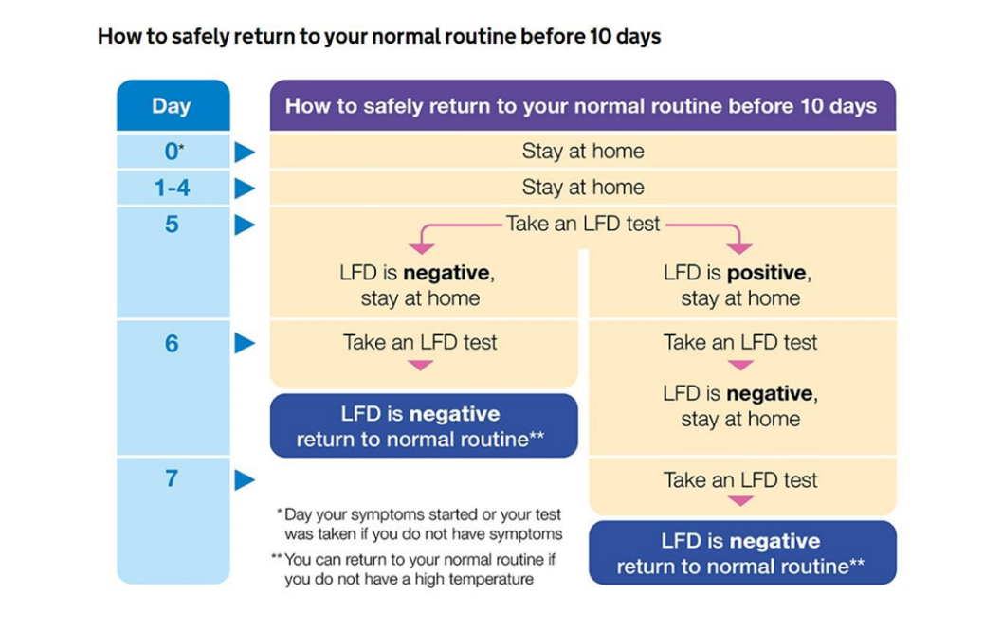
Testing: | PCR testing is still currently available for anyone with Covid-19 symptoms.  Regular asymptomatic testing of staff and pupils in mainstream secondary schools will not be expected to continue. Any outstanding test orders from the DfE will now not be delivered.  Staff and pupils in specialist SEND settings, Alternative Provision, and SEND units in mainstream schools are advised to continue regular twice weekly testing. For further information, see SEND and specialist settings: additional COVID-19 operational guidance (publishing.service.gov.uk).  In the event of an outbreak, a school may also be advised by their local health team or director of public health to undertake testing for staff and students of secondary age and above for a period of time. This would only be as an exceptional measure and any tests schools have currently should be kept in case, they are needed for this. If schools do not have tests available, they will be able to be ordered from the DfE for use if in response to an outbreak.
Dealing with outbreak. | Schools are required to update their contingency plan (or outbreak management plan) and describe how they will respond if children, pupils, or staff test positive for COVID-19, how they will operate if they are advised to reintroduce any measures to help break chains of transmission
Thresholds - most settings, it will make sense to think about taking extra action if they face severe operational disruption to face-to-face education, however thresholds for when to consider seeking further advice: | For most education and childcare settings may consider seeking advice when:  • a higher than previously experienced and/or rapidly increasing number of staff or student absences due to COVID-19 infection  • evidence of severe disease due to COVID-19, for example if a pupil, student, child or staff member is admitted to hospital due to COVID-19  • a cluster of cases where there are concerns about the health needs of vulnerable staff or students within the affected group
For special schools, alternative provision, SEND/AP units within schools and colleges, open and secure children’s homes and settings that operate with 20 or fewer children, pupils, students and staff at any one time, may consider when: | 2 children, pupils, students, and staff, who are likely to have mixed closely, test positive for COVID-19 within a 10-day period and/or there are concerns about the health needs of vulnerable individuals within the affected group | NA
Outbreak Key principles:  Contingency Planning (Outbreak management) Contingency Framework | The school to maximise the number of children and young people in face-to-face education or childcare and minimise any disruption, while protecting those most vulnerable to increased risk from COVID-19.  Any benefits in managing COVID-19 risk should be weighed against any educational drawbacks and the additional measures described in this guidance should be considered only in exceptional circumstances and be time limited, to minimise disruption to face-to-face education and protect the most vulnerable.  Measures should affect the minimum number of children for the shortest time  attendance restrictions advised as a last resort only – neither contacts or sibling of positive cases should be asked to isolate under normal circumstances.  In addition to day-to-day control measures, additional 'outbreak control measures' may be advised by DsPH (or their teams) or UKHSA Health Protection Team following an individual risk assessment.  Measures may include:  - Warn and inform information to setting, or group within the setting.  - Measures to promote social distancing, reduce crowding or inter-group mixing  - Measures to reduce mixing of staff  - Temporary limits on visits in and out of setting (e.g. performances, educational visits)  - Temporary reintroduction of face coverings in communal areas and/or classrooms  - One off targeted outbreak testing of staff and pupils/students (in yr 7 and above). This may include temporary onsite LFD testing in SEND settings,  - Attendance restrictions
Pupil /staff related issues | Settings should continue to encourage coronavirus (COVID-19) vaccination uptake for eligible students and staff.
Vulnerable groups who are clinically, extremely vulnerable. | Following successful roll-out of vaccine programme + rapid access to therapeutics for those at highest risk, people previously considered clinically extremely vulnerable (CEV) will not be advised to shield again.  People at higher risk advised to follow same guidance as everyone else with additional advice available here COVID-19: guidance for people whose immune system means they are at higher risk - GOV.UK (www.gov.uk)/ Guidance for people previously considered clinically extremely vulnerable from COVID-19 GOV.UK (www.gov.uk)
Assessment of all staff, including high risk staff with vulnerable / shielding family member, underlying health conditions or other risk factors | A risk assessment should be undertaken with clinically extremely vulnerable and clinically vulnerable. A risk assessment should also be undertaken (or reviewed/updated if one was previously undertaken) with staff who may be anxious about returning to school and/or due to the increased numbers. The ‘Risk assessment for all staff including vulnerable groups’ can be used to aid and record this assessment - https://devoncc.sharepoint.com/:w:/s/PublicDocs/Education/ESoXeZkAQylLupPG5VVG6yQB2iEFDD4pgkko5qBbtOSEkw?e=040Qiy
Pregnant staff | Coronavirus (COVID-19): advice for pregnant employees - GOV.UK (www.gov.uk)  - should have a risk assessment in place: Coronavirus (COVID-19) infection and pregnancy (rcog.org.uk) can support risk assessment.  - a more precautionary approach advised for those >28 weeks pregnant or for individuals with underlying health conditions that place them at greater risk.
Transport
Travel and quarantine | Where pupils travel from abroad to attend a boarding school, you will need to explain the rules to pupils and their parents before they travel to the UK. All pupils travelling to England must adhere to travel legislation, details of which are set out in government travel advice. Additional guidance has been issued on the quarantine arrangements for boarding school pupils travelling from red-list countries to attend a boarding school in England.
Transport to/from school | There is no longer a legal requirement to wear a face covering but the government suggests people continue to wear one in crowded and enclosed spaces where they may come into contact with people they do not normally meet  You may wish to consider, in light of this advice, whether to ask children and young people aged 11 and over to continue to wear face coverings on dedicated school and college transport.  Dedicated transport to schools and colleges COVID-19 operational guidance (publishing.service.gov.uk)
Curriculum considerations

Educational visits | You should undertake full and thorough risk assessments in relation to all educational visits and ensure that any public health advice, such as hygiene and ventilation requirements, is included as part of that risk assessment. General guidance about educational visits is available and is supported by specialist advice from the Outdoor Education Advisory Panel (OEAP). | All visits planned using Evolve and the SOP.
Resources
DfE daily email- DfE - COVID daily email subscription service (office.com)
Posters and promotional material - https://coronavirusresources.UKHSA.gov.uk/back-to-school/resources/

NHS resources and videos
- Handwashing for teachers
- Handwashing for children
- Coronavirus factsheet for kids
- PPE Donning and Doffing advice

Other resources and videos
- COVID-19: the facts | Scouts
- eBug https://e-bug.eu/
- UKHSA webcast - Breaking the chain of infection

Oversight of the governing body
Governor oversight during the COVID-19 outbreaks. | The governing body agendas are structured to ensure all statutory requirements are discussed and school leaders are held to account for their implementation. The Headteacher’s report to governors includes content and updates on how the school is continuing to meet its statutory obligations in addition to covering the school’s response to COVID-19 outbreaks Regular dialogue with the Chair of Governors and those governors with designated responsibilities is in place.  Minutes of governing body meetings are reviewed to ensure that they accurately record governors’ oversight and holding leaders to account for areas of statutory responsibility.

Section | List Actions / Additional Control Measures | Date action to be carried out | Person Responsible

Signed: Headteacher/Head of Department: Demelza Higginson Date: 26th February 2022

The outcome of this assessment should be shared with the relevant staff and Governing Body.
A copy of the completed assessment to be kept on file and copied to the Health & Safety Co-ordinator.

