Heathcoat Primary School
PSHE Curriculum – Progression of Key Skills and Knowledge
Date | Review date | Subject leaders
July 2023 | July 2024 | Sharon Daniel  Mark Ferdinando
It is our intention that pupils will be taught a curriculum that:
- provides pupils with the knowledge, understanding, attitudes, values and skills they need in order to reach their potential as individuals and within their community now and in their future as well as preparing them for life and work in modern Britain.
- encourages and develops all children to have a sense of purpose which enables them to value themselves and others
- teaches children how to form positive relationships where they communicate effectively and work as a team
- encourages children to challenge themselves in their own learning
- teaches the children the skills and provides knowledge to become active citizens in the wider local community and explore issues related to living in a democratic society.
- teaches children to become healthy and fulfilled individuals.

Within in our school we cover the three aspects of personal, social, health and economic (PSHE) education, health & wellbeing, and relationships and living in the wider world. We also deliver the mandatory health Education and Relationships and Sex Education (or ‘Relationships Education’ in primaries).

PSHE within our school will be taught through a nurturing and supportive learning environment to encourage every child to reach their full potential and for their achievements to be rewarded and celebrated. As a school, we believe that children are all individuals and therefore, we aim to encourage mutual respect, responsibility and foster self-esteem in a happy and caring atmosphere. The teaching and learning of PSHE using the Jigsaw programme supports this.

Curriculum Organisation
Year / Term | Autumn 1 | Autumn 2 | Spring 1 | Spring 2 | Summer 1 | Summer 2
1 | Being in my world  Feeling special and safe Being part of a class Rights and responsibilities Rewards and feeling proud Consequences Owning the Learning Charter | Celebrating difference  Similarities and differences Understanding bullying and knowing how to deal with it Making new friends Celebrating the differences in everyone | Dreams & goals  Setting goals Identifying successes and achievements Learning styles Working well and celebrating achievement with a partner Tackling new challenges Identifying and overcoming obstacles Feelings of success | Healthy me  Keeping myself healthy Healthier lifestyle choices Keeping clean Being safe Medicine safety/safety with household items Road safety Linking health and happiness | Relationships  Belonging to a family Making friends/being a good friend Physical contact preferences People who help us Qualities as a friend and person Self-acknowledgement Being a good friend to myself Celebrating special relationships | Changing me  Life cycles – animal and human Changes in me Changes since being a baby Differences between female and male bodies (correct terminology) Linking growing and learning Coping with change Transition
2 | Hopes and fears for the year Rights and responsibilities Rewards and consequences Safe and fair learning environment Valuing contributions Choices Recognising feelings | Assumptions and stereotypes about gender Understanding bullying Standing up for self and others Making new friends Gender diversity Celebrating difference and remaining friends | Achieving realistic goals Perseverance Learning strengths Learning with others Group co-operation Contributing to and sharing success | Motivation Healthier choices Relaxation Healthy eating and nutrition Healthier snacks and sharing food | Different types of family Physical contact boundaries Friendship and conflict Secrets Trust and appreciation Expressing appreciation for special relationships | Life cycles in nature Growing from young to old Increasing independence Differences in female and male bodies (correct terminology) Assertiveness Preparing for transition
3 / 4  Year B  Year 3 jigsaw lessons | Setting personal goals Self-identity and worth Positivity in challenges Rules, rights and responsibilities Rewards and consequences Responsible choices Seeing things from others’ perspectives | Families and their differences Family conflict and how to manage it (child-centred) Witnessing bullying and how to solve it Recognising how words can be hurtful Giving and receiving  compliments | Difficult challenges and achieving success Dreams and ambitions New challenges Motivation and enthusiasm Recognising and trying to overcome obstacles Evaluating learning processes  Managing feelings Simple budgeting | Exercise Fitness challenges Food labelling and healthy swaps Attitudes towards drugs Keeping safe and why it’s important online and off line scenarios Respect for myself and others Healthy and safe choices | Family roles and responsibilities Friendship and negotiation Keeping safe online and who to go to for help Being a global citizen Being aware of how my choices affect others Awareness of how other children have different lives Expressing appreciation for family and friends | How babies grow Understanding a baby’s needs Outside body changes Inside body changes Family stereotypes Challenging my ideas Preparing for transition
3 /4  Year A  Year 4  Jigsaw lessons | Being part of a class team Being a school citizen Rights, responsibilities and democracy (school council) Rewards and consequences Group decision-making Having a voice What motivates behaviour | Challenging assumptions Judging by appearance Accepting self and others Understanding influences Understanding bullying Problem-solving Identifying how special and unique everyone is First impression | Hopes and dreams Overcoming disappointment Creating new, realistic dreams Achieving goals Working in a group Celebrating contributions Resilience Positive attitudes | Healthier friendships Group dynamics Smoking Alcohol Assertiveness Peer pressure Celebrating inner strength | Jealousy Love and loss Memories of loved ones Getting on and Falling Out Girlfriends and boyfriends Showing appreciation to people and animals | Being unique Having a baby Girls and puberty Confidence in change Accepting change Preparing for transition Environmental change
5 | Planning the forthcoming year Being a citizen Rights and responsibilities Rewards and consequences How behaviour affects groups Democracy, having a voice, participating | Cultural differences and how they can cause conflict Racism Rumours and name-calling Types of bullying Material wealth and happiness Enjoying and respecting other cultures | Future dreams The importance of money Jobs and careers Dream job and how to get there Goals in different cultures Supporting others (charity)  Motivation | Smoking, including vaping Alcohol Alcohol and anti-social behaviour Emergency aid Body image Relationships with food Healthy choices Motivation and behaviour | Self-recognition and self-worth Building self-esteem Safer online communities Rights and responsibilities online Online gaming and gambling Reducing screen time Dangers of online grooming SMARRT internet safety rules | Self- and body image Influence of online and media on body image Puberty for girls Puberty for boys Conception (including IVF) Growing responsibility Coping with change Preparing for transition
6 | Identifying goals for the year Global citizenship Children’s universal rights Feeling welcome and valued Choices, consequences and rewards Group dynamics Democracy, having a voice Anti-social behaviour Role-modelling | Perceptions of normality Understanding disability Power struggles Understanding bullying Inclusion/exclusion Differences as conflict, difference as celebration Empathy | Personal learning goals, in and out of school Success criteria Emotions in success Making a difference in the world Motivation Recognising achievements Compliments | Taking personal responsibility How substances affect the body Exploitation, including ‘county lines’ and gang culture Emotional and mental health Managing stress | Mental health Identifying mental health worries and sources of support Love and loss Managing feelings Power and control Assertiveness Technology safety Take responsibility with technology use | Self-image Body image Puberty and feelings Conception to birth Reflections about change Physical attraction Respect and consent Boyfriends/girlfriends Sexting Transition

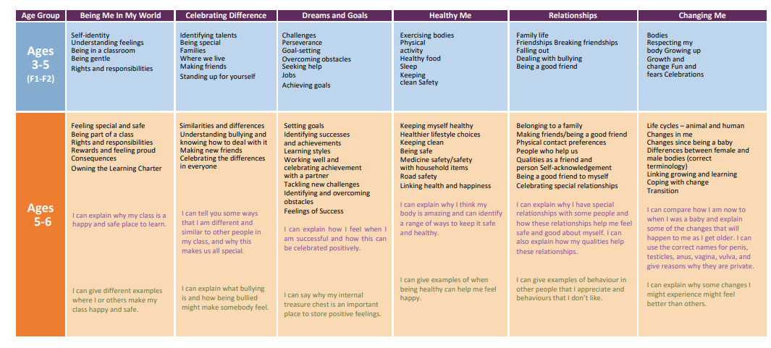

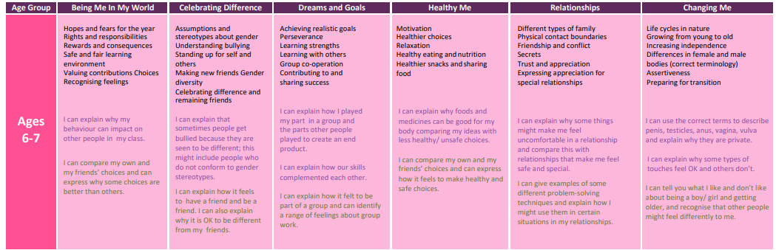
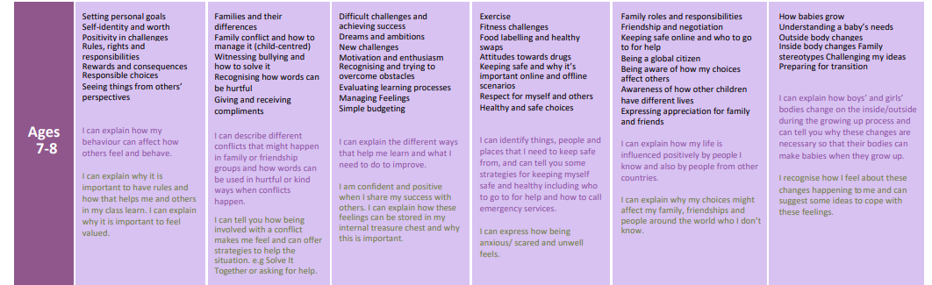

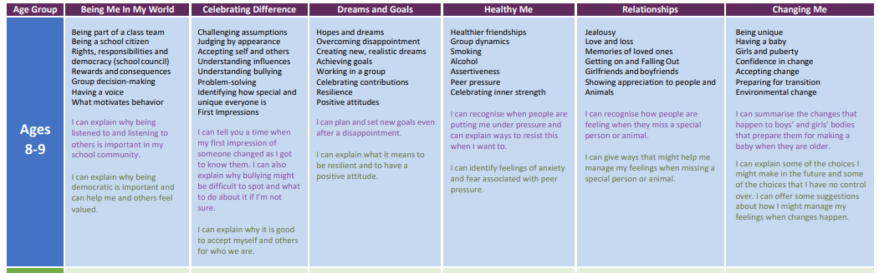

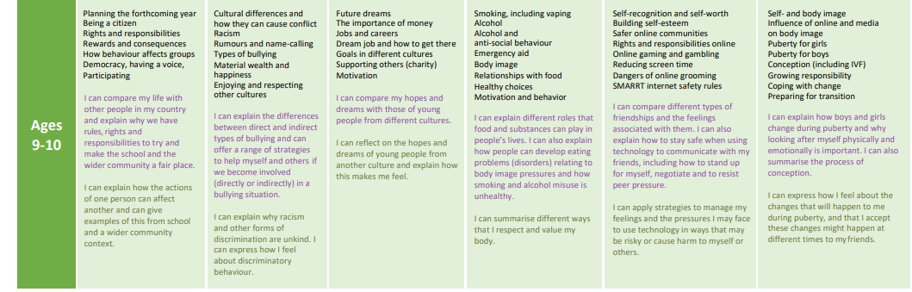

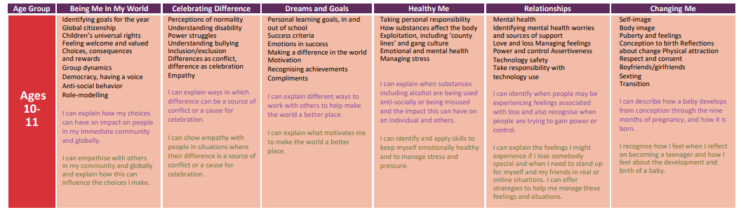

Vocabulary
Being in my world  Safe  Special  Calm  Belonging  Rights & responsibilities  Learning charter  Rewards  Proud  Consequences  Upset, disappointed  Illustration  Celebrating difference  Similarity, similar, same as  Difference, different from  Bullying, bully, bullied  Deliberate, on purpose, unfair  Celebration, special, unique  Dreams & goals  Achievement, achieve, celebrate, challenge  Goals, dreams  Learning,  working together, team work  feelings  overcome obstacles  Healthy me  Healthy, unhealthy  Balanced exercise  Sleep, exercise  Choices  Clean  Body parts  Toiletry items  Hygienic  Safe, medicines  Trust  Relationships  Family, belong  Different, same  Friends, friendships  Qualities, caring, sharing, kind, greeting  Touch, feel, texture  Like/dislike  Help, helpful  Community  Confidence, praise  Skills, self-belief  Incredible, proud  Celebrate  Relationships  Special, appreciate, feelings  Changing me  Changes  Life cycles  Baby, adulthood, adult, grown up, mature,  Male female  Vagina, penis, testicle, vulva, anus  Learn, new, grow  Feelings, anxious, worried, excited, coping | Being in my world  Worries, hopes, fears  Belonging  Rights & responsibilities  Responsible, actions  Praise, reward  Consequence  Positive, negative  Choices  Co operate  Learning charter  Problem solving  Celebrating difference  Boys, girls, male, female  Similarities, differences  Assumptions  Shield  Stereotypes  Special friends  Unique  Bully  Purpose, on purpose  Kind, unkind  Feelings  Sad, lonely, help  Stand up for diversity  Fairness, kindness, value  Dreams & goals  Realistic Proud Success Celebrate Achievement Goal  Strengths Persevere Challenge Difficult Easy  Learning together Success Celebrate Achievement Partner Team work  Product Dream bird Group Team work Problem-solve  Healthy me  Healthy choices Lifestyle Motivation  Relax Relaxation Tense Calm  Healthy Unhealthy Dangerous Medicines Safe Body  Balanced diet Portion Proportion  Energy Fuel Nutritious  Relationships  Family Different Similarities Special Relationship Important Cooperate  Touch Physical contact Communication Hugs Like Dislike Acceptable Not acceptable  Friends Likes/dislikes Conflict Point of view Positive problem solving  Secret Surprise Good secret Worry secret Telling Adult Trust Surprised Happy Sad Frightened  Trust Trustworthy Honesty Reliability  Compliments Celebrate Positive Negative Appreciate  Compliments Celebrate Positive Negative Appreciate  Changing me  Change Grow Life cycle Control Baby Adult Fully grown  Growing up Old Young Change Respect Appearance Physical  Baby Toddler Child Teenager Adult Independent Timeline Freedom Responsibilities  Male Female Vagina Penis Testicles Vulva Anus Public Privates  Touch Texture Cuddle Hug Squeeze Like Dislike Acceptable Unacceptable Comfortable Uncomfortable  Change Looking forward Excited Nervous Anxious Happy | Being in my world  Welcome Valued Achievements Proud Pleased Personal goal Praise Acknowledge Affirm  Emotions Feelings Nightmare Fears Worries Solutions Support  Rights Responsibilities Learning Charter  Nightmare Dream  Behaviour Rewards Consequences Actions Fairness Choices  Co-operate  Learning Charter Challenge Group dynamics Team work  View point Ideal  school Belong  Celebrating difference  Family Loving Caring Safe Connected Difference Special  Conflict Solve it together Solutions Resolve  Witness Bystander Bullying Gay Unkind Feelings Tell  Consequences Hurtful  Compliment  Unique Similarity  Dreams & goals  Perseverance Challenges Success Obstacles Dreams Goals  Ambitions Future Aspirations  Garden Decoration Team work Enterprise Design Cooperation  Product Team Cooperation Strengths Motivated Enthusiastic Excited Efficient Responsible  Frustration ‘Solve it together’ technique Solution  Review Learning Strengths Self-review Celebrate Evaluate  Healthy me  Oxygen Energy Calories/ Kilojoules Heartbeat Lungs Heart Fitness  Labels Sugar Fat Saturated Fat  Healthy Drugs Attitude  Safe Anxious Scared Strategy Advice Dangerous Emergency Emergency Services Ambulance Fire engine Police car Coastguard helicopter  Harmful Risk Feelings  Complex Appreciate Body Choice  Relationships  Men Women Male Female Unisex Role Job Responsibilities Differences Similarities Respect Stereotype  Conflict Solution Problem solving Friendship Win-win  Safe Unsafe Risky Internet Social media Private Messaging (PM) Gaming  Global Communications Transport Interconnected Food journeys Climate Trade Inequality  Needs Wants Rights Deprivation United Nations Equality Justice  Happiness Celebrating Relationships Friendship Family Thank you Appreciation  Changing me  Changes Birth Animals Babies Mother Growing up  Baby Grow Uterus Womb Nutrients Survive Love Affection Care  Change Puberty Control  Male Female Testicles Sperm Penis Ovaries Egg Ovum/ Ova Womb/ Uterus Vagina  Stereotypes Task Roles Challenge  Looking forward Excited Nervous Anxious Happy | Being in my world  Included Excluded  Welcome Valued Team Charter  Role Job description  School Community Responsibility  Rights Responsibilities Democracy  Reward Consequence Democratic  Decisions Voting Authority Learning Charter Role Contribution Observer  Decisions Choices  UN Convention on Rights of Child  Celebrating difference  Character Assumption Judgement Surprised Different Appearance Accept  Influence  Opinion  Attitude Judgement  Bullying Friend Secret Deliberate On purpose Bystander Witness  Witness Bystander Bully Problem solve  Cyber bullying Text message Website Troll  Special Unique Different Characteristics Physical features  Impression Changed Special Different Accept  Dreams & goals  Dream Hope Goal Determination Perseverance Resilience Positive Attitude  Disappointment Fears Hurt  Positive experiences Hopes Plans Cope Help Self-belief Commitment  Team work Enterprise Design co operation  Review Learning Strengths Success Celebrate Evaluate  Healthy me  Friendships Emotions Healthy Relationships Friendship groups Value  Roles Leader Follower Assertive Agree / disagree  Smoking Vaping Pressure Peers Guilt Advice  Alcohol Liver Disease  Anxiety Fear  Believe Assertive Opinion Right Wrong  Relationships  Relationship Close Jealousy Problem-solve Emotions Positive Negative  Loss Strategy Shock Disbelief Numb Denial Anger Guilt Sadness Pain Despair Hopelessness Relief Acceptance Depression  Souvenir Memento Memorial Memories  Special Remember  Friendships Negotiate Compromise Trust Loyalty Anger Betrayal Empathy  Boyfriend Girlfriend Attraction Pressure Personal Comfortable  Special Love Appreciation Symbol Care  Changing me  Personal Unique Characteristics Parents  Sperm Egg/ Ovum Penis Testicles Vagina/ Vulva Womb/ Uterus Ovaries Making love Having sex Sexual Intercourse Fertilise Conception  Puberty Menstruation Periods  Circle Seasons Change Control  Range of emotions Acceptance  Change Looking forward Excited Nervous Anxious Happy | Being in my world  Education Appreciation Opportunities Goals Motivation Vision Hopes Challenge  Rights Responsibilities Citizen Denied Empathise Refugee Persecution Conflict Asylum Migrant  Rights Wealth Poverty Responsibilities Prejudice Citizen Privilege Deprive  Rewards Consequences Choices Learning Charter  Rewards  Cooperation Collaboration  Participation Motivation  Celebrating difference  Culture Conflict Difference Similarity Belong  Culture wheel  Racism Colour Race Discrimination  Bullying Rumour Name-calling Racist Homophobic Cyber bullying Texting Problem-solving  Indirect Direct  Happiness Difference Culture Similarity Continuum  Developing world  Culture Celebration Artefacts Display Presentation  Dreams & goals  Dream Hope Goal Feeling Achievement Money Grown up Adult Lifestyle  Job Career Profession Money Salary Contribution Society  Determination Perseverance Motivation  Aspiration Culture Country  Sponsorship Communication  Support Rallying Team work Cooperation Difference  Healthy me  Choices Healthy behaviour Unhealthy behaviour Informed decision Pressure Media  Media Influence  Emergency Procedure Recovery position Calm Level-headed  Body image Media Social media Celebrity Altered Self-respect Comparison  Eating problem Eating disorder Respect Pressure  Debate Opinion Fact Choices Healthy lifestyle Motivation  Relationships  Characteristics Personal qualities Attributes Self-esteem  Responsibility/Being responsible Age-limit  Social network Community Online Off line Responsibility Rights Risky  Age-limit Community Violence Appropriate Grooming Trolled Gambling/ betting Trustworthy Responsibility Rights Risky  Devices Screen time Social Off line Mental health Physical health  Personal information Safe Online Choices Vulnerable Risk Grooming  Changing me  Self Self-image Body image Self-esteem Perception Characteristics Aspects Affirmation  Puberty Menstruation Periods Sanitary towels Sanitary pads Tampons Ovary/ Ovaries Vagina Oestrogen Vulva Womb/Uterus  Sperm Semen Testicles/Testes Erection Ejaculation Wet dream Larynx Facial hair Growth spurt Hormones  Relationships Conception Making love Sexual intercourse Fallopian tube Fertilisation Pregnancy Embryo Umbilical cord Contraception Fertility treatment (IVF)  Teenager Milestone Perceptions Responsibilities  Change Hope Manage Cope Opportunities Emotions Fear Excitement Anxious | Being in my world  Goals Worries Fears Value Welcome  Choice Ghana West Africa Cocoa plantation Cocoa pods Machete Rights Community Education  Wants Needs Maslow Empathy Comparison Opportunities Education  Choices Behaviour Rights Responsibilities Rewards Consequences Empathise Learning Charter Obstacles  Cooperation Collaboration Legal Illegal Lawful  Laws Learning Participation Motivation  Democracy Decision  Proud  Celebrating difference  Normal Ability Disability Visual impairment Empathy Perception Medication Vision Blind  Male Female Diversity Transgender Gender diversity Courage Fairness Rights Responsibilities  Power Struggle Imbalance Control Harassment Bullying  Bullying behaviour Direct Indirect Argument Recipient  Para Olympian Achievement Accolade Disability Sport Perseverance Admiration Stamina  Celebration Difference Conflict  Dreams & goals  Dream Hope Goal Learning Strengths Stretch Achievement Personal Realistic Unrealistic  Feeling  Success Criteria  Learning steps  Money Global Issue Suffering Concern Hardship  Sponsorship  Empathy Motivation  Admire Respect Achievement Praise Compliment Contribution Recognition  Healthy me  Responsibility Choice Immunisation Prevention  Drugs Effects Motivation Prescribed Unrestricted Over-the-counter Restricted Illegal Volatile substances Synthetic highs New psychoactive substances  Exploited Vulnerable Criminal Illegal Gangs  Pressure Strategies Reputation Anti-social behaviour Crime Illegal  Mental health  Emotional health  Mental illness Symptoms  Stress Triggers Strategies Managing stress Pressure  Relationships  Mental health Ashamed Stigma Stress Anxiety Support  Mental health Worried Signs Warning Self-harm  Emotions Feelings Sadness Loss Grief Denial Despair Guilt Shock Hopelessness Anger Acceptance Bereavement Coping strategies  Power Control Authority Bullying Script Assertive  Risks Pressure Influences Self-control Real/Fake True/untrue Assertiveness Judgement  Communication Technology Power Control Cyberbullying Abuse Safety  Changing me  Self-image Self-esteem Real self Celebrity  Opportunities Freedoms Responsibilities Puberty vocabulary  Pregnancy Embryo Foetus Placenta Umbilical cord Labour Contractions Cervix Midwife  Attraction Relationship Pressure Love Sexting  Self-esteem Negative body-talk Choice Feelings/emotions Challenge Mental health  Transition Secondary Looking forward Journey Worries Anxiety Hopes Excitement

